**Evaluation of a Coated Paper Mulch Provided by WestRock Company in Comparison to a Standard Low Density Polyethylene Film for Watermelon Yield, Rate of Degradation and Resistance to Nutsedge Penetration**

**Robert Hochmuth, Kelsey Steller, and Morgan Morrow**

**University of Florida, Institute of Food and Agricultural Sciences**

**North Florida Research and Education Center- Suwannee Valley**

**7580** **CR 136 East**

**Live Oak, FL 32060**

[**bobhoch@ufl.edu**](mailto:bobhoch@ufl.edu)

**Industry Cooperator: Fritz Paulsen, WestRock Company, Headquarters: Richmond,** **VA.**

**Special thanks to the NFREC-SV farm crew for implementing, maintaining, and assisting in harvesting the watermelon crop**

**Materials and Methods**

This trial was conducted at the North Florida Research and Education Center- Suwannee Valley (NFREC-SV) during the spring of 2022. The goal of this trial was to evaluate the effectiveness of the WestRock Gen 3 paper mulch in comparison to commonly used standard Low-Density Polyethylene (LDPE) mulch by evaluating its ability to resist degradation and nutsedge growth, as well as the effect on watermelon yield.

The experimental area was prepared by power-tilling the soil and pressing the beds using a Kennco Manufacturing Inc. (Ruskin, Fl) bed press. Twelve rows were pressed and spaced ten feet apart and 200 feet long. The formed beds were 24-inches wide and 6-inches high.

Mulch treatments were applied to the pressed beds on March 17, 2022, with a “Kennco Speed Layer.” There were two mulch treatments replicated six times. The first mulch treatment included a WestRock paper mulch, Gen 3, which was applied with the treated side down and the paper side up. The second mulch treatment was a standard Low-Density Polyethylene (LDPE) plastic mulch.

Data collection focused on three parameters; nutsedge plants that emerged ***through*** the mulch treatments, the rate of degradation of the mulch, and marketable yield of watermelons from each treatment.

* + Nutsedge Population Count

The population of nutsedge (purple and yellow) that emerged through the mulch treatments on a 25-ft section of each bed was counted. This count did not include nutsedge that emerged through the soil covering the buried tuck or through the holes punched in the mulch for transplanting watermelons. Any nutsedge counted would have to pierce through the mulch.

* + Mulch Degradation

The mulches were periodically rated visually for initiation of degradation and progression of degradation (Table 1). Degradation was assessed primarily on the buried tuck area on the side of the bed as this is where the earliest sign of degradation typically occurred in past research trials.

**Results and Discussion**

The WestRock Gen 3 paper mulch was effective regarding resisting a high level of degradation throughout the growing season (Figure 1). WestRock’s Gen 3 paper mulch resisted degradation with the buried tuck becoming slightly weak but still intact about 25 days after application. Small holes or tears were present in a few buried tuck spots in WestRock Gen 3 paper mulch at 100 days after application, but the paper mulch, in general, was still maintaining sufficient integrity to remain covering the beds under the full vine cover. The vine cover helped keep the paper mulch on the bed. The LDPE plastic mulch maintained its integrity at the buried tuck line throughout the growing season.

The WestRock Gen 3 paper mulch was effective in resisting penetration of nutsedge with no nutsedge being reported throughout the entire watermelon growing season (Figure 2). The LDPE plastic mulch did allow nutsedge penetration with an early flush of plants in the first month of the growing season and seemed to only increase slightly as time went on. After 120 days there was an average stand count of 375 nutsedge per 25 feet of bed in the LDPE plastic mulch treatments (Figure 2).

At harvest, each marketable watermelon weight was recorded. Weights from three harvest dates were collected, totaled, and converted to a pounds per acre basis for each treatment (Figure 3). As shown in Figure 3, the first and third harvests showed no distinct difference in harvested marketable watermelon weight for the two treatments. However, the second harvest did show an obvious difference between the WestRock Gen 3 paper mulch and LDPE plastic mulch. Totaled harvest yields revealed that the plants on LDPE plastic mulch produced a higher yield than the WestRock Gen 3 paper mulch. Based on our observations, this yield difference is likely attributed to the LDPE plastic mulch’s ability to heat up the soil early in the growing season due to its black color. There was a very cold period in mid-April that had a visible impact on vine growth during that time. This warmer soil favors watermelon growth during the early season's cooler temperatures and therefore allowed for more vigorous growth, better overall plant growth and higher yields. Since WestRock’s Gen 3 paper mulch is light in color, it did not have this advantage. Although WestRock Gen 3 paper mulch did well at holding together and mitigating nutsedge growth, this color variation did seem to be related to the impact on yields. Future research is suggested to evaluate adding a black dye to the upper side of the mulch so to better warm the soil early in the spring season in Florida.

**Table 1. Degradation rating scale and description for mulches.**

|  |  |  |  |  |  |  |  |  |  |  |  |  |  |  |  |  |  |  |  |  |  |  |  |  |  |  |  |  |  |  |  |  |  |  |  |  |  |  |  |  |  |  |
| --- | --- | --- | --- | --- | --- | --- | --- | --- | --- | --- | --- | --- | --- | --- | --- | --- | --- | --- | --- | --- | --- | --- | --- | --- | --- | --- | --- | --- | --- | --- | --- | --- | --- | --- | --- | --- | --- | --- | --- | --- | --- | --- |
| |  |  |  |  |  |  |  | | --- | --- | --- | --- | --- | --- | --- | | **Rating** | **Mulch Degradation Rating Scale** | | | | | | | 1 | No visible degradation |  |  |  |  |  | | 2 | Mulch beginning to soften but intact | |  |  |  |  | | 3 | Initial degradation visible with small holes or tears in mulch | | | |  |  | | 4 | Significant degradation, nearly 50% of tuck area degraded, some detachment of paper from tuck | | | | | | | 5 | Nearly 100% of buried tuck area degraded, paper detached at tuck area | | | | |  | |

**Figure 1. WestRock Gen 3 paper mulch degradation rating over time.**

**Figure 2. LDPE plastic mulch vs WestRock Gen 3 paper mulch nutsedge counts over time.**

**Figure 3. Marketable watermelon yield from 3 harvests and total seasonal yield in pounds per acre.**

**Photo 1. March 17th, 2022, Day 0 (Date of application), WestRock Gen 3 paper mulch (right), LDPE plastic mulch (left).**

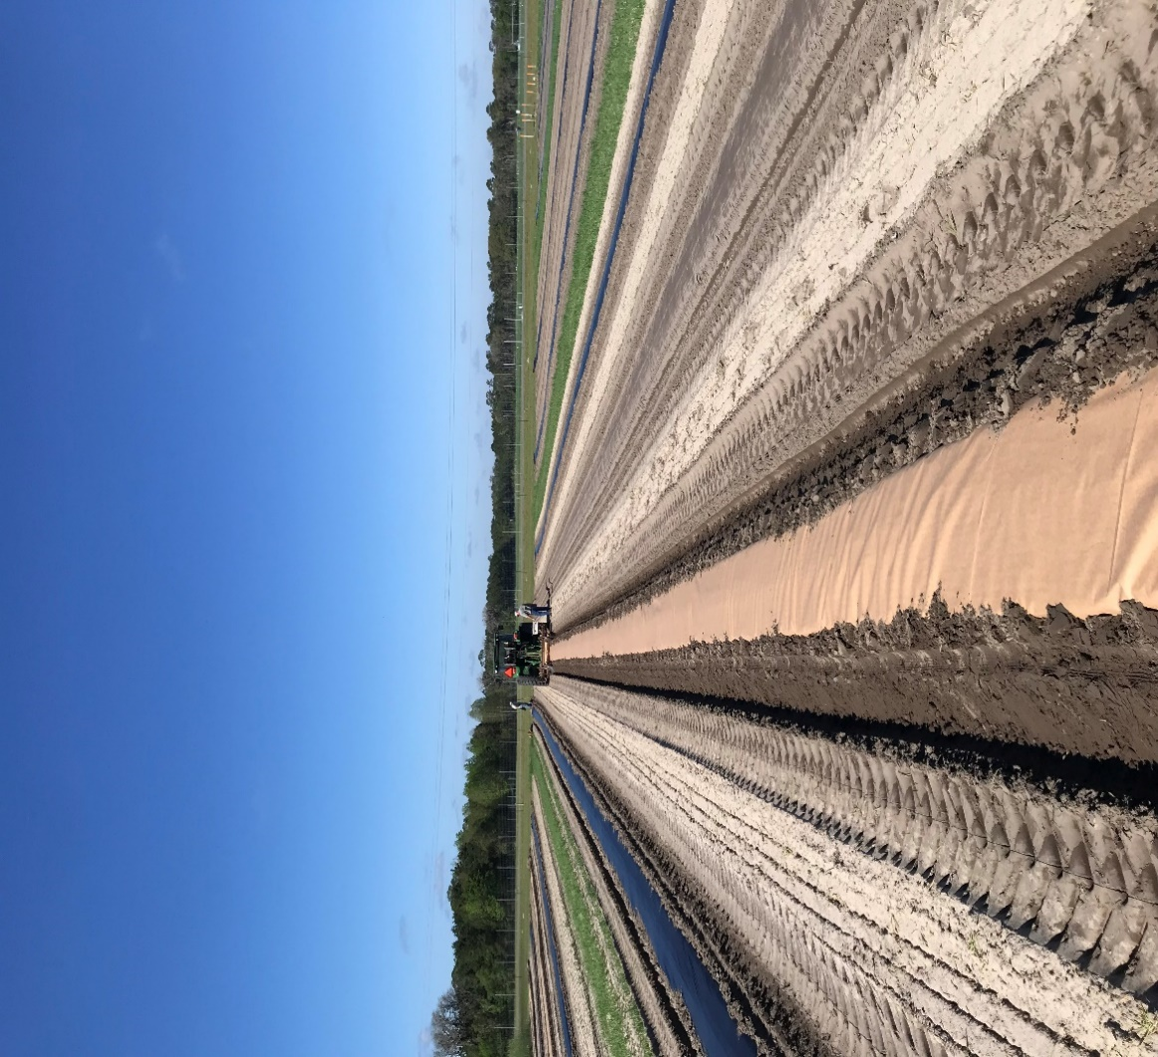

**Photo 2. April 4th, 2022, (15 days after transplanting), WestRock Gen 3 paper mulch (left, LDPE plastic right.**

**Photo 3. May 6th, 2022, (46 days after transplanting), WestRock Gen 3 paper mulch (two rows on right), LDPE plastic mulch (one row onleft).**

**Photo 4. June 14th, 2022, (94 days after transplanting) WestRock Gen 3 paper mulch (left), LDPE plastic mulch (right). Note in the LDPE bed the vine coverage is better that the paper but nutsedge is more prevalent in the LDPE plot**

**Photo 5. August 1st, 2022, (136 days after application), WestRock Gen 3 paper mulch (right), LDPE plastic mulch bed (left). Note the LDPE plastic was removed by hand labor while the WestRock Gen 3 paper mulch is still mostly intact, but ready to be tilled into the soil.**

**Photo 6. August 18th, 2022, (153 days after application) project terminated. Since the paper mulch is biodegradable, hand removal is not necessary. The paper was tilled into the soil.**

