**Evaluation of Different WestRock Paper Mulches in Comparison to Standard and Degradable Polyethylene Mulches for their Performance in Watermelon Production and Nutsedge Control**

**Robert Hochmuth, Morgan Morrow, and Alexandor McMillan**

**University of Florida, Institute of Food and Agricultural Sciences**

**North Florida Research and Education Center- Suwannee Valley**

**7580 CR 136 East**

**Live Oak, FL 32060**

[**bobhoch@ufl.edu**](mailto:bobhoch@ufl.edu)

**Materials and Methods**

This trial was conducted at the North Florida Research and Education Center- Suwannee Valley (NFREC-SV) during the spring of 2021. The goal of this trial was to evaluate the effectiveness of three paper mulch materials in comparison to a standard polyethylene mulch and a biodegradable polyethylene mulch.

The experimental area was prepared by power-tilling the soil and marking rows spaced ten feet apart. The soil was fertilized with 400 lbs per acre of a complete fertilizer (14-4-14) (N- P2O5-K2O plus micronutrients). The fertilizer was incorporated into the soil by rototilling. Any additional fertilizer (liquid 7-0-7) was fertigated through drip irrigation tape on a weekly basis. A Kennco Manufacturing Inc. (Ruskin, Fl) bed press was used to form and press beds. The formed beds were 24 inches wide and 6 inches high. The plots were 100 feet long with a 2 foot “alley” of separation between plots down the row.

Mulch treatments and drip irrigation tape were then applied on March 24, 2021 with a “Kennco Speed Layer” to cover the pressed beds. There were 4 reps of mulch treatment. Treatments included 3 WestRock paper mulches Gen 1, Gen2, and Gen 3; biodegradable polyethylene mulch Bio360, and a standard nondegradable polyethylene mulch (black on white with black side up). Drip irrigation tape was installed in the center of the bed top along with the application of the mulches and was used to irrigate the crop in all plots.

A standard seedless watermelon cultivar, Fascination, was selected for the trial. The superpollinizer cultivar, SP-7, was used to provide pollen to the seedless plants. Holes were punched with a Kennco metal spoked water wheel in the mulches 3-feet apart for seedless transplants. Superpollinizer transplants were planted between the third and fourth seedless plants on the opposite side of the drip tape as the seedless transplants. All transplants were planted on April 5, 2021. The watermelon crop was managed for diseases and insects as needed during the season using standard pesticides commonly used in watermelons.

Data collection focused on two parameters, nutsedge plants that emerged through the mulch treatments, and a rate of degradation for mulch treatments.

* + Nutsedge Population Count

The population of nutsedge that emerged through the mulch treatments was counted. This count did not include nutsedge that emerged through the punched plant holes.

* + Mulch Degradation

The mulches were periodically rated visually for initiation of degradation and progression of degradation. The assessment of degradation was emphasized on the buried tuck area to the side of the bed, as this is where the earliest signs of degradation occurred. The date was noted when the mulch area was entirely separated from the buried tuck with a rating of 5 (Table 1).

**Results and Discussion**

Degradation:

The standard polyethylene mulch treatment showed no degradation during the period of time ratings were taken, through May 12. The biodegradable mulch treatment, Bio360, showed no signs of degradation until April 28 (35 days after mulch application). Slight degradation was detected in Bio360 on April 28 and May 12. Gen 1 paper mulch began degradation along the buried tuck within the first 14 days after application and by April 14, 21 days after application, all plots showed full degradation at the buried tuck line. Gen 2 and Gen 3 showed minor signs of initial degradation, mostly softening of the paper, on April 14 and 21, but all plots remained intact through April 21. On April 28, Gen 3 showed significant degradation with nearly all plots having major degradation along the buried tuck, but also tearing along the bed top, resulting in complete exposure of the beds. By May 12, both Gen 2 and Gen 3 had complete degradation along the buried tuck and along the bed top. The paper mulches, Gen 2 and Gen 3, were applied with the coating side up. As the season progressed, it was noticed the paper portion of Gen 2 and Gen 3 began to be degraded under the coated layer. As the degradation of the paper became advanced, the clear coating remained intact. This created a critical set of factors whereby the clear coating layer without the paper served as a “clear layer” covering the bed, allowing weed growth under the mulch layer. Weed populations were very high and growth was accelerated with the high soil temperature created under the clear coating layer in Gen 2 and Gen 3. Ultimately, the weed growth “pushed” up on the clear coating layer until the coating tore on top of the bed or gave way along the buried tuck. In a traditional situation of mulch materials, the sun-blocking coatings, or the black color of the polyethylene, prevent sunlight from penetrating to the soil covered by the mulch. This reduces or prevents weed growth (other than at the plant hole) under the mulch layer. However, clear polyethylene mulches allow (and encourage) weed growth if herbicides are not used under the clear mulch. This is basically what happened in Gen 2 and Gen 3 in this trial. When the paper layer was intact, no sunlight was allowed through during the first 2-3 weeks after application. But, as the paper in contact with the moist soil layer, under the coating layer, was degraded (biodegradation), sunlight began to penetrate through and eventually the sunlight was blocked very little. Approximately 4-5 weeks after application, Gen 2 and Gen 3 had reached a point where weed growth under the mulch layer dictated ultimate result of breaking integrity. The trial was terminated on May 12 due to the complete loss of integrity of the three paper mulches.

Table 1. Degradation rating scale and description.

|  |  |  |  |  |  |  |  |  |  |  |  |  |  |  |  |  |  |  |  |  |  |  |  |  |  |  |  |  |  |  |  |  |  |  |  |  |  |  |  |  |  |  |
| --- | --- | --- | --- | --- | --- | --- | --- | --- | --- | --- | --- | --- | --- | --- | --- | --- | --- | --- | --- | --- | --- | --- | --- | --- | --- | --- | --- | --- | --- | --- | --- | --- | --- | --- | --- | --- | --- | --- | --- | --- | --- | --- |
| |  |  |  |  |  |  |  | | --- | --- | --- | --- | --- | --- | --- | | **Rating** | **Degradation Rating Scale** | | | | | | | 1 | No visible degradation |  |  |  |  |  | | 2 | Mulch beginning to soften but intact | |  |  |  |  | | 3 | Initial degradation visible with small holes or tears in mulch | | | |  |  | | 4 | Significant degradation, nearly 50% of tuck area degraded, some detachment of paper from tuck | | | | | | | 5 | 100% of buried tuck area degraded, paper detached at tuck area | | | | |  | |

Insert Tables and bar graphs here with titles above each table.

Fig. 1 Gen 1 paper mulch application with Kennco Speed Layer.

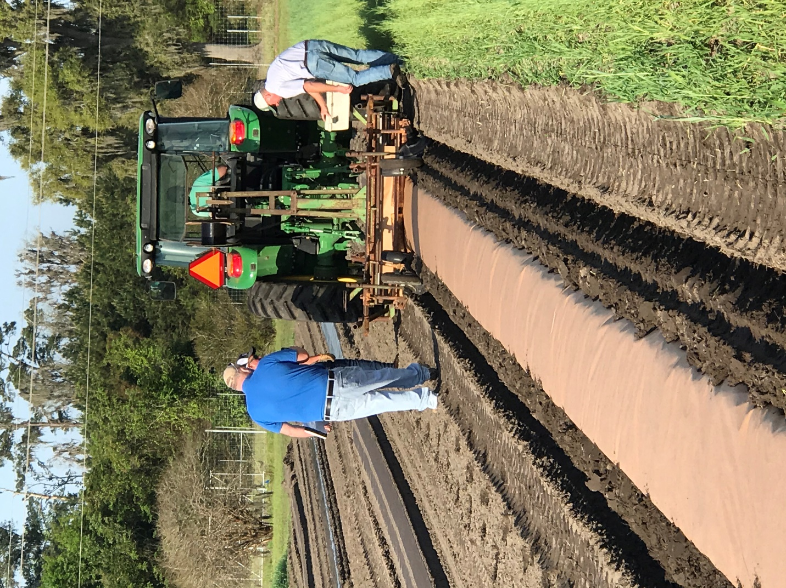

Fig. 2 Completed much application for all 5 treatments.

Fig. 3 Nutsedge population piercing through black Bio360 mulch (bed in the center).

Fig. 4. Early season degradation of Gen 1 paper mulch.

Fig. 5. Degradation of Gen 1 paper mulch along interface of buried tuck area.

Fig. 6. Photo showing biodegradation of the paper fiber area under the coated layer,

note weed growth and transparency of the mulch.

Fig. 7. Weed growth pressure splitting paper mulches in Gen 2 and Gen 3

(note transparency of the mulch).

Fig. 8. High weed population under transparent Gen 2 and Gen 3 mulches

resulting in splitting of the coated layer on bed top area.

