Evaluation of Different WestRock Paper Mulches in Comparison to Polyethylene Mulches for their Performance in Vegetable Production
Robert Hochmuth and Alexandor McMillan
University of Florida, Institute of Food and Agricultural Sciences
North Florida Research and Education Center- Suwannee Valley
7580 CR 136 East
Live Oak, FL 32060
bobhoch@ufl.edu

Materials and Methods
This trial was conducted at the North Florida Research and Education Center- Suwannee Valley (NFREC-SV). The goal of this trial was to evaluate the effectiveness of two paper mulch materials in comparison to a standard polyethylene mulch and a biodegradable polyethylene mulch. The trial began 4-Nov-2020.
The experimental area was prepared by power-tilling the soil and marking rows spaced six feet apart. The soil was fertilized with 400 lbs per acre of a complete fertilizer (14-4-14) (N- P₂O₅-K₂O plus micronutrients). The fertilizer was incorporated into the soil by rototilling. Any additional fertilizer was fertigated through drip irrigation tape on a weekly basis. A Kennco Manufacturing Inc. (Ruskin, Fl) bed press was used to form and press beds. The formed beds were 24 inches wide and 6 inches high. The plots were 43 feet long with a 10 foot “alley” of separation between each other down the row.
Mulch treatments and drip irrigation tape were then applied with a “Kennco Speed Layer” to cover the pressed beds. There were 4 reps of mulch treatment. Treatments included paper mulch Ex50rt, paper mulch Ex43rt, biodegradable polyethylene mulch Bio360, and a standard nondegradable polyethylene mulch. Drip irrigation tape was installed in the center of the bed top along with the application of the mulchesand was used to irrigate the crop in all plots.
A standard cabbage cultivar, “Bravo”, was selected for the trial. Holes were punched in the mulches and cabbage transplants were planted on 4-Nov-2020. The cabbage crop was managed for diseases and insects as needed during the season.
Data collection focused on two parameters, nutsedge populations that emerged through the mulch treatments, and a rating of degradation for mulch treatments.
  - Nutsedge Population Count
The population of nutsedge that emerged through the mulch treatments was counted. This count did not include nutsedge that emerged through the punched plant holes.
  - Mulch Degradation
The mulches were periodically rated visually for initiation of degradation and progression of degradation. The assessment of degradation was emphasized on the buried tuck area to the side of the bed, as this is where the earliest signs of degradation occurred. The assessment of degradation was done with regard to orientation of the beds. The beds ran North/South, and therefore the buried tucks were on the East(E) and West(W) sides. Two separate assessments of degradation were done on each plot for each side (E/W) for a total of two ratings per plot per date. The date was noted when the mulch area was entirely separated from the buried tuck with a rating of 5 (Table 1).

There were 6 degradation ratings recorded over time.
  - 4-Nov-2020
  - 12-Nov-2020
  - 16-Nov-2020
  - 23-Nov-2020
  - 25-Nov-2020
  - 2-Dec-2020

There were 4 nutsedge counts recorded over time.
  - 17-Nov-2020
  - 23-Nov-2020
  - 25-Nov-2020
  - 2-Dec-2020

Rating | Degradation Rating Scale
1 | No visible degradation
2 | Mulch beginning to soften but intact
3 | Initial degradation visible with small holes or tears in mulch
4 | Significant degradation, nearly 50% of tuck area degraded, some detachment of paper from tuck
5 | 100% of buried tuck area degraded, paper detached at tuck area

Table 1: Description of degradation ratings

Treatment Code | Mulch Treatments
A | Ex50RT
B | Ex43FSP
C | BIO360
D | Standard Poly

Table 2: Mulch treatment codes and corresponding types

Plot | Mulch Treatment | Average Nutsedge Count per Treatment
 |  | 17-Nov | 23-Nov
A | Ex50RT | 0 | 0
B | Ex43FSP | 0 | 0
C | BIO360 | 28 | 32.25
D | Standard Poly | 17 | 17.75

Table 3: Nutsedge counts per mulch treatments

Plot | Mulch Treatment | Average Days to Complete Degradation at Buried Tuck Line
 |  | W | E
A | Ex50RT | 19 | 19
B | Ex43FSP | 12 | 19
C | BIO360 | N/A | N/A
D | Standard Poly | N/A | N/A

Table 4: Number of days to reach complete degradation at the buried tuck line

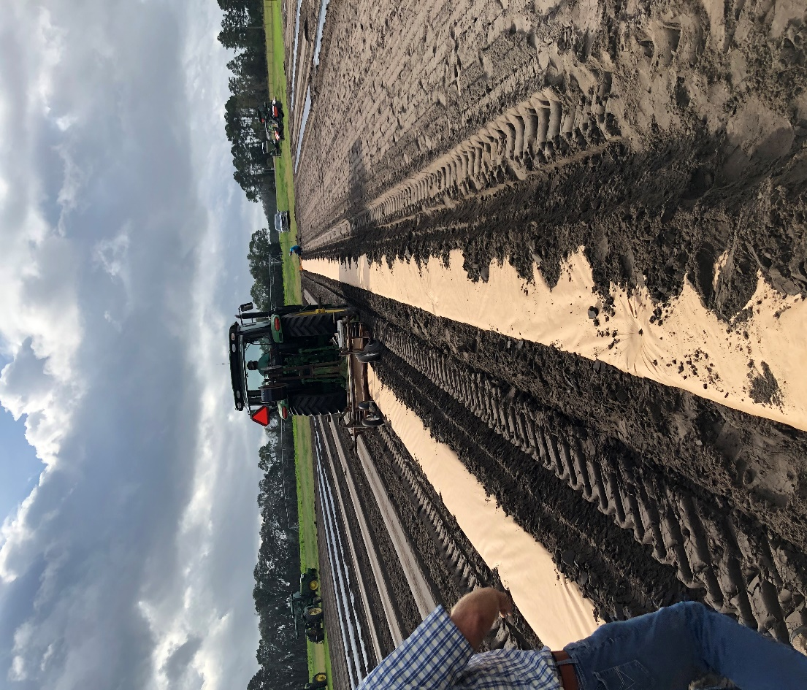
Image 1: 4-Nov-2020. Kennco Speed layer in action, laying paper Ex50RT. The paper could withstand being stepped on, as seen by the footprint in the paper mulch.

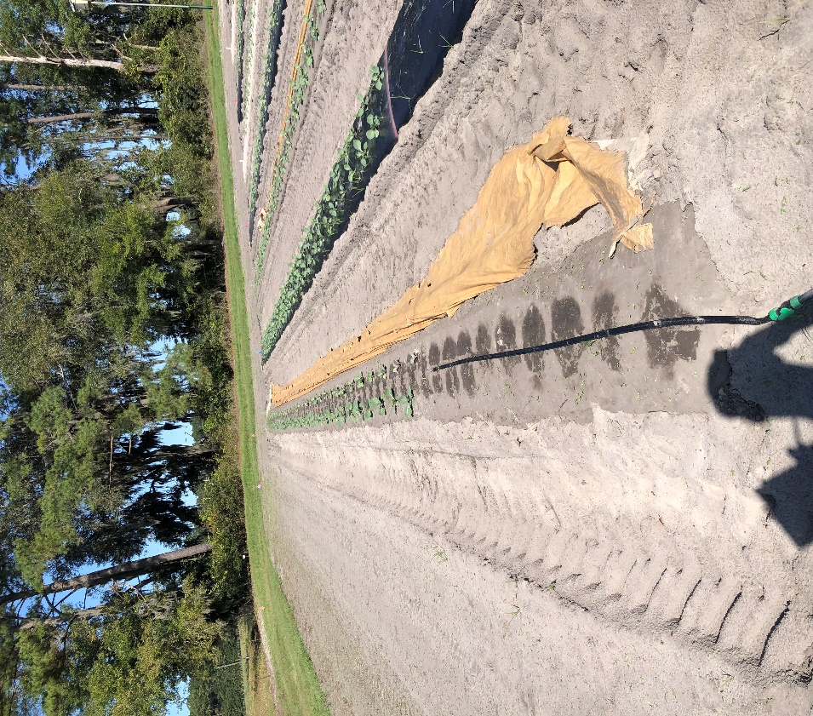
Image 2: 17-Nov-2020. Plot 2B (Ex43FSP). Note the degradation of the East side compared to the West.

