Evaluation of Several Coated Paper Mulches Provided by Smurfit WestRock Company in Comparison to a Standard Low Density Polyethylene Film for Performance in Watermelon
Robert Hochmuth, Sydney Williams, Shivendra Kumar, and Kaleb Kelley
University of Florida, Institute of Food and Agricultural Sciences
North Florida Research and Education Center- Suwannee Valley
7580 CR 136 East
Live Oak, FL 32060
Corresponding author: bobhoch@ufl.edu

Industry Cooperator: Cas Siegling and Bill Statelman, Smurfit WestRock Company
US Headquarters: Richmond, VA.
Special thanks to the NFREC-SV farm crew for implementing, maintaining, and assisting in harvesting the watermelon crop and in data collection and analysis.

Materials and Methods
This trial was conducted in the spring of 2024 at the North Florida Research and Education Center- Suwannee Valley (NFREC-SV). The goal of this trial was to evaluate the effectiveness of several Smurfit WestRock paper mulch conditions in comparison to commonly used standard Low-Density Polyethylene (LDPE) (Table 1) mulch by evaluating several parameters, including the ability to resist degradation and nutsedge growth, impact on soil temperature, soil moisture, as well as the effect on watermelon early and total season yield.
The experimental area was prepared by power-tilling the soil and pressing the beds using a Kennco Manufacturing Inc. (Ruskin, Fl) bed press. Rows for were pressed and spaced ten feet apart for watermelon. Each paper mulch plot was 70 feet long. The formed beds were 24-inches wide and 6-inches high. Preplant controlled release fertilizer was incorporated into the soil where the beds were to be formed. Any additional nitrogen and potassium needed at the end of the season was applied via fertigation through the drip tape. After mulches were applied, a standard herbicide for each crop was applied to the row middles.
Mulch treatments were applied to the pressed beds on 13 March 2024, with a “Kennco Speed Layer”. Drip irrigation tape was laid as the mulches were laid with the same machine. Drip tape was applied to the bed center and slightly buried in a shallow groove. Plots were arranged in a randomized complete block design with 4 replications. There were eleven mulch treatments, each replicated four times (Figure 1).
Seedless watermelon transplants (Cracker Jack) and superpollinizer (Ace) transplants were established on 20 March 2024. Seedless plants were transplanted on a 36-inch spacing in the row and superpollinizer plants were transplanted on the opposite side of the drip tape between every third and fourth seedless plant. Holes were punched with a Kennco “water wheel” metal drum with spokes at the designated distance of 36 inches. The crop was managed with commonly used fungicide and insecticide applications as needed, typically weekly.
Data collection focused on three parameters; nutsedge plants that pierced and emerged through the mulch treatments, the rate of degradation of the mulch at the buried tuck, and marketable yield of watermelons.
- Nutsedge Population Count
The population of nutsedge (purple and yellow) that emerged through the mulch treatments on each plot was counted. This count did not include nutsedge that emerged through the soil covering the buried tuck or through the holes punched in the mulch for transplanting watermelons. Any nutsedge counted would have to pierce through the mulch.
- Mulch Degradation Ratings
The mulches were periodically rated visually for initiation of degradation and progression of degradation (Table 2). Degradation was assessed primarily on the buried tuck area on the side of the bed as this is where the earliest sign of degradation typically occurred in past research trials.
- Soil Temperature Readings
Temperatures were measured at one and four-inch depths using a standard hand-held “meat thermometer”.
- Soil Moisture Content Measurements
Soil moisture in this trial was measured with a TDR probe from Spectrum Technologies. Moisture readings were recorded by the probe giving the average soil moisture content (%) from 0-8 inches.

Results and Discussion- Watermelon
The Smurfit/WestRock paper mulches were all effective at resisting a high level of degradation throughout the growing season. Ratings were taken on 4 dates (29-March, 25-April, 7-May, and 18-June). The ratings taken on 18- June, 90 days after application, are shown in Figure 2. Paper mulches resisted degradation with the buried tuck becoming slightly weak but still intact throughout the entire growing season. The LDPE plastic mulch, as expected, maintained its full integrity at the buried tuck line throughout the growing season. The integrity of the buried tuck in all the paper mulches lasted much longer than needed to perform adequately in watermelons. In all paper treatments, the paper that covered the top of the bed was very strong and had very little loss of integrity.
The paper mulches were all very effective in resisting penetration of nutsedge with no nutsedge being reported throughout the entire watermelon growing season (Table 3). The LDPE plastic mulch allowed nutsedge piercing and penetration of nutsedge plants early in the season with counts taken on 25-April. This year’s trial location generally had very low populations of nutsedge. After the season ended, all paper mulch treatments were easily disced into the soil after the drip tape was pulled. This facilitates early crop clean up after the final harvest and requires much less labor than the hand-pulling of a nondegradable plastic mulch.
Soil temperature readings under the mulch treatments were taken on two dates (19-March and 20-March) when overnight ambient temperature was cold. A standard “meat thermometer” was used to take temperature readings at both 1 inch and 4 inches on each plot. Three readings were taken from each plot, at each depth and recorded. The data from both dates at one inch is provided in Figure 3. Very small differences were detected between most mulch treatments, however, it should be noted there is a trend of certain paper mulches having slightly, but consistently, higher temperatures on both dates than the standard black plastic mulch treatment. Those paper mulches include LVN-Up, LVB-S1, and LVB-S2.
The presence of female flowers may be used as an early season indicator of advanced early growth. We chose to record the number of female flowers to see if we could correlate the higher soil temperatures to advanced early physiological growth. Ten plants were marked from each plot and every female flower on the vines were counted and recorded. The mean total number of blooms from the ten plants represents the total number of blooms as presented in Figure 4. Of those paper mulch treatments that had high soil temperatures, only LVN-Up showed the same trend of high numbers of female blooms when compared to black plastic mulch.
For this report, we are including soil temperature data taken from one of the on-farm trials where black Gen 3 paper mulch was installed in rows next to standard black plastic mulch. This early season soil temperature data is presented in Figure 5. This figure shows the slight differences in soil temperature at 4-inch depth between black paper and plastic mulches. This same trend was also observed at other farms (data not presented here) in 2024. The observed trend was that the soil temperature under black plastic gets higher during the day and yet colder on cold nights when compared to black paper. This trend was observed and documented at several farm locations and dates. Maintaining higher soil temperatures at night could be a very important characteristic and benefit for paper mulches. Further research is needed to continue to evaluate this comparison.
Soil moisture was measured on one date during the season by using a portable hand-held Field Scout Model 100 TDR soil moisture probe (https://www.specmeters.com/shop/soilmonitoring/soilmonitoring-TDR). This device measures the average soil moisture from 0 to 8 inches. Only one black paper mulch (LVB) and black plastic were used in this test. Soil moisture was higher (10.9%) under the black paper mulch vs the black plastic (9.4%) (Figure 6). This was a very interesting and potentially very important characteristic of paper mulches that certainly needs and deserves further research. Conservation of moisture is a very important concern in many areas where watermelon and other vegetables are grown, including North Florida. There are currently legislatively supported funds as cost-share incentives for farmers who adopt proven moisture conserving practices on their farm.
At harvest, each marketable watermelon weight was recorded. Weights from four harvest dates (3-June, 12-June, 18-June, and 26-June) were recorded, totaled, and converted to a pounds per acre basis for each treatment (Table 4 and Figures 7 and 8). Yields were highly variable within replications of treatments making it difficult to show significant differences between mulch treatments. However, the white plastic mulch treatment showed a significant trend of much lower yields at every harvest. There were non-significant trends to be noted, including black mulches (paper and plastic) typically had higher yields than brown papers, however significant differences were not found within color groups. The observational trend of high early yield (first harvest) for LVN-Up, LVB-S2, and black plastic mulch was noted. Overall yields were somewhat less than typically expected in this trial. The overall lower yields were likely due to several high wind events after planting, one event in early May with winds over 70 miles per hour. No plants were killed during these events, but plant abrasion damage was observed on most plants.
Conclusions
This trial continues to demonstrate the viable commercial performance of coated paper mulches provided by Smurfit WestRock in watermelon production in North Florida. Past research and on-farm trials where high nutsedge populations are high have consistently shown yield benefits of using paper mulch. In this trial, the nutsedge population was low and had little impact on this trial. This trial did, however, show new factors that need additional research to draw further conclusions. New discoveries in 2024 included the black paper mulches retain soil temperatures slightly higher overnight on cold nights than black plastic. This results in potential benefits of advanced early season growth in cold seasons after planting, and potentially a margin of protection on nights with frost or freezing temperatures. The second observation found in this University research trial and also made by farmers based on their on-farm trials is that soil moisture may be retained better under paper versus plastic mulches. During this 2024 season, we have attempted to document these discoveries in mid-season. However, future research trials need to be designed to specifically test these premises, based on our preliminary data. These two factors, in addition to nutsedge control, would greatly increase the value assessment of paper mulches, however, future research will be needed to further identify these actual values.

Table 1. Watermelon Trial Mulch Treatments
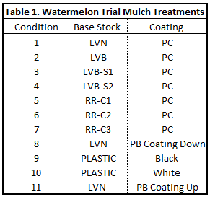

Figure 1. Field plots after application of mulches.
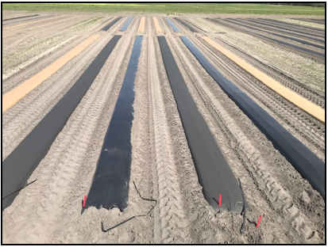

Table 2. Degradation rating scale and associated description for mulches.
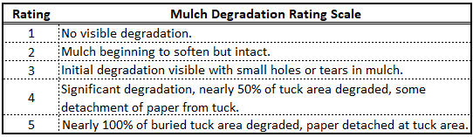

Figure 2. Degradation ratings of mulch buried tuck area.
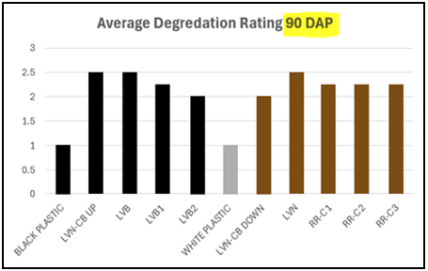

Table 3. Nutsedge populations penetrating through mulch treatments.
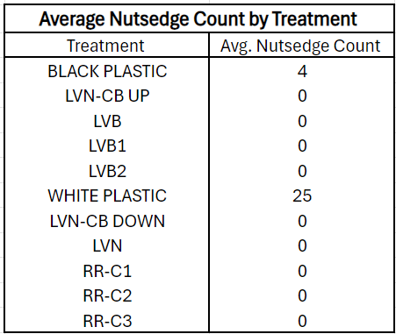

Figure 3. Soil temperatures at 1-inch depth on two dates.
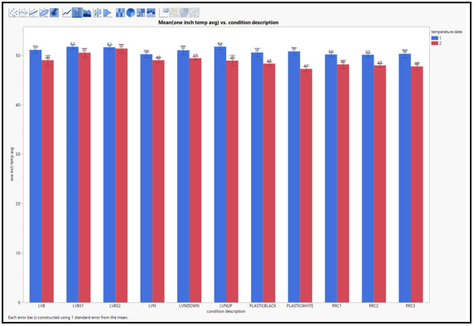
Figure 4. Number of female watermelon flowers (blooms) per ten plants.
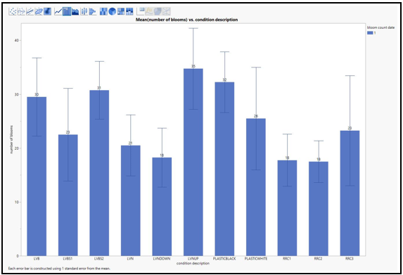

Figure 5. Soil temperatures at 4-inch depth on cooperating farm.
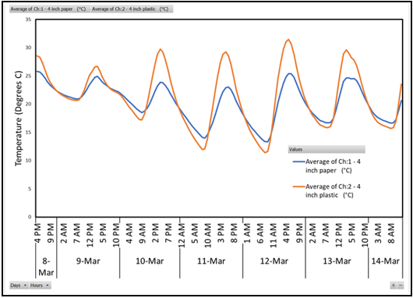
Figure 6. Soil moisture readings (%) using a TDR probe in one black paper and one black plastic mulch treatment.
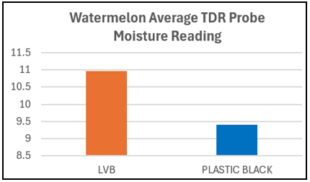

Table 4. Watermelon yield data for 4 harvests and total seasonal yield for 11 mulch treatments.
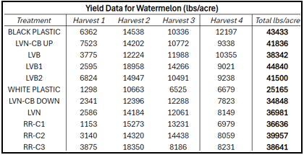

Figure 7. Total seasonal yield of watermelon for 11 mulch treatments.
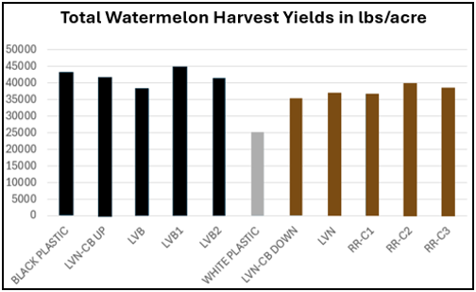

Figure 8. Watermelon yield data for 4 harvests and total seasonal yield for 11 mulch treatments.
