**Evaluation of a Coated Paper Mulch Provided by WestRock Company in Comparison to a Standard Low Density Polyethylene Film for Watermelon Yield, Rate of Degradation and Resistance to Nutsedge Penetration**

**Robert Hochmuth, Sydney Williams, and Sudeep Sidhu**

**University of Florida, Institute of Food and Agricultural Sciences**

**North Florida Research and Education Center- Suwannee Valley**

**7580** **CR 136 East**

**Live Oak, FL 32060**

**Corresponding author:** [**bobhoch@ufl.edu**](mailto:bobhoch@ufl.edu)

**Industry Cooperator: Fritz Paulsen, WestRock Company, Headquarters: Richmond,** **VA.**

**Special thanks to the NFREC-SV farm crew for implementing, maintaining, and assisting in harvesting the watermelon crop and in data collection and analysis.**

**Materials and Methods**

This trial was conducted at the North Florida Research and Education Center- Suwannee Valley (NFREC-SV) during the spring of 2023. The goal of this trial was to evaluate the effectiveness of the WestRock Gen 3 paper mulch in comparison to commonly used standard Low Density Polyethylene (LDPE) mulch by evaluating its ability to resist degradation and nutsedge growth, as well as the effect on watermelon early and total season yield.

The experimental area was prepared by power-tilling the soil and pressing the beds using a Kennco Manufacturing Inc. (Ruskin, Fl) bed press. Eight rows were pressed and spaced ten feet apart and 150 feet long. Each plot was 70 feet long with a 5-foot buffer. The formed beds were 24-inches wide and 6-inches high. Preplant controlled release fertilizer was incorporated into the soil where the beds were to be formed. Any additional nitrogen and potassium needed at the end of the season was applied vis fertigation through the drip tape. After mulches were applied, a herbicide combination of Sinbar and Sandea was applied to the row middles.

Mulch treatments were applied to the pressed beds on March 13, 2023, with a “Kennco Speed Layer.” Drip irrigation tape was laid as the mulches were laid with thew same machine. Drip tape was applied to the bed center and slightly buried in a shallow groove. Plots were arranged in a randomized complete block design with 4 replications. There were four mulch treatments, each replicated four times. The first mulch treatment included a WestRock paper mulch, Gen 3, which was applied with the treated side down and paper side facing upwards. The Gen 3 paper is a light brown color. The second mulch treatment included WestRock paper mulch, Gen 3, which was applied as in the previous treatment and then sprayed with black COLORBACK Liquid Mulch Colorant. The third mulch treatment was a standard Low-Density Polyethylene (LDPE) plastic mulch (white-on-black) placed with the white side up. The fourth mulch treatment was a standard Low-Density Polyethylene (LDPE) plastic mulch (white-on-black) placed with the black side up.

Seedless watermelon transplants (cultivar XX) and superpollinizer (cultivar YY) transplants were established on March 16, 2023. Seedless plants were transplanted on a 36-inch spacing in the row and superpollinizer plants were transplanted on the opposite side of the drip tape between every third and fourth seedless plant. Holes were punched with a Kennco “water wheel” metal drum with spokes every 36 inches. The crop was managed with commonly used fungicide and insecticide applications as needed, typically weekly.

Data collection focused on three parameters; nutsedge plants that pierced and emerged through the mulch treatments, the rate of degradation of the mulch at the buried tuck, and marketable yield of watermelons.

* + Nutsedge Population Count

The population of nutsedge (purple and yellow) that emerged through the mulch treatments on each plot was counted. This count did not include nutsedge that emerged through the soil covering the buried tuck or through the holes punched in the mulch for transplanting watermelons. Any nutsedge counted would have to pierce through the mulch.

* + Mulch Degradation

The mulches were periodically rated visually for initiation of degradation and progression of degradation (Table 1). Degradation was assessed primarily on the buried tuck area on the side of the bed as this is where the earliest sign of degradation typically occurred in past research trials.

**Results and Discussion**

The WestRock Gen 3 paper mulch was effective resisting a high level of degradation throughout the growing season (Figures 1-4). WestRock’s Gen 3 paper mulch resisted degradation with the buried tuck becoming slightly weak but still intact throughout the majority of the growing season. Small holes or tears were present in a few buried tuck spots in WestRock Gen 3 paper mulch at 105 days after application, but the paper mulch, in general, was still maintaining sufficient integrity to remain covering the beds under the full vine cover. The vine cover helped keep the paper mulch on the bed. The LDPE plastic mulch maintained its full integrity at the buried tuck line throughout the growing season.

The WestRock Gen 3 paper mulch was effective in resisting penetration of nutsedge with no nutsedge being reported throughout the entire watermelon growing season (Figures5 and 6). The LDPE plastic mulch did allow nutsedge piercing and penetration with an early flush of plants in the first month of the growing season and increased somewhat as time went on. After 36 days, there was an average stand count of 110 nutsedge per 70 feet of bed in the LDPE plastic mulch treatments (Figure 2).

On March YY, after transplanting, a near freeze event occurred. It was decided to not cover the transplants for this event so we could determine the impact of very cold temperatures on the watermelon plants in the various mulch treatments. It is widely accepted darker colored mulches retain higher temperatures during these occasional freeze events. The darker, typically black colored, plastic mulches warm the soil during sunny days and retain the heat in the warmer soils. In this trial, the near freeze event demonstrated this result. The plants in the brown paper and white-on-black plastic plots were noticeably damaged due to the cold in comparison to the black paper and black plastic plots. This was exhibited in early season plant vigor (Figure 7), vine growth and early season harvests.

At harvest, each marketable watermelon weight was recorded. Weights from three harvest dates were collected, totaled, and converted to a pounds per acre basis for each treatment (Figures 8-10). As shown in Figure 8, the first harvest yielded the highest of the three harvests. The Black Paper mulch had the highest yields in pounds per acre for all three harvests. Totaled harvest yields revealed that the plants on black paper mulch produced a higher yield than the black plastic, white plastic, or the brown Gen 3 paper. Based on our observations, this yield difference is likely attributed to the black treated paper mulch’s ability to heat up the soil early in the growing season due to its black color, as well as its ability to resist penetration of nutsedge and other problematic weeds. Although WestRock Gen 3 paper mulch did well at holding together and mitigating nutsedge growth, the color variation did seem to be related to the impact on yields. Future research is suggested to evaluate adding a black dye to the upper side of the mulch so to better warm the soil early in the spring season in Florida**.**

**Table 1. Degradation rating scale and description for mulches.**

|  |  |  |  |  |  |  |  |  |  |  |  |  |  |  |  |  |  |  |  |  |  |  |  |  |  |  |  |  |  |  |  |  |  |  |  |  |  |  |  |  |  |  |
| --- | --- | --- | --- | --- | --- | --- | --- | --- | --- | --- | --- | --- | --- | --- | --- | --- | --- | --- | --- | --- | --- | --- | --- | --- | --- | --- | --- | --- | --- | --- | --- | --- | --- | --- | --- | --- | --- | --- | --- | --- | --- | --- |
| |  |  |  |  |  |  |  | | --- | --- | --- | --- | --- | --- | --- | | **Rating** | **Mulch Degradation Rating Scale** | | | | | | | 1 | No visible degradation |  |  |  |  |  | | 2 | Mulch beginning to soften but intact | |  |  |  |  | | 3 | Initial degradation visible with small holes or tears in mulch | | | |  |  | | 4 | Significant degradation, nearly 50% of tuck area degraded, some detachment of paper from tuck | | | | | | | 5 | Nearly 100% of buried tuck area degraded, paper detached at tuck area | | | | |  | |

**Figure 1.** **Mulch degradation ratings on first rating date (X days after application)**

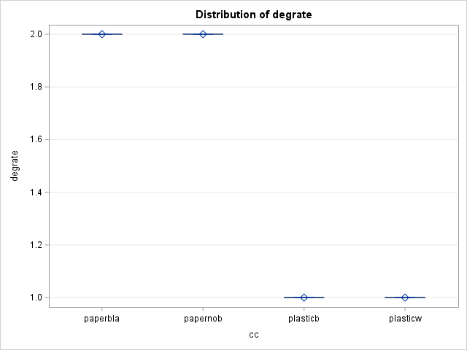

**Figure 2. Mulch degradation ratings on second rating date (X days after application)**

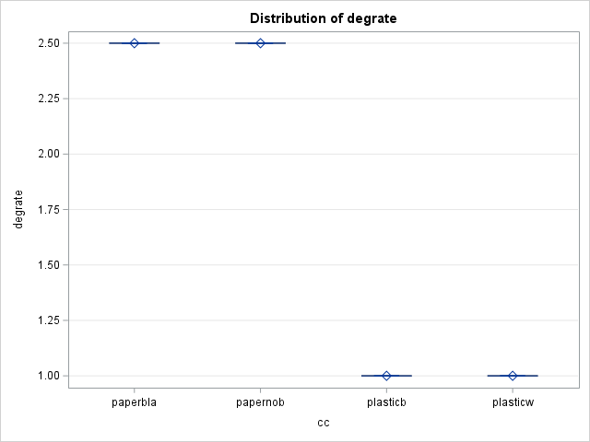

**Figure 3. Mulch degradation ratings on third rating date (X days after application)**



**Figure 4. Mulch degradation ratings on fourth rating date (X days after application)**

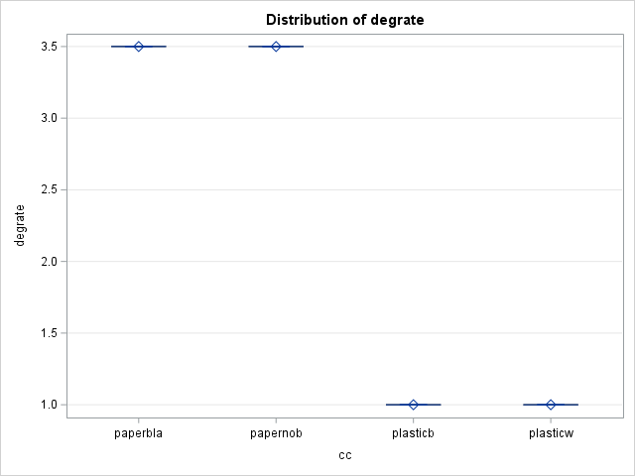

**Figure 5. LDPE plastic mulches vs WestRock Gen 3 paper mulches nutsedge counts 14 days after planting.**

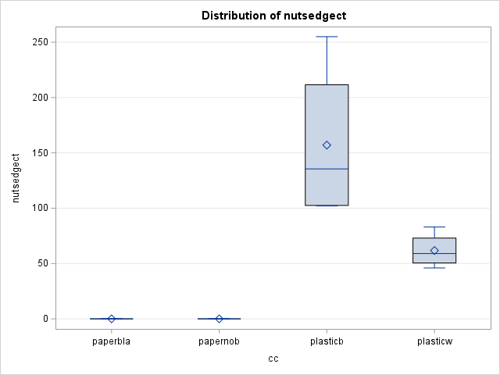

**Figure 6. LDPE plastic mulches vs WestRock Gen 3 paper mulches nutsedge counts 36 days after planting.**

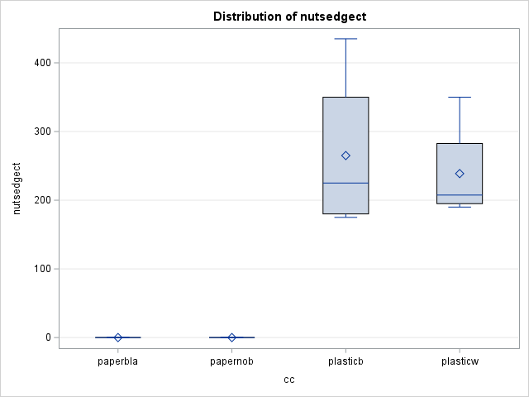

**Figure 7. Plant vigor rating after exposure to near freezing temperatures (rating 1-5, 1 = no vigor, 5 = excellent vigor).**

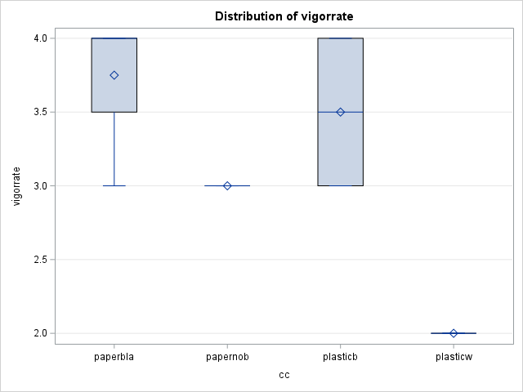

**Figure 8. Marketable watermelon yield from 3 harvests and total seasonal yield in pounds per acre.**

**Figure 9. Marketable watermelon yield from first harvest in pounds per acre.**

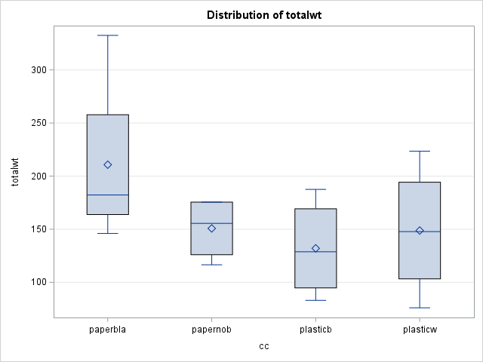

**Figure 10. Marketable watermelon yield from 3 harvests, total seasonal yield in pounds per acre.**

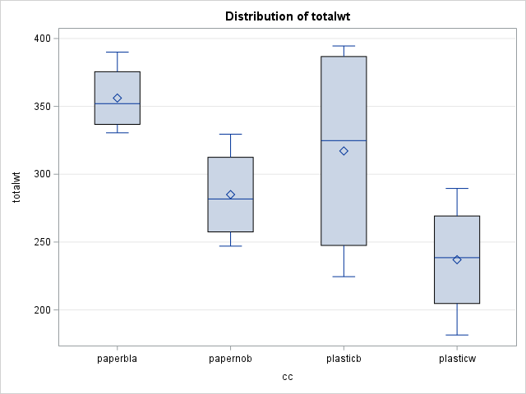

**Photo 1. March 13th, 2023, Day 0 (Date of application), (From Left to right) Black Plastic, Brown Gen 3 Paper, White Plastic, Brown Gen 3 Paper in process of being sprayed black.**

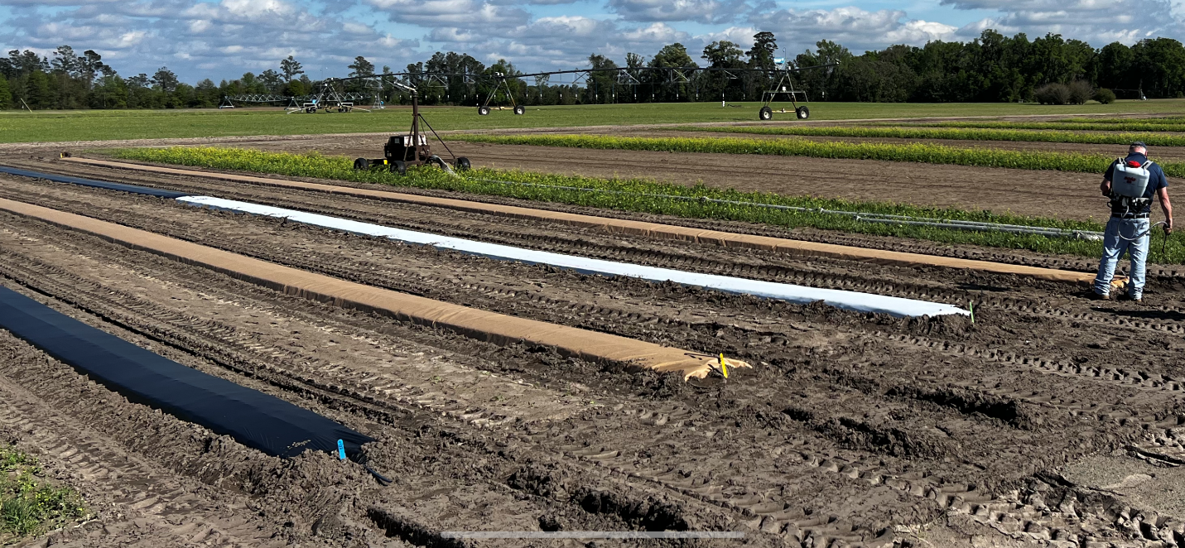

**Photo 2. March 13th, 2023, Gen 3 Paper Mulch In process of being sprayed Black.**

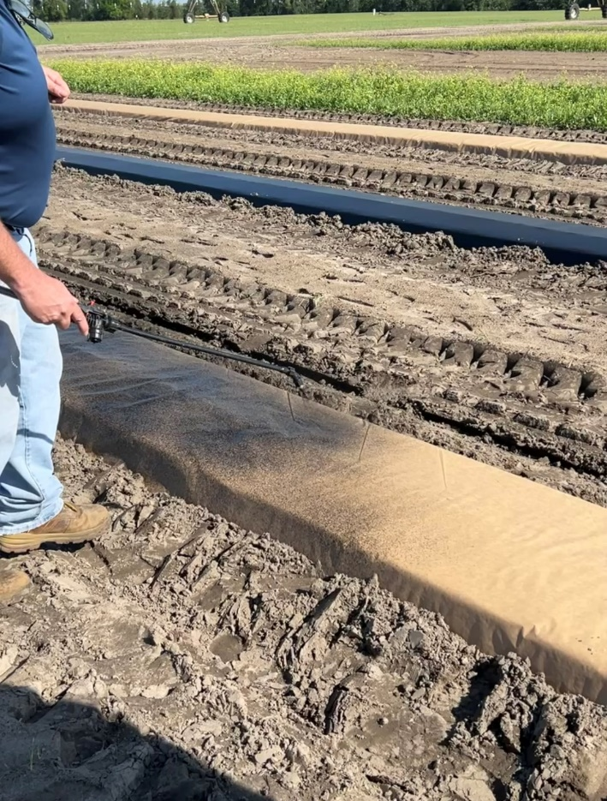

**Photo 3. March 13th, 2023, the product used to spray onto Gen 3 Paper mulch, COLORBACK Liquid Mulch Colorant.**

**Photo 4. March 16th, 2023, (day of transplanting).**

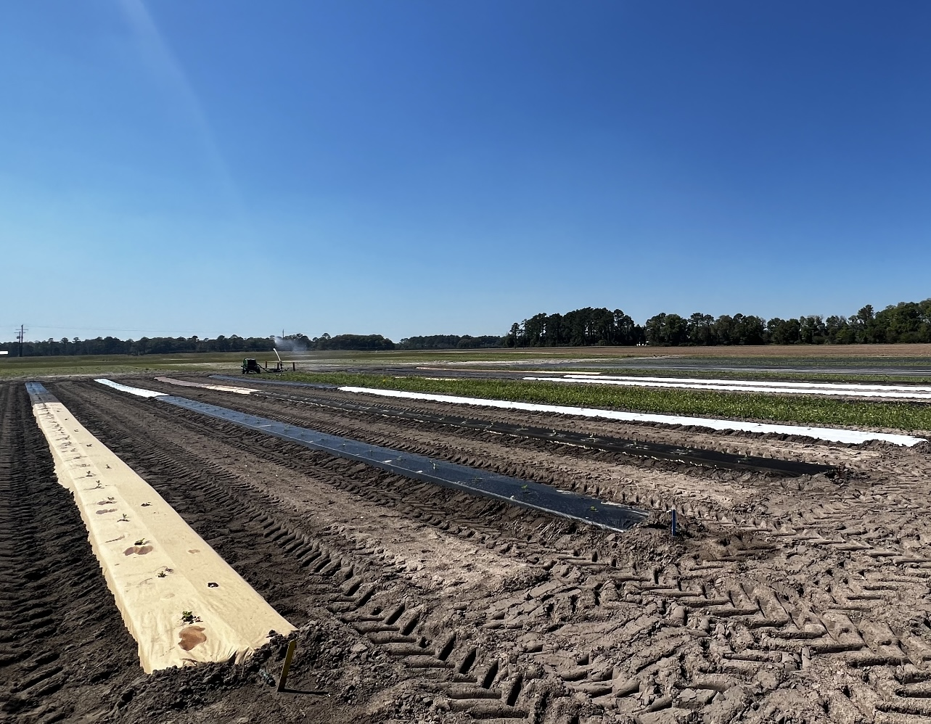

**Photo 5. April 13th, 2023. Black paper mulch on left with no nutsedge in comparison to black plastic on right with high nutsedge population.**

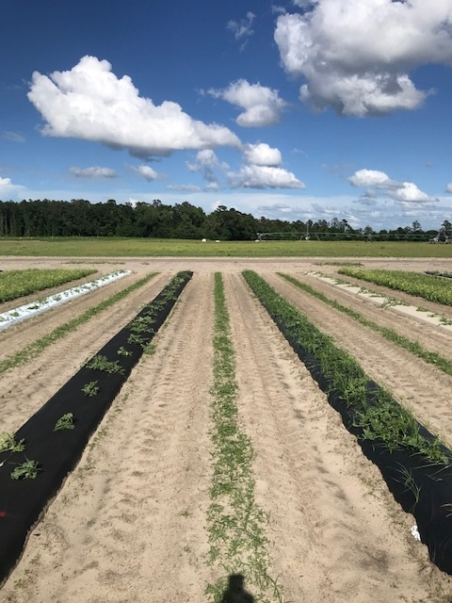

**Photo 6. April 19th, 2023. Black plastic mulch on left shows high nutsedge population and greater growth after near freeze event. Brown paper mulch and white plastic mulch on right and far right shows no nutsedge penetration and also delay in growth after near freeze in comparison to black plastic and black paper treatments.**

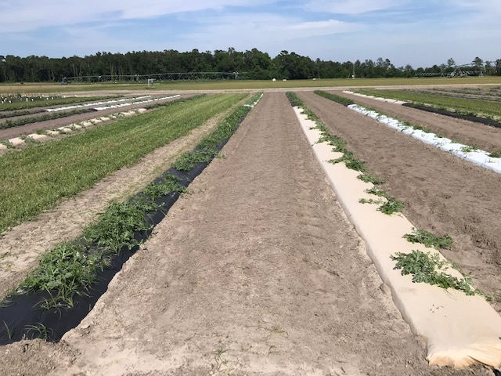

**Photo 7. June 26th, 2023, WestRock black Gen 3 paper mulch(right), LDPE white plastic mulch (left with high population of nutsedge).**

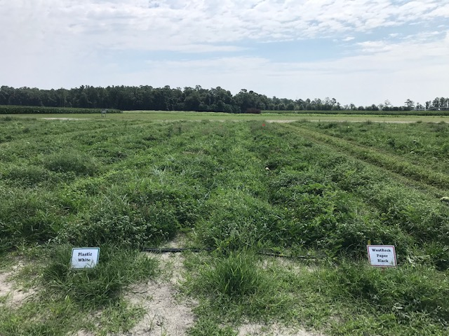

**Photo 8. June 26th, 2023, WestRock Gen 3 paper mulch(left) LDPE plastic mulch (right with high population of nutsedge).**

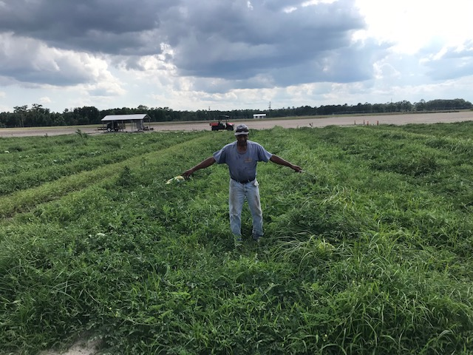

**Photo 9. June 14th, 2023, (93 days after transplanting) First Harvest, collecting weights from individual watermelons on each plot.**

**Photo 10. June 29th at project terminated (108 days after planting). Since the paper mulch is biodegradable, hand removal is not necessary. The paper was tilled into the soil using large field disc.**

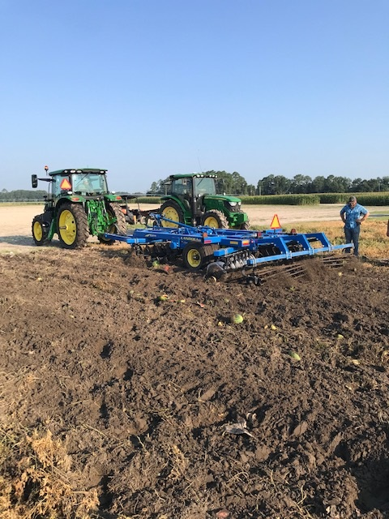

**Photo 11. June 29th, 2023 (108 days after planting). Completion of soil incorporation of the paper mulch plots after 3 passes of the field disc.**

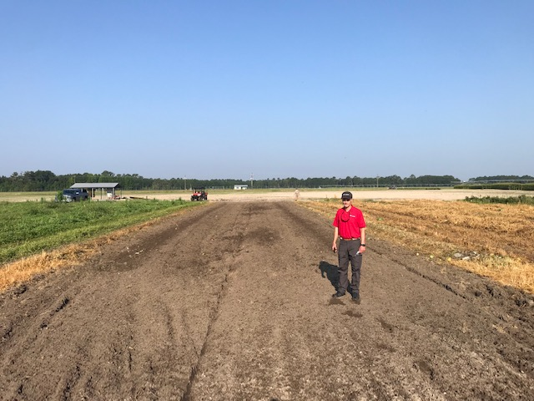

**Photo 12. August 7th, 2023, (147 days after application) LDPE plastic mulch beds awaiting the hand-removal of all plastic mulch.**

