

**UF/IFAS**

North Florida Research and Education Center - Suwannee Valley

7580 County Road 136

Live Oak, FL 32060

386-362-1725

386-362-3067 Fax

**Evaluation of a Complete Analysis and Controlled Release Fertilizer on a**

**Commercial Watermelon Farm in Suwannee Valley, Florida**

Robert Hochmuth, Charles E. Barrett, Marina Burani-Arouca, and Elizabeth Martin

University of Florida, Institute of Food and Agricultural Sciences (UF/IFAS)

North Florida Research and Education Center- Suwannee Valley (NFREC-SV), Live Oak, FL

Jay Skillman

Specialty Ag Sales, Harrell’s Fertilizer Company, Lakeland, FL

Jack and Riley Putnal

Putnal Farms, Live Oak, FL

**Corresponding author**: Robert Hochmuth, bobhoch@ufl.edu

**Funding:** This trial was conducted as part of a Florida Department of Agriculture, Office of Ag Water Policy (FDACS OAWP) grant. Harrell’s Fertilizer Company and Waters Agricultural Labs (Camilla, GA) were in-kind partners in this research project.

**Overview**

This report is part of an ongoing research program on the use of controlled release fertilizer in watermelon production in North Florida. The objective of this overall two-year project was to evaluate a controlled release nitrogen source as an alternative to in bed applications of conventional, soluble, sources of nitrogen fertilizers. Recent research at NFREC- Suwannee Valley with controlled release fertilizers (CRF), especially nitrogen, has shown great promise in watermelon, carrot, and corn production. Our objective was to expand the research onto a commercial watermelon farm in the Suwannee Valley. This large scale on-farm trial compared the season long CRF to the conventional fertilizer being used on this farm. The farmer has adopted and is currently using Best Management Practices (BMPs), including applying some fertilizer preplant and the remainder applied via fertigation based on leaf tissue analysis and petiole sap analysis. The farmer uses plastic mulch, drip irrigation, and soil moisture sensors as components of the overall BMP program. We measured the movement of nitrogen in the soil over time by taking multi-depth soil samples with a manual soil auger and analyzing the soil for nitrate- N. CRFs offer the possibility of adopting new fertilizer coating technology (potentially an advanced BMP) to help reduce N losses in commercial watermelon production.

**Materials and Methods**

A 20-acre field at a watermelon farm in Suwannee Valley was selected for this trial. One ten-acre zone was established as the current conventional fertilizer BMP area and was compared to a ten-acre zone where the season-long CRF was used. Each of these ten-acre sections were established as their own irrigation zone so any fertigation could be implemented on the conventional fertilizer zone only and not affect the CRF treatment. The CRF irrigation zone did not receive any fertilizer via drip irrigation for the entire season.

The entire experimental area was prepared the same with tillage. Once the field area was marked, the preplant fertilizers were applied. The CRF treatment targeted 150lbs per acre of N by applying 1,000 lbs per acre of 15-3-21 (N-P2O5-K2O) plus micronutrients prior to bedding (this was the only fertilizer applied to this treatment season long). The CRF was supplied by Harrell’s Fertilizer Company. Most, but not all of the nitrogen, phosphorus, and potash sources in this fertilizer were coated and controlled release (93% coated N, 88% coated P, 96% coated K). In the conventional fertilizer zone, the pre-bed fertilizer analysis was 8-8-32 (N-P2O5-K2O) plus micronutrients and was applied at a rate of 560 lbs per acre. Fertilizers were incorporated and soil was bedded and press to form beds 24 inches wide and 6 inches high on 8-ft centers. The pressed beds were covered with a nondegradable black plastic and the drip tape was laid on the soil surface slightly off-center of the bed as the plastic was laid. In addition to the preplant fertilizer application, the remaining nitrogen and potassium was applied via drip irrigation (fertigations). The sources included 21% N solution, used early in the season, and the remaining fertigations used 10-0-10 (N-P2O5-K2O).

Seedless watermelon and super pollinizer transplants were established on March 10 in a single row with seedless plant spaced every 48 inches and a super pollinizer was planted between every second and third plant in the same row. Irrigation scheduling was set based on a 3.5-foot Sentek EnviroSCAN SMS (BMP Logic, Trenton, FL) installed in a representative watermelon bed in the conventional fertilizer zone. Both irrigation zones were irrigated on the same schedule. The insect and disease management programs were implemented by the grower in consultation with Extension agent input each week. No significant insect or disease problems occurred in this production area due to the effective management programs implemented.

Beginning March 10, 2020 and approximately every two weeks after, soil sample collection was conducted. The frequency (every 14 days) was set to capture potential movement of N through the soil profile. In each fertilizer zone, soil samples were taken from four areas. Soil samples were taken at depths of 0-6, 6-12, 12-24 and 24-36 inches in each plot using a manual soil auger. The eight sampling dates were March 10, April 3, 15, 30, May 12, 28, June 8, and one later sampling on June 26, 11 days after the final harvest was completed. After samples were collected, they were sent to Waters Agricultural Lab for analysis on nitrate-N. Samples were ground in preparation for analysis, so any CRF polymer-coated granules would be crushed and nutrients released in the process.

Leaf tissue samples were taken from each fertilizer zone four times during the season. At least 30 leaves were taken in each of the two fertilizer zones. The samples were split in half; half of the leaves were sent to Waters Agricultural Lab for whole leaf analysis, and the remaining half was used to measure nitrate-nitrogen and potassium in the petiole sap using Laqua Twin ion selective meters (Spectrum Technologies, Aurora, IL). Leaf samples were collected on April 15, April 26, May 10, and June 4.

Soil sample data were analyzed using the Generalized Linear Mixed Model Procedure of SAS (SAS Version 9.4; SAS Inst. Inc.). A two-way analysis of variance was performed to determine significance of main effects. Means separation was used to examine differences between treatments. Whole leaf nutrient analysis and petiole sap testing are presented as observational data.

**Results**

Nitrate-N Soil Samples

Results from the statistical analysis show that Nitrate-N levels at 0-6 in depth, were significantly higher when fertilized with CRF versus conventional fertilizer. These results were consistent at five samplings (Apr.15, Apr. 30, May 12, Jun. 8, and Jun. 26). This result is related to the soil sample analysis methodology. When the soil samples were ground in the initial processing step, the N would have been released and contributed to the N amount found in that sample. These results show higher levels of N in the 0-6 and 6-12-inch deep samples in the CRF plots due to this factor. Any N found in the top 12 inches of soil in the CRF plots would have been due to N both in the polymer and N released to the soil from the polymer prior to soil sampling. The total N requirement in the CRF plots was applied preplant and therefore the soil analysis shows the total seasonal N in the bed. Each time a soil sample was taken, it was taken near the previous sampling site, so new CRF materials would be included. To assess the movement of N through the soil profile, the 12-24 and 24-36-inch deep samples would only show any soluble nitrate-N in both fertilizer treatments. These deeper samples are better indicators of potential N leaching. In future research trials, it is possible to only capture the released nitrate-N outside of the polymer coated granules, by changing the soil sample processing to include a filtration step to capture the polymers before assessing the nitrate-N amount.

At samplings Apr.15, Apr. 30, and May 12, the interaction between fertilizer treatment and depth was significant. For all three dates, results from 0-6 in depth fertilized with CRF showed significantly higher levels of nitrate-N than any other combination of fertilizer treatment and soil sampling depth.

Figure 1 shows movement of nitrate-N through the soil profile over time, for each sampling depth. The deeper soil samples (12 to 36 inches), show very similar levels of nitrate-N in both conventional and CRF plots. These deeper samples also show very low levels of nitrate-N even toward the end of the season.

Leaf Tissue Nutrient Analysis

Table 1 shows the results from the leaf tissue nutrient analysis, performed four times during the season. Table 2 shows the ranges of adequate nutrient levels for watermelons.

Nitrogen levels were high for both treatments, in all four sampling dates. Phosphorus and potassium levels were adequate for both treatments, in all four samplings. Levels of Mg, Ca, S, and Cu were adequate throughout the season for both treatments. Boron levels were low for the CRF treatment at samplings April 30th and May 12th. Levels of Zn, Mn, and Fe were high for both treatments. High Zn and Mn was due to application of mancozeb fungicide.

Petiole Sap Testing for Nitrate-N and Potassium

Figures 2 and 3 show the results of petiole sap testing over time for nitrate-N and potassium. Table 3 shows the results for petiole sap testing. Overall, the nitrate-N and potassium level in the petiole sap moved up and down in a similar fashion in both fertilizer treatments throughout the preharvest part of the season.

According to the adequate ranges for watermelon as shown in Table 4, the conventional program started off with adequate levels of nitrate-N, followed by two samplings of low levels. Nitrate-N concentration increased towards the end of May, reaching a borderline high level and ending the season with adequate levels. In relation to potassium levels for the conventional program, potassium concentration was adequate until May 22 sampling, when concentrations went up to a higher than adequate level.

Petiole sap results for the CRF program showed adequate levels of nitrate-N for the first two samplings, followed by a low level at May 10. Nitrate-N concentration increased after that to higher than adequate levels on the last two samplings. Potassium concentrations were adequate for all samplings with the exception of the last one, when potassium level was found to be higher than adequate, despite no increase in K application since last sampling.

Figures 2 and 3 show the sharp decrease in levels on nitrate-N and potassium that occurred around May 10. The decrease in concentration of both nutrients may be attributed to rapid fruit development and plant growth with a high fruit yield potential. Leaching rain events can typically affect the concentration of such nutrients in fresh petiole sap testing, however, no leaching rain event was identified during that time (May 1st to May 10th). This is also verified by the soil moisture sensor installed at the trial plot (Figure 4), in association with the FAWN weather stations of Live Oak and Mayo, FL (data not shown). The soil moisture sensor data (Figure 4) also show no significant sharp increase in soil moisture level at the 20-inch depth. Significant leaching events would be exhibited by a sharp peak in the 20-inch depth line, but no such reading is seen. This interpretation and summary of the soil moisture data lends support to the assessment that no significant leaching occurred during this entire season from either a leaching rain event or any over-irrigation.

Yield

Harvest data was not taken in this trial largely due to limited labor availability and travel restrictions due to COVID-19 on the part of the researcher. However, observations made during the season by researchers and the farmer indicated there was no apparent difference in yield when the two treatment areas were compared. Both areas resulted in very high yields, over 60,000 lbs per acre. The similarities in nutrient content in petiole sap and whole leaf analysis would also support this observation of similar yields between treatments. It is also noted by the researcher that no differences in plant growth or fruit set were ever noticed in any farm visit, which happened every two weeks.

**Conclusions**

The results of this study indicate both conventional and CRF programs can be used in a well-managed production system and result in very little or no nitrate-N leaching below the watermelon root zone throughout the season, and at the same time, attain very high yield. The seasonal soil moisture data show there was no potentially leaching rain event until the first week in June, well into the harvest season, and there was no over-irrigation event during the season. In years when the potential of N leaching would be higher from one or both of these events, the level of N at the deeper levels may be different, however, the high level of BMP adoption on this farm minimized the likelihood of leaching from occurring. This collective data verifies the effectiveness of well-managed BMP practices for irrigation and nutrient management implemented on this watermelon farm.

Figure 1. Nitrate N found in soil samples collected at four different depths during the growing season.z

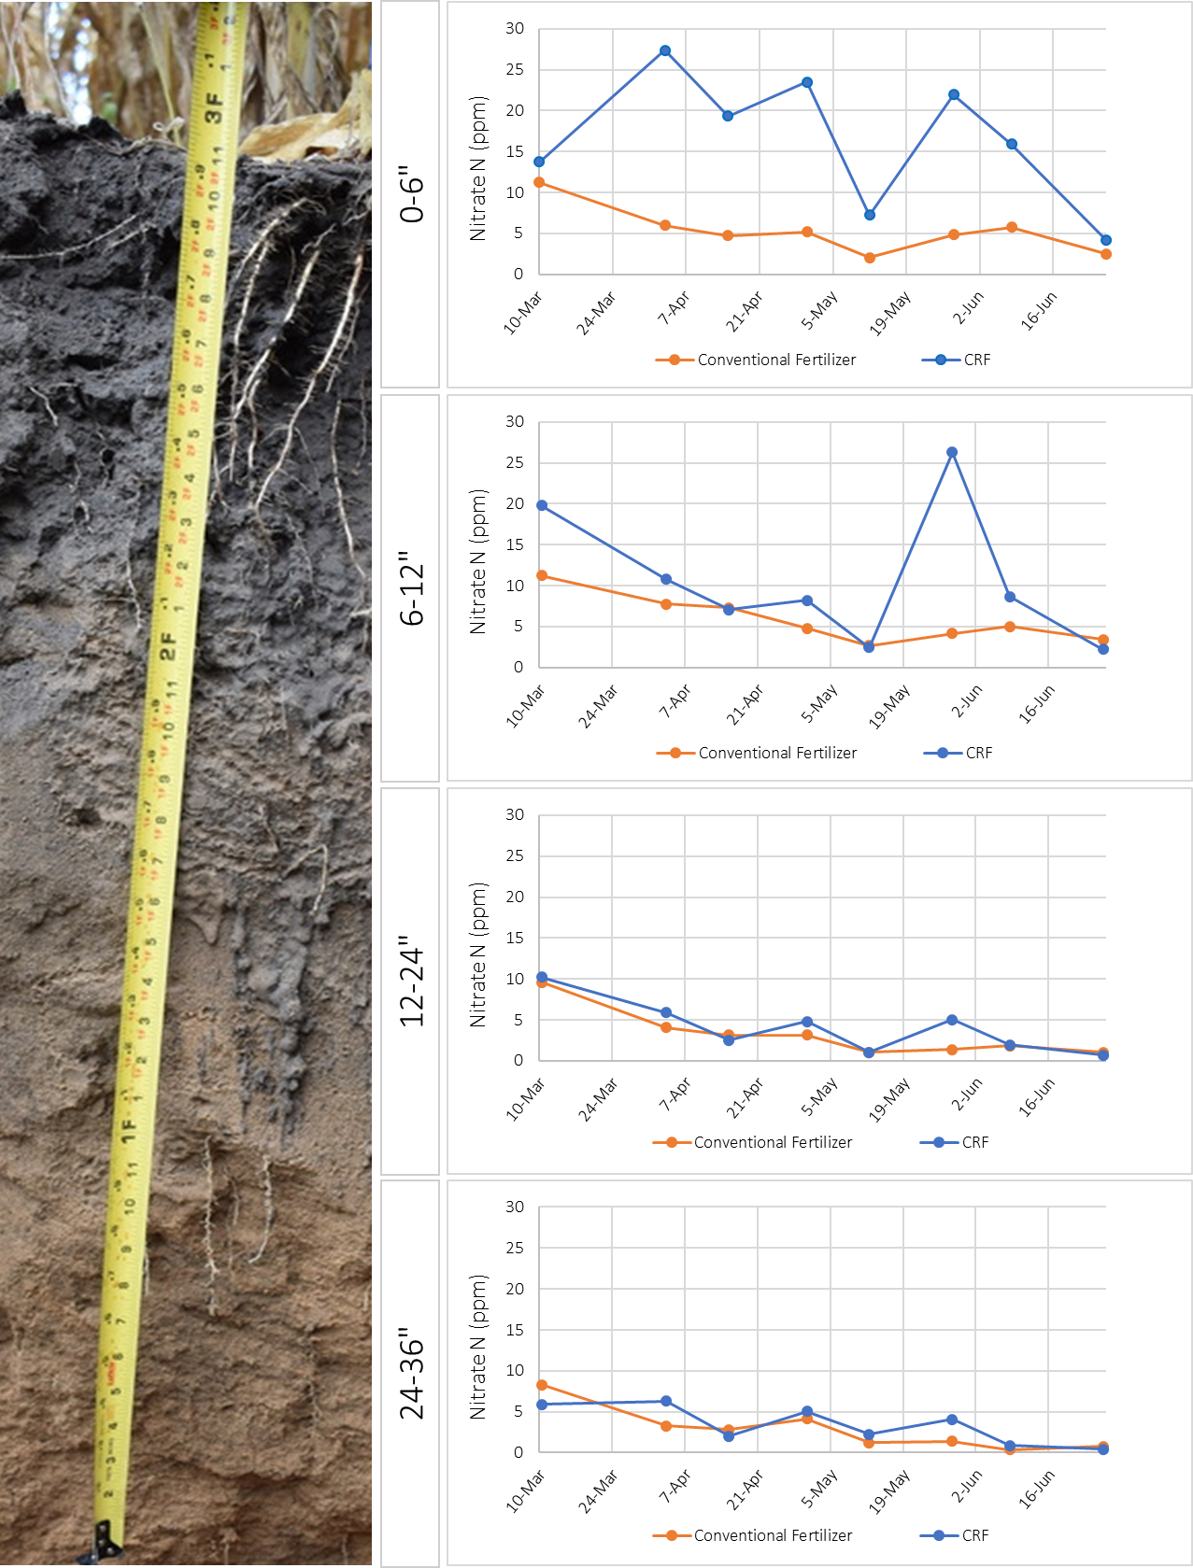

zNote the photo shows the typical soil profile in North Florida, in this case, the profile is under a corn crop (Barrett, 2019).

Figure 2. Petiole sap testing results over time for nitrate-N.

Figure 3. Petiole sap testing results over time for potassium.

Figure 4. Soil moisture content during the growing season[1].

Table 1. Results of leaf tissue analysis for four sampling dates. Lab results from Waters Agricultural Laboratories (Camilla, GA).

|  |  |  |  |  |  |  |  |  |  |  |  |  |
| --- | --- | --- | --- | --- | --- | --- | --- | --- | --- | --- | --- | --- |
|  |  |  |  |  |  |  |  |  |  |  |  |  |
| Sampling Date | Fertilizer Treatment | Leaf Tissue Nutrients | | | | | | | | | | |
| N | P | K | Mg | Ca | S | B | Zn | Mn | Fe | Cu |
| ---------------------------- % ---------------------------- | | | | | | ---------------------- ppm ---------------------- | | | | |
| 16-Apr | CRF | 5.69 | 0.50 | 3.22 | 0.48 | 1.54 | 0.42 | 19 | 91 | 427 | 154 | 14 |
| Conventional | 5.35 | 0.50 | 3.52 | 0.64 | 2.21 | 0.45 | 32 | 95 | 415 | 174 | 13 |
|  |  |  |  |  |  |  |  |  |  |  |  |  |
| 30-Apr | CRF | 5.05 | 0.47 | 3.17 | 0.48 | 1.08 | 0.34 | 13 | 46 | 92 | 114 | 10 |
| Conventional | 4.82 | 0.53 | 3.60 | 0.40 | 0.96 | 0.33 | 25 | 49 | 80 | 100 | 11 |
|  |  |  |  |  |  |  |  |  |  |  |  |  |
| 12-May | CRF | 3.27 | 0.35 | 2.18 | 0.37 | 1.35 | 0.24 | 9 | 43 | 173 | 81 | 8 |
| Conventional | 3.29 | 0.35 | 2.33 | 0.39 | 1.43 | 0.25 | 19 | 48 | 193 | 90 | 8 |
|  |  |  |  |  |  |  |  |  |  |  |  |  |
| 8-Jun | CRF | 4.26 | 0.32 | 1.89 | 0.50 | 2.43 | 0.29 | 34 | 62 | 299 | 138 | 11 |
| Conventional | 3.87 | 0.38 | 2.22 | 0.36 | 1.33 | 0.27 | 40 | 40 | 151 | 85 | 10 |
|  |  |  |  |  |  |  |  |  |  |  |  |  |

Table 2. UF/IFAS adequate ranges for macronutrients and micronutrients in leaf tissue for Florida grown watermelons.

|  |  |  |  |  |  |  |  |  |  |  |  |  |  |  |  |
| --- | --- | --- | --- | --- | --- | --- | --- | --- | --- | --- | --- | --- | --- | --- | --- |
|  |  | |  | Leaf Tissue Nutrients | | | | | | | | | | | |
| Stage of Growth | | N | | | P | K | Mg | Ca | S | B | Zn | Mn | Fe | Cu |
| ------------------------------- % -------------------------------- | | | | | | | | ----------------------- ppm ----------------------- | | | | | |
| Vines 12 to 18 inches in length | | 3.0-4.0 | | | 0.3-0.5 | 3.0-4.0 | 0.25-0.5 | 1.0-2.0 | 0.2-0.4 | 20-40 | 20-40 | 20-100 | 30-100 | 5-10 |
| First Flower | | 2.5-3.5 | | | 0.3-0.5 | 2.7-3.5 | 0.25-0.5 | 1.0-2.0 | 0.2-0.4 | 20-40 | 20-40 | 20-100 | 30-100 | 5-10 |
| First Fruit | | 2.0-3.0 | | | 0.3-0.5 | 2.3-3.5 | 0.25-0.5 | 1.0-2.0 | 0.2-0.4 | 20-40 | 20-40 | 20-100 | 30-100 | 5-10 |
| Harvest Period | | 2.0-3.0 | | | 0.3-0.5 | 2.0-3.0 | 0.25-0.5 | 1.0-2.0 | 0.2-0.4 | 20-40 | 20-40 | 20-100 | 30-100 | 3-10 |

Table 3. Readings of fresh petiole sap concentration of nitrate-N and potassium at various growth stages.

|  |  |  |  |  |  |  |
| --- | --- | --- | --- | --- | --- | --- |
|  |  |  |  |  |  |  |
| Sampling Date | Stage of Growth | Fresh Petiole Sap Concentration (ppm) | | | | |
| NO3-N concentration | |  | K concentration | |
| Conventional Fertilizer | CRF |  | Conventional Fertilizer | CRF |
| 12-Apr | Vines 4 to 6-feet in length | 1200 | 1200 |  | 4800 | 4500 |
| 26-Apr | Full vine cover | 700 | 1000 |  | 4700 | 4800 |
| 10-May | 2-3 weeks to first harvest | 390 | 300 |  | 3800 | 3500 |
| 22-May | 1 week to first harvest | 850 | 1000 |  | 4600 | 3900 |
| 4-Jun | Between second and third harvest | 440 | 800 |  | 4400 | 3900 |
|  |  |  |  |  |  |  |

Table 4. Adequate levels of fresh petiole sap concentration of nitrate-N and potassium at various growth stages of seedless watermelon.

|  |  |  |  |
| --- | --- | --- | --- |
| Crop | Stage of Growth | Fresh Petiole Sap  Concentration (ppm) | |
| NO3-N | K |
| Seedless Watermelon1 | Vines 1 to 4-feet in length | 1200-1500 | 4000-5000 |
| Fruits 2-inches in length | 800-1000 | 4000-5000 |
| Fruits one-half mature | 600-800 | 3500-4000 |
| At first harvest | 400-600 | 3000-3500 |
|  |  |  |  |
| 1Adequate levels of fresh petiole sap concentration of nitrate-N are lower in seedless when compared to seeded varieties after fruit are set. Adapted from Hochmuth et. al, 1991, 'Plant Tissue Analysis and Interpretation for Vegetable Crops in Florida', (data not published). | | | |

1. The graph shows soil moisture content readings for each soil moisture sensor placed at different depths beneath the soil surface: 4” (light blue line), 8” (orange line), 12” (gray line), 16” (yellow line), and 20” (dark blue line).

   The highlighted area encompasses the volumetric water content during the period of May 1st to May 10th, 2020.

   During this period, there was a sharp drop in plant nutrient levels. Such phenomena could potentially be explained by events of leaching rain, however, in this trial, we do not observe leaching rain events in the period of discussion.

   Leaching rain or over-irrigation events would be characterized by a sharp increase in soil moisture at deeper sensors, such as the sensor at 20” depth (dark blue line).