

**UF/IFAS**

North Florida Research and Education Center - Suwannee Valley

7580 County Road 136

Live Oak, FL 32060

386-362-1725

386-362-3067 Fax

Watermelon Yield, Leaf Tissue Response,

and Effect on Soil Nitrogen at Four Depths When Using

Conventional Soluble Fertilizer Versus Controlled Release Fertilizer Programs

Robert Hochmuth, Charles Barrett, Marina Burani-Arouca, and Betsy Martin

University of Florida, Institute of Food and Agricultural Sciences (UF/IFAS)

North Florida Research and Education Center- Suwannee Valley (NFREC-SV), Live Oak, FL

Jay Skillman, Specialty Ag Sales, Harrell’s Fertilizer Company, Lakeland, FL

Corresponding author: Robert Hochmuth, bobhoch@ufl.edu

**Acknowledgments:**

Thanks to the Florida Department of Agriculture and Consumer Services, Office of Agricultural Water Policy and the Florida Watermelon Association for their continued partnership and funding support for this watermelon production research in North Florida.

We thank Ben Broughton, Mike Boyette and the NFREC-SV farm crew for implementing and executing the trial, from soil preparation to harvest and Harrell’s Fertilizer for providing fertilizer materials, planning and guidance. We also would like to thank Waters Agricultural Labs (Camilla, GA) for their support with the leaf tissue analyses, and Syngenta (Bradenton, FL) and Clifton Seed (Faison, NC) for providing the watermelon seeds for this trial.

**Introduction**

This study was conducted to compare different sources and strategies for supplying nitrogen (N) fertilizer in watermelon production in North Florida. A standard multiple-application program of ammonium nitrate (AN) applied as a preplant application and followed by weekly fertigation applications during the season was compared to a single preplant application of a complete analysis, controlled release fertilizer formulation. Data were collected for watermelon fruit weight and count, leaf tissue nutrients, and soil nitrate N.

**Materials and Methods**

The field trial was conducted at the University of Florida, North Florida Research and Education Center - Suwannee Valley in Live Oak, Florida.

*Bed Preparation*

Although bed spacing varies in the industry from 6 to 12 ft, the industry standard bed spacing for watermelons grown in North Florida is 8 ft. In this trial we used a wider 10 ft spacing to reduce vine crossing which helps to accommodate taking leaf tissue samples. When a close row spacing is used in a watermelon research trial, it is very difficult to separate vines from one plot to another when taking leaf samples and harvesting fruit making sure the leaves or fruit are positively tracked back to a specific plot. Fertilizer treatments were calculated based on linear bed foot method using the standard 8-ft bed spacing (Hochmuth and Hanlon, 2018).

Nondegradable black plastic mulch was applied to the beds forming a bed 24 inches across the top with 6-inch high sides. Drip irrigation was installed in the center of the bed top in a shallow groove. Drip irrigation was used to irrigate the crop in all plots and was also used to supply the fertigation treatments to the conventional plots. The drip irrigation system was set up with an injection table with two ports, each port was plumbed separately to only the plots for each fertilizer treatment.

Nitrogen and potassium were injected into the drip irrigation system during the growing season for the conventional treatment and water only was injected for the controlled release complete analysis fertilizer treatment. Injections were made using a peristaltic pump. Injection protocol was as follows: the irrigation system was pressurized for 5 minutes; injection period was 20 minutes; and flushing with water only after the injection was 15 minutes.

*Fertilizer Applications*

The seasonal total for nitrogen (150 lbs per acre) used in this trial was equal between the two fertilizer treatments and the rate of 150 lbs per acre was selected because it is the current UF/IFAS recommendation based on a summary of watermelon field research (Hochmuth and Hanlon, 2016). For both treatments, all phosphorus and micronutrients were applied before bedding and mulch application. In the controlled release fertilizer treatment, all fertilizer material was also applied before bedding and mulch application. The total seasonal potash rate used in the conventional fertilizer treatment was 110 lbs per acre based on soil test recommendations; and the total seasonal potash rate for the controlled release fertilizer treatment made available for this study was 210 lbs per acre, all applied in the soil prior to bed formation.

Controlled release fertilizer treatment targeted 150lbs per acre of N by applying 1,000 lbs per acre of 15-3-21 (N-P2O5-K2O) prior to bedding (this was the only fertilizer applied to this treatment season long). Only the N was controlled release (Table 1).

Conventional fertilizer treatment plots received 10-6-10 (N-P2O5-K2O) at 500 lbs per acre prior to bedding. The remainder of the N and K2O were applied via drip irrigation applications of ammonium nitrate ((28-0-0 (N-P2O5-K2O)) and potassium nitrate ((15-0-44 (N-P2O5-K2O)) applied weekly beginning the week of April 23. (Table 1 and 2).

*Seeding and Transplanting*

A commonly used standard seeded cultivar, ‘Jamboree’, was selected for the trial. A seeded cultivar was chosen to accommodate leaf tissue sampling in comparison to a seedless and pollinator type being used. The combination of two plant types in the same plot when growing a seedless/pollinator system makes it more difficult to select the treatment plants only.

Transplants were seeded February 19th, 2019 in Speedling (Sun City, FL) 128-cell transplant trays. Transplants were planted in single rows into the beds at a 3-ft spacing on March 26th, 2019. Each plot was 100 ft in length.

*Sample Collection*

Soil sample collection was based on a 7 to 14-day schedule and stage of growth. The frequency was set to capture potential movement of N through the soil profile. Soil samples were taken at depths of 0-6, 6-12, 12-24 and 24-36 inches in each plot. Soil samples were taken April 1st (seven days after transplant) and April 15th, after which, all other soil samples were taken just prior to the fertilizer injection that week. Ten sets of soil samples were taken.

Leaf samples were also taken three times for leaf tissue analysis during the growing season. The N and K2O injections were based on published weekly injection rates at the physiological stage of growth. IFAS recommendations (Simonne et al., 2019). Nutrient injections started on April 25th and seven more injections were made for the conventional treatment (Table 2) during the growing season.

The crop was managed for weeds, insects and diseases in accordance with recommended management strategies and no unusual or impactful problems were encountered.

Watermelon fruit were harvested on May 30th, June 5th, June 18th and June 28th. Individual watermelon fruit were counted, and weights were taken for all watermelons harvested. Fruit at harvest were identified as marketable or nonmarketable. The majority of culls were due to fruit deformities or fruit splitting.

*Plot Design and Data Analysis*

Plots were arranged in a randomized complete block design with four replications. Data were analyzed using the Generalized Linear Mixed Model Procedure of SAS (SAS Version 9.4; SAS Inst. Inc.). A two-way analysis of variance was performed to determine significance of main effects. Means separation was used to examine differences between treatments.

**Results and Discussion**

Total marketable yield in this trial was excellent at approximately 75,000 lbs and 3,553 fruit per acre and both yield parameters were not significantly different between the two fertilizer programs (Figure 1, Table 3). The first harvest fruit number from the controlled release fertilizer program was significantly higher than the fruit number in the conventional fertilizer program during the first harvest (Figure 1, Table 3). The trend in the fruit weight during the first harvest was higher numerically in the controlled release fertilizer treatment, however, there was no significant difference. Fruit weight for all harvests and fruit number harvested during the second, third and fourth harvests were not significantly different between fertilizer treatments (Figure 1, Table 3). Average fruit weights were not significantly different for any individual harvest or total harvests and were well within the target fruit weights targeted by growers. Cull fruit weight and number was very low respective to total yield and generally were not different between treatments except for total cull number of fruits which was higher for the conventional fertilizer treatment (Table 3).

Figure 2 shows the soil moisture levels at five depths during the season and associated rainfall at this field site, both for the duration of the season. The graph of soil moisture indicates the irrigation schedule followed during the season provided adequate moisture during the season with very little likelihood leaching rain or irrigation events occurred during this trial. The soil moisture sensor readings were used daily to assess soil moisture and to adjust the number and duration of irrigation events during the season (Dukes et al., 2018). Overirrigation during the early part of the season typically result in the highest risk of leaching soluble fertilizer below the root zone. Once the root system expands deeper in the soil profile, leaching risk still exists, but is typically less because the plant root system can pick up nutrients at deeper depths. Figure 3 also shows the soil moisture levels focused on the first month of the season after transplanting and how the irrigation and rainfall events did not result in leaching during this period as shown by the soil moisture sensor data at the 12, 16 and 20-inch depths. During the end of the season, nitrate nitrogen levels were low at all depths indicating most residual nitrogen had been used by the crop and very little left to be leached from the soil below 24 to 36 inches.

Soil nitrate nitrogen levels were measured ten times during the season and the results are shown in Figure 4. The nitrate nitrogen level in the 0 to 6-inch samples on day 31 after planting shows a higher concentration in the controlled release fertilizer treatment which may mean the release rate during this period was higher than anticipated, possibly due to higher than expected temperatures during this period (Table 4). This higher concentration may have moved gradually deeper in the soil profile over the following two weeks (day 51 after planting).

Plant tissue samples were taken three times during the season and that data (Table 5) were compared to the published adequate ranges as reported by Hochmuth et al. (2018), as shown on Table 6. The treatments in this study were focused on two nitrogen fertilizer programs and therefore, our comparisons of nitrogen levels in the leaf tissue will be primarily discussed. However, we present all the nutrient data to show levels of all nutrients were maintained in the adequate range or above. Only the potassium levels 56 days after planting were at or just below the adequate level but were very similar between fertilizer treatments on all three sampling dates. Leaf tissue nitrogen was not significantly different between fertilizer treatments at all three sampling dates. The nitrogen levels found in this trial were slightly higher that the reported adequate range on all three sampling dates, typically 1.0 to 1.5% higher.

**References**

1. Barrett, C.E. 2019. North Florida sandy soil profile picture under a corn crop. UF, IFAS.
2. Dukes, M.D., L. Zotarelli, G. D. Liu, and E. H. Simonne. 1995 (reviewed as electronic document in 2018). Principles and practices of irrigation management for vegetables. UF/IFAS Extension EDIS publication AE260. Available at: <http://edis.ifas.ufl.edu/pdffiles/CV/CV10700.pdf>
3. Hochmuth, G. and E. Hanlon. 2000 (reviewed in 2016). A Summary of N, P, and K Research with Watermelon in Florida. UF/IFAS Extension EDIS publication SL 325. Available at: <https://edis.ifas.ufl.edu/pdffiles/CV/CV23200.pdf>
4. Hochmuth, G. and E. Hanlon. 2015 (reviewed in 2018). Calculating recommended fertilizer rates for vegetables growing in raised-bed, mulched cultural systems. UF/IFAS Extension EDIS publication SL303. Available at: <http://edis.ifas.ufl.edu/pdffiles/SS/SS51600.pdf>
5. Hochmuth, G., D. Maynard, C. Vavrina, E. Hanlon, and E. Simonne. 1991 (reviewed as electronic document in 2018). Plant Tissue Analysis and Interpretation for Vegetable Crops in Florida. Available at: <https://edis.ifas.ufl.edu/pdffiles/EP/EP08100.pdf>
6. Simonne, Eric, David Studstill, Bob Hochmuth, Teresa Olczyk, Michael Dukes, Rafael Munoz-Carpena, and Yuncong Li. 2003. (reviewed as electronic document in 2019). Drip Irrigation: The BMP Era—An Integrated Approach to Water and Fertilizer Management for Vegetables Grown with Plasticulture. Available at: <https://edis.ifas.ufl.edu/pdffiles/HS/HS17200.pdf>

**Figures and Tables**

**Figure 1.** Total marketable fruit weight and number per treatment per harvest date.

|  |  |  |  |  |  |  |
| --- | --- | --- | --- | --- | --- | --- |
|  | Conventional |  |  | CRF |  | Marketable Fruit Numbera |

aMeans with the same letter in a bar are not significantly different. Mean separation by Tukey-Kramer test at 5% level (Alpha=0.05).

**Figure 2.** Daily rainfall and soil moisture content during the growing season of March 26, 2019 to June 28, 2019.[1]

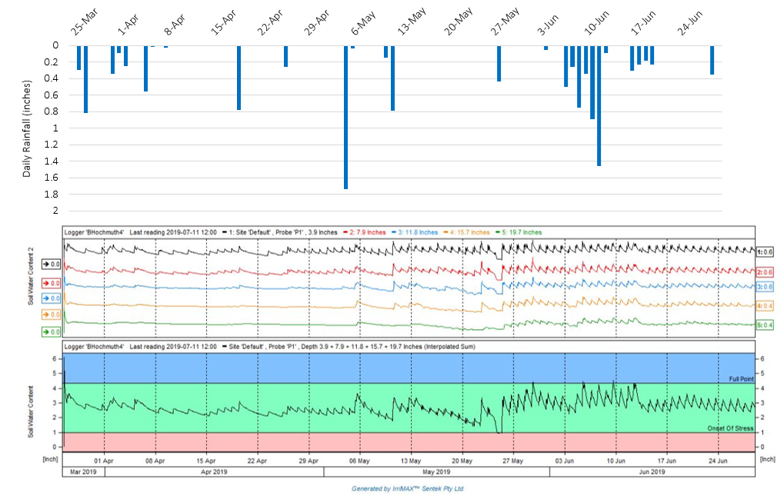

**Figure 3.** Daily rainfall and soil moisture content during the first four weeks of the trial, March 26, 2019 to April 23, 2019.[2]

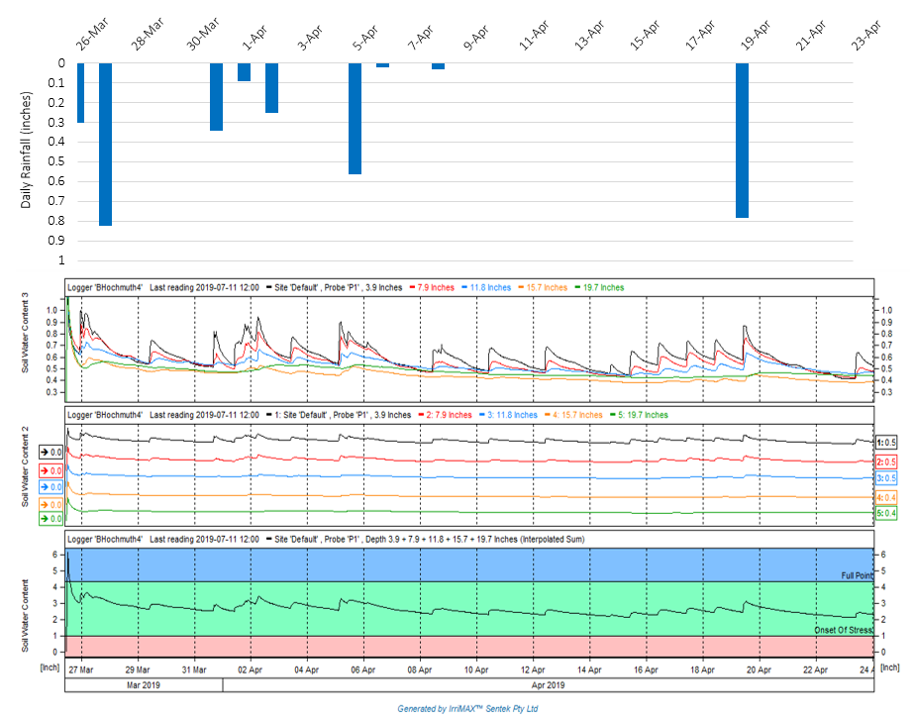

**Figure 4.** Nitrate N found in soil samples collected at four different depths during the growing season.[3]

**Table 1**. Summary of the two fertilizer treatments studied in this trial.

|  |  |  |  |  |  |  |  |  |
| --- | --- | --- | --- | --- | --- | --- | --- | --- |
| **Fertilizer Treatment** | **Season Total N (lbs/A)** | **Season Total K2O (lbs/A)** |  | **Preplant**  **Fertilizer Application** | |  | **Drip Irrigation Fertilizer Applicationa** | |
|  |  |
|  |  |
|  | **Analysis** | **Pounds per Acre** |  | **N Pounds per Acre** | **K2O Pounds per Acre** |
| Conventional (AN) | 150 | 110 |  | 10-6-10 | 500 |  | 100 | 60 |
| Controlled Release | 150 | 210 |  | 15-3-21 | 1,000 |  | 0 | 0 |
|  |  |  |  |  |  |  |  |  |
| aRefer to Table 2 for the complete fertilizer injection schedule. | | | | | |  |  |  |

**Table 2.** Fertigation schedule for the injection of nitrogen and potassium during the watermelon growing season for the Conventional Fertilizer Program (AN) treatment.

|  |  |  |  |  |  |  |  |  |
| --- | --- | --- | --- | --- | --- | --- | --- | --- |
| **Fertilizer Injection Date** | **Days after Transplanting** | **Week Number** |  | **N Injection** | |  | **K2O Injection** | |
|  | **UF/IFAS Daily rate recommendation** (pounds per acre) | **Total N Injected** (pounds per acre per week) |  | **UF/IFAS Daily rate recommendation** (pounds per acre)a | **Total K2O Injected** (pounds per acre per week) |
| 26-Mar-19 | 0 | 0 |  | 0 | 0 |  | 0 | 0 |
| 2-Apr-19 | 6 | 1 |  | 0 | 0 |  | 0 | 0 |
| 9-Apr-19 | 13 | 2 |  | 0 | 0 |  | 0 | 0 |
| 16-Apr-19 | 20 | 3 |  | 0 | 0 |  | 0 | 0 |
| 23-Apr-19 | 29 | 4 |  | 1 | 7 |  | 1.07 | 7.49 |
| 1-May-19 | 37 | 5 |  | 1.5 | 10.5 |  | 1.07 | 7.49 |
| 10-May-19 | 46 | 6 |  | 2 | 14 |  | 1.07 | 7.49 |
| 16-May-19 | 52 | 7 |  | 2.5 | 17.5 |  | 1.07 | 7.49 |
| 22-May-19 | 58 | 8 |  | 2.5 | 17.5 |  | 1.07 | 7.49 |
| 29-May-19 | 65 | 9 |  | 2 | 14 |  | 1.07 | 7.49 |
| 5-Jun-19 | 72 | 10 |  | 1.5 | 10.5 |  | 1.07 | 7.49 |
| 12-Jun-19 | 79 | 11 |  | 1.5 | 10.5 |  | 1.07 | 7.49 |

aThe recommended rate of K2O was calculated based on soil test results.

**Table 3.** Summary of results of the two fertilizer treatments on fruit weight and number of fruits.

|  |  |  |  |  |  |  |  |  |  |  |
| --- | --- | --- | --- | --- | --- | --- | --- | --- | --- | --- |
| **Harvest Date (Days after transplanting)** | **Fertilizer Treatment** |  | Fruit Weighta | | |  | Fruit Numbera | | | |
|  | **Average Weight of Individual Marketable Fruit** (pounds per fruit) | **Marketable Fruit Weight** (pounds per acre) | **Culls Weight** (pounds per acre) |  | **Marketable Fruit Number** (number of fruit per acre) | | **Culls Fruit Number** (number of fruit per acre) | |
|  |  |  |  |  |  |  |  |  |  |  |
| 5/30/2019 (66) | Conventional (AN) |  | 21.00 | 19,764.81 | 0.00 |  | 926 | B | 0 |  |
| Controlled Release |  | 21.27 | 31,581.00 | 0.00 |  | 1,484 | A | 0 |  |
|  |  |  |  |  |  |  |  |  |  |  |
| 6/5/2019 (72) | Conventional (AN) |  | 20.75 | 22,450.82 | 1,436.39 |  | 1,103 |  | 123 |  |
| Controlled Release |  | 20.82 | 13,858.07 | 1,212.06 |  | 667 |  | 109 |  |
|  |  |  |  |  |  |  |  |  |  |  |
| 6/18/2019 (85) | Conventional (AN) |  | 23.56 | 7,161.81 | 1,749.48 |  | 299 |  | 95 |  |
| Controlled Release |  | 20.69 | 7,415.55 | 692.60 |  | 354 |  | 41 |  |
|  |  |  |  |  |  |  |  |  |  |  |
| 6/28/2019 (95) | Conventional (AN) |  | 20.81 | 25,303.46 | 1,129.84 |  | 1,225 |  | 54 |  |
| Controlled Release |  | 21.36 | 22,164.96 | 492.23 |  | 1,048 |  | 27 |  |
|  |  |  |  |  |  |  |  |  |  |  |
| **Season Totalb** | Conventional (AN) |  | 21.53 | 74,680.35 | 4,315.16 |  | 3,553 | | 272 | A |
| Controlled Release |  | 21.03 | 75,019.58 | 2,396.89 |  | 3,553 | | 177 | B |
|  |  |  |  |  |  |  |  |  |  |  |
| aMeans followed by the same letter in a column are not significantly different. Mean separation by Tukey-Kramer test at 5% level (Alpha=0.05). If no letters are shown, no significant differences were found within the data shown on a given column. | | | | | | | | | | |
| bSeasonal data was obtained by lumping the four harvests data together. | | | | |  |  |  |  |  |  |

**Table 4.** Summary of growing conditions (temperature and rainfall) during the growing season.

|  |  |  |  |  |
| --- | --- | --- | --- | --- |
|  | 2019 Growing Season | | | |
|  | March | April | May | June |
| Temperature at 7' (F) |  |  |  |  |
|  |  |  |  |
| Min. | 32.02 | 42.66 | 57.02 | 65.10 |
| Max. | 84.60 | 88.72 | 98.64 | 97.05 |
|  |  |  |  |  |
| Total Accumulated Rainfall (inches) | 3.82 | 1.99 | 3.17 | 5.67 |
|

Source: Florida Automated Weather Network (FAWN), Report Generator for Live Oak, Florida.

**Table 5**. Summary of leaf tissue analysis lab results from Waters Agricultural Laboratories for the three sampling dates.

|  |  |  |  |  |  |  |  |  |  |  |  |  |  |  |
| --- | --- | --- | --- | --- | --- | --- | --- | --- | --- | --- | --- | --- | --- | --- |
| **Sampling Date (Days After Transplanting)** | **Stage of Growth** | **Treatment** |  | **Leaf Tissue Nutrients** | | | | | | | | | | |
|  | **N** | **P** | **K** | **Mg** | **Ca** | **S** | **B** | **Zn** | **Mn** | **Fe** | **Cu** |
|  | ----------------------- % ------------------------ | | | | | | ----------------- ppm ----------------- | | | | |
|  |  |  |  |  |  |  |  |  |  |  |  |  |  |  |
| 4/24/2019 (30) | First flowers | Conventional (AN) |  | 5.5 | 0.7 | 3.8 | 0.8 | 3.3 | 0.5 | 65 | 45 | 105 | 300 | 16 |
| Controlled Release |  | 5.4 | 0.7 | 4.0 | 0.5 | 2.9 | 0.5 | 43 | 52 | 150 | 337 | 16 |
|  |  |  |  |  |  |  |  |  |  |  |  |  |  |  |
| 5/7/2019 (43) | First fruits | Conventional (AN) |  | 5.3 | 0.5 | 3.4 | 0.6 | 2.2 | 0.4 | 31 | 39 | 66 | 187 | 17 |
| Controlled Release |  | 5.5 | 0.5 | 3.8 | 0.6 | 2.5 | 0.4 | 34 | 42 | 115 | 213 | 15 |
|  |  |  |  |  |  |  |  |  |  |  |  |  |  |  |
| 5/20/2019 (56) | Harvest period | Conventional (AN) |  | 4.5 | 0.3 | 1.8 | 0.5 | 2.6 | 0.4 | 30 | 55 | 295 | 218 | 9 |
| Controlled Release |  | 4.6 | 0.3 | 2.0 | 0.6 | 2.6 | 0.4 | 29 | 57 | 320 | 212 | 9 |

**Table 6**. UF/IFAS adequate ranges for macronutrients and micronutrients in leaf tissue for Florida grown watermelons.

|  |  |  |  |  |  |  |  |  |  |  |  |  |  |  |
| --- | --- | --- | --- | --- | --- | --- | --- | --- | --- | --- | --- | --- | --- | --- |
|  |  | |  | Leaf Tissue Nutrients | | | | | | | | | | |
| Stage of Growth | | N | | | P | K | Mg | Ca | S | B | Zn | Mn | Fe | Cu |
| ------------------------------- % -------------------------------- | | | | | | | | ----------------------- ppm ----------------------- | | | | |
| Layby  (last cultivation) | | 3.0-4.0 | | | 0.3-0.5 | 3.0-4.0 | 0.25-0.5 | 1.0-2.0 | 0.2-0.4 | 20-40 | 20-40 | 20-100 | 30-100 | 5-10 |
| First Flower | | 2.5-3.5 | | | 0.3-0.5 | 2.7-3.5 | 0.25-0.5 | 1.0-2.0 | 0.2-0.4 | 20-40 | 20-40 | 20-100 | 30-100 | 5-10 |
| First Fruit | | 2.0-3.0 | | | 0.3-0.5 | 2.3-3.5 | 0.25-0.5 | 1.0-2.0 | 0.2-0.4 | 20-40 | 20-40 | 20-100 | 30-100 | 5-10 |
| Harvest Period | | 2.0-3.0 | | | 0.3-0.5 | 2.0-3.0 | 0.25-0.5 | 1.0-2.0 | 0.2-0.4 | 20-40 | 20-40 | 20-100 | 30-100 | 3-10 |

Source: Plant Tissue Analysis and Interpretation for Vegetable Crops in Florida. G. Hochmuth, D. Maynard, C. Vavrina, E. Hanlon, and E. Simonne.

1. The top graph shows rainfall in inches. The graph in the center shows soil moisture content readings for each soil moisture sensor placed at different depths beneath the soil surface: 4” (black line), 8” (red line), 12” (blue line), 16” (orange line), and 20” (green line). The bottom graph shows soil moisture content as the sum of all sensors and are shown within a blue zone indicating soil moisture saturation, a green zone indicating optimum soil moisture, and a red zone indicating low soil moisture and potential crop stress. Note the sudden drop in soil moisture on May 24-25 was due to an irrigation line becoming temporarily disconnected.
2. The top graph shows rainfall in inches. The graphs in the center show soil moisture content readings for each soil moisture sensor placed at different depths beneath the soil surface: 4” (black line), 8” (red line), 12” (blue line), 16” (orange line), and 20” (green line). The bottom graph shows soil moisture content as the sum of all sensors and are shown within a blue zone indicating soil moisture saturation, a green zone indicating optimum soil moisture, and a red zone indicating low soil moisture and potential crop stress.
3. Note the photo shows the typical soil profile in North Florida, in this case, the profile is under a corn crop.