Welcome to our UF/IFAS Extension Suwannee Valley Watermelon Crop Update. These updates will be summarized by Bob Hochmuth, Regional Specialized Extension Agent- Vegetable Crops, with input from Suwannee Valley Extension Agents: Mark Warren (Levy), Tyler Pittman (Gilchrist), Tatiana Sanchez-Jones (Alachua), Luke Harlow (Bradford), Dan Fenneman (Madison), Keith Wynn (Hamilton), Emily Beach (Lafayette), Jim Devalerio (Union), Ben Hoffner (Jefferson), Raymond Balaguer(Suwannee), Derick Conover (Columbia) Kevin Athearn (RSA-Agri- business), Shivendra Kumar (RSA-Agronomic Crops), and Jay Capasso (RSA- Water Resources).
If you know someone who wants to be added to this weekly notice, contact your Extension Agent or Mark Warren (352-949-8288) if you want to be added to the regional watermelon group text app.
We will continue this year to support our watermelon growers with a rapid diagnostics system through Suwannee Valley Regional and County Extension Agents. This industry-funded program allows Extension Agents to submit and pay for watermelon grower’s plant disease and other diagnostic samples. This SV Rapid Diagnostic Watermelon Program will help us to get quicker diagnostic results, helping to give early alerts to everyone, and not have to charge the growers directly. Plant disease samples are typically $40 and leaf tissue analyses are typically $20. We are currently solicitating those industry reps interested in sponsoring this effort. The past year’s sponsorships have ranged from $200 to $2,000 per company. Sponsors will be recognized every week beginning this week. Those interested in being added as a sponsor can contact Bob Hochmuth at bobhoch@ufl.edu or 386-288-6301.

Current 2025 sponsors of our Watermelon Rapid Diagnostics Program include: Mayo Ag Services, Gowan USA, Smurfit/WestRock Paper Mulch, Orbia Netafim, Syngenta Crop Protection, Harrell’s Fertilizer, TriEst Ag, and Triangle Chemical Company. Other sponsors are still welcome to join.

Disease and insect spray update:
Reports from this past week maintain a generally low disease incidence. You can continue to maintain a simple program again this week with Mancozeb (Manzate, Penncozeb, or other trade name) plus something as a preventative for powdery mildew (Quintec, Rhyme (preferred as a spray), or Procure), plus something as a preventative for rindworms (Bt; Intrepid or Troubadour; or Coragen eVo or generic versions. It is advisable to maintain preventative rindworm sprays if not already started. It could be only about two weeks to our earliest harvests in the region, so we need to be on alert overall now. Some growers prefer to use a spray of Inspire Super (7 day PHI) or Aprovia Top (0 day PHI) one week before first harvest or just after first harvest, mainly targeted as a gummy stem blight preventative. This strategy generally makes sense, but keep in mind, gummy incidence has been very low to date. So we may be able to delay that strategy until harvest season. (Bob Hochmuth)

Using these Updates in your Food Safety Programs:
This past week Allison Meharg, of Schachle Enterprises - Farm Compliance and Food Safety was discussing with me how these weekly updates can be a big help to a watermelon farmer’s food safety program. Primus GFS added a new Module (9) to address IPM at the request of Walmart. These weekly updates can be used along with the farmer’s information to back up their own scouting and reasoning behind their spray decisions. Some farms are using this information from Extension teams like ours in the Suwannee Valley and in other states too where similar alert systems exist. Using this information can save farmers a lot of money paying companies to do the same data. Our weekly updates are uniquely positioned to help in this regard. All issues this year and from past years are posted at this web site. https://svaec.ifas.ufl.edu/crops/vegetables/watermelon/
(Allison Meharg and Bob Hochmuth)

Two Watermelon Field Days set for the Suwannee Valley- Hold the Dates. Flyers and Registration information below.
- Watermelon On Farm/ NFREC-SV Field Day, Monday, May 5, 2025, starting at 3:30 PM at a farm of Adrian Land’s near Obrien; then moving to the NFREC- Suwannee Valley to see the research plots there and enjoy dinner and fellowship.
Register here: Watermelon On Farm/ NFREC-SV Field Day Tickets, Mon, May 5, 2025 at 3:30 PM | Eventbrite

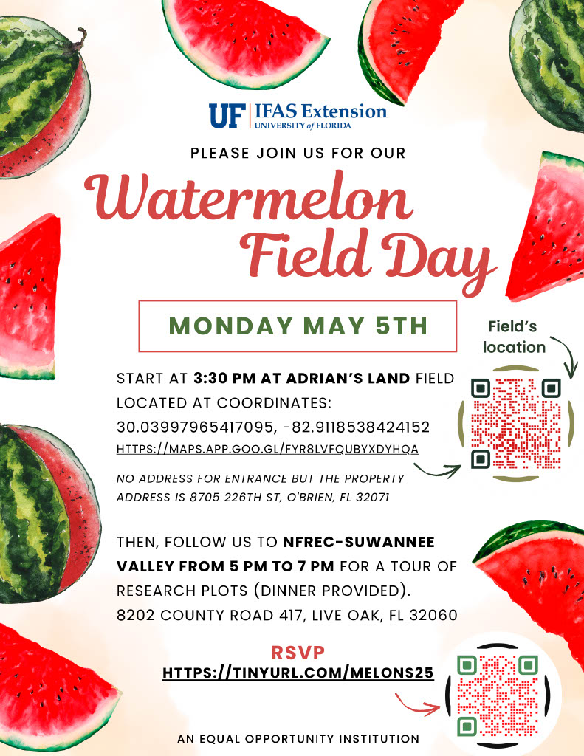

- Union County Watermelon Field Day Co-planned by BASF and UF/IFAS Extension at Dukes Family Farm, near Lake Butler. This will be a morning field day starting at 9 am on Wednesday, June 11, 2025.
Watermelon Variety Trial Tickets, Wed, Jun 11, 2025 at 8:30 AM | Eventbrite
