**Welcome to our first 2025 season’s weekly issue of our UF/IFAS Extension Suwannee Valley Watermelon Crop Update. These updates will be summarized by Bob Hochmuth, Regional Specialized Extension Agent- Vegetable Crops, with input from Suwannee Valley Extension Agents: Mark Warren (Levy), Tyler Pittman (Gilchrist), Tatiana Sanchez-Jones (Alachua), Luke Harlow (Bradford), Dan Fenneman (Madison), Keith Wynn (Hamilton), Emily Beach (Lafayette), Jim Devalerio (Union), Ben Hoffner (Jefferson), Raymond Balaguer(Suwannee), Derick Conover (Columbia) Kevin Athearn (RSA-Agri- business), Shivendra Kumar (RSA-Agronomic Crops), and Jay Capasso (RSA- Water Resources).**

**If you know someone who wants to be added to this weekly notice, contact your Extension Agent or Mark Warren (352-949-8288) if you want to be added to the regional watermelon group text app.**

We will continue this year to support our watermelon growers with a rapid diagnostics system through Suwannee Valley Regional and County Extension Agents. This industry-funded program allows Extension Agents to submit and pay for watermelon grower’s plant disease and other diagnostic samples. This **SV Rapid Diagnostic Watermelon Program** will help us to get quicker diagnostic results, helping to give early alerts to everyone, and not have to charge the growers directly. Plant disease samples are typically $40 and leaf tissue analyses are typically $20. **We are currently solicitating those industry reps interested in sponsoring this effort. The past year’s sponsorships have ranged from $200 to $2,000 per company. Sponsors will be recognized every week beginning this week. Those interested in being added as a sponsor can contact Bob Hochmuth at** [**bobhoch@ufl.edu**](mailto:bobhoch@ufl.edu) **or 386-288-6301.**

**Current 2025 sponsors of our Watermelon Rapid Diagnostics Program include: Mayo Ag Services, Gowan USA, Smurfit/WestRock Paper Mulch, Orbia Netafim, Syngenta Crop Protection, and Harrell’s Fertilizer. Others are still welcome to join.**

**Frost, wind and sand:**

Since planting started in late February, the region has seen 3 frosty nights. Some parts of the region have seen scattered frosts, while others have seen widespread frost. Several cases of mild frost damage have been reported, none seem to be excessive, although some have reported plenty of “glazing” on the tops of leaves. (See Photo). In addition, high winds and sand blasting were very common across the region the first week in March. The sandblasted plants exhibit a more general leaf burn, rather than an upper leaf surface glazing. In some cases, the damage from the winds and sand blasting was significant resulting in some replanting likely being needed. In both cases, the focus should be on that newest leaf and whether that leaf is emerging nicely or whether that newest leaf or growing point are damaged. Suggestions regarding post cold or wind damage include getting started early with a fungicide application, perhaps chlorothalonil. I would not suggest using copper because of the stunting and slowing of new growth. Likewise, I do not recommend additions to the spray tanks of foliar fertilizers or other additives. Fertilizer salts will often result in more burning than good. Be patient and allow the plants to recover. A small fertigation of a total of 1-2 lbs per acre of nitrogen would be more sensible. (Bob Hochmuth)

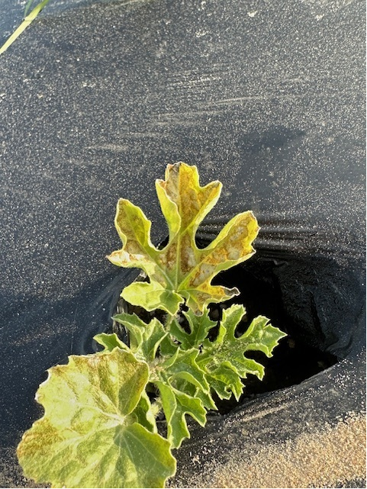

**Early season disease management:**

We will plan to update everyone as soon as we confirm foliar or other disease prevalence. The crops generally look very clean right now. We recommend using a weekly Bravo or other chlorothalonil product schedule for this early part of the season, perhaps the first few sprays, while we can use chlorothalonil prior to fruit sizing stage. Banding sprays over the beds only while plants are small is very economical. (Bob Hochmuth)

**Early season irrigation and nutrient management:**

It is important to protect your bed fertilizer investment. Without question, the early part of the season is the most difficult to manage potential loss of fertilizer in our drip irrigated cropping system. We can lose valuable nutrients due to leaching this time of the season with either heavy rainfall events or over-irrigation. We can manage the second one with a good irrigation management program. Soil moisture sensors are a great tool to keep us on track. Our Extension Agents and Regional Extension Agent for Water Resources, Jay Capasso, can be excellent resources in helping interpret sensor data. As a way of example here, early in the season assuming a medium flow drip tape (about 0.4 gal/min/100 ft), you should not run more than about 45 minutes per event this time of year. The main point is that longer events every day undoubtedly will push water down well below the top 12 inches of the soil. With the water, goes the soluble portion of fertilizer. We are continuing our demonstrations with pre-plant, controlled release fertilizer (CRF) demonstrations on 5 farms this spring through the pilot cost-share program with funding through FDACS Office of Ag Water Policy and Suwannee River Water Management District. The primary objective is to demonstrate the use of CRFs in the bed as a way to reduce leaching losses and still maintain an excellent fertilizer program. (Bob Hochmuth)

**Fertigation system calibration:**

On-farm testing done in the Suwannee Valley in recent years has shown that significant amounts (30-100%) of liquid fertilizer being left in irrigation systems following fertigation events due to inadequate time during the flush cycles. While it is well understood that excessive irrigation will increase nutrient losses due to leaching, we speculate that poorly flushed systems may negatively affect fertilizer placement uniformity and may even lead to premature emitter failure due to fertilizer salt crystallization. If correct, the earlier this situation is identified and corrected in your field, the greater the potential benefit. Fertilizer salt concentrations can be measured with an electrical conductivity (EC) meter in the irrigation water. EC tests performed on your irrigation systems will provide measured times required for fertilizer to both reach and to clear your drip systems. If you would like to perform a fertigation system calibration on your fields, contact your local county Extension office. Find your UF/ IFAS County Extension Office (Mark Warren)

**Label Interpretation of Proline and Propulse injections:**

There have been questions regarding how to figure the application rates of materials such as Proline or Propulse or generics of these products. It may make sense to calculate the rate based on portion of the field with the “wetted zone” under the mulch and use that as the rate. However, the labels allow for the full label rate to be used even though only a portion of the acreage is actually treated. After follow-up discussions with UF research specialist, Dr. Nick Dufault and industry reps, all agree the correct amount to use is the full rate per acre via chemigation through the drip irrigation system. One very important aspect that supports this situation is that the research trials that have been conducted all use the full rate. For instance, research with Proline used the full 5.7 ounces per acre, not a reduced amount based on the “wetted zone” only. There was no research on whether the reduced rate of Proline would result in the same level of Fusarium wilt reduction/suppression. Therefore, our recommendation is we can only recommend following the rates used in the research trials to as this approach is the only one known for Fusarium wilt control/suppression, as there is no data supporting the efficacy of reduced rates attaining the same level of control. (Bob Hochmuth and Nick Dufault)