Welcome to our UF/IFAS Extension Suwannee Valley Watermelon Crop Update. These updates will be summarized by Bob Hochmuth, Regional Specialized Extension Agent- Vegetable Crops, with input from Suwannee Valley Extension Agents: Mark Warren (Levy), Tyler Pittman (Gilchrist), Tatiana Sanchez-Jones (Alachua), Luke Harlow (Bradford), Dan Fenneman (Madison), Keith Wynn (Hamilton), Emily Beach (Lafayette), Jim Devalerio (Union), Ben Hoffner (Jefferson), Raymond Balaguer(Suwannee), Derick Conover (Columbia) Kevin Athearn (RSA-Agri- business), Shivendra Kumar (RSA-Agronomic Crops), and Jay Capasso (RSA- Water Resources).
If you know someone who wants to be added to this weekly notice, contact your Extension Agent or Mark Warren (352-949-8288) if you want to be added to the regional watermelon group text app.

We will continue this year to support our watermelon growers with a rapid diagnostics system through Suwannee Valley Regional and County Extension Agents. This industry-funded program allows Extension Agents to submit and pay for watermelon grower’s plant disease and other diagnostic samples. This SV Rapid Diagnostic Watermelon Program will help us to get quicker diagnostic results, helping to give early alerts to everyone, and not have to charge the growers directly. Plant disease samples are typically $40 and leaf tissue analyses are typically $20. We are currently solicitating those industry reps interested in sponsoring this effort. The past year’s sponsorships have ranged from $200 to $2,000 per company. Sponsors will be recognized every week beginning this week. Those interested in being added as a sponsor can contact Bob Hochmuth at bobhoch@ufl.edu or 386-288-6301.

Current 2025 sponsors of our Watermelon Rapid Diagnostics Program include: Mayo Ag Services, Gowan USA, Smurfit/WestRock Paper Mulch, Orbia Netafim, Syngenta Crop Protection, Harrell’s Fertilizer, TriEst Ag, and Triangle Chemical Company. Others are still welcome to join.

Fusarium is back in 2025:
The cooler night temperatures we experienced last month created ideal conditions for Fusarium growth. Disease incidence is highest at soil temperatures between 80.6°F and 84.2°F. Just last week, we confirmed Fusarium wilt diagnosis in several fields. Fusarium’s growth in the soil will slow down as temperature increases but plants that are already infected will continue to express symptoms in the upcoming weeks.
How to recognize it: Early in the season, it is relatively normal to observe plant mortality. During establishment, wilting may be caused by bad placement of the transplant in relation to the drip tape, physical damage as well as other soilborne pathogens such as Pythium where the roots of the plant are eaten away. We are past the establishment period and as the plants start to vine, you may notice a runner or two starting to wilt, and as the season progresses, the entire plant may succumb to the disease. As the demand for water increases after fruit set, you will notice more plants exhibiting symptoms resulting from the clogging of the vascular system responsible for transporting water. If you notice plants with low vigor, wilting during the hottest parts of the day and with a grayish-green appearance (Picture A), you can test in the field. Sample plants that exhibit these symptoms but that have the crown area intact (the area around the soil line that separates roots from above-ground growth). Avoid vines that have rolled in circles with the wind or stems cracked or affected by ants. Once you sample, cut downward through the middle of the crown and inspect the color of the vascular system (Picture B). If the plant is infected, you will notice discoloration along the vascular vessels, if healthy, it will look whitish.
Management: In research trials, there are two active ingredients that demonstrate the most effectiveness against Fusarium: Prothioconazole and Pydiflumetofen (found in Proline and Miravis). The most critical time to apply these fungicides is at transplanting and during the first two weeks of establishment. At this stage of the season, infection has already occurred, so we do not recommend further fungicide applications for Fusarium wilt, as they may not provide additional control. If you suspect Fusarium wilt and want confirmation, contact your local agent to submit a sample. For more information, refer to page 33 of the Watermelon Field Guide. (Tatiana Sanchez-Jones)

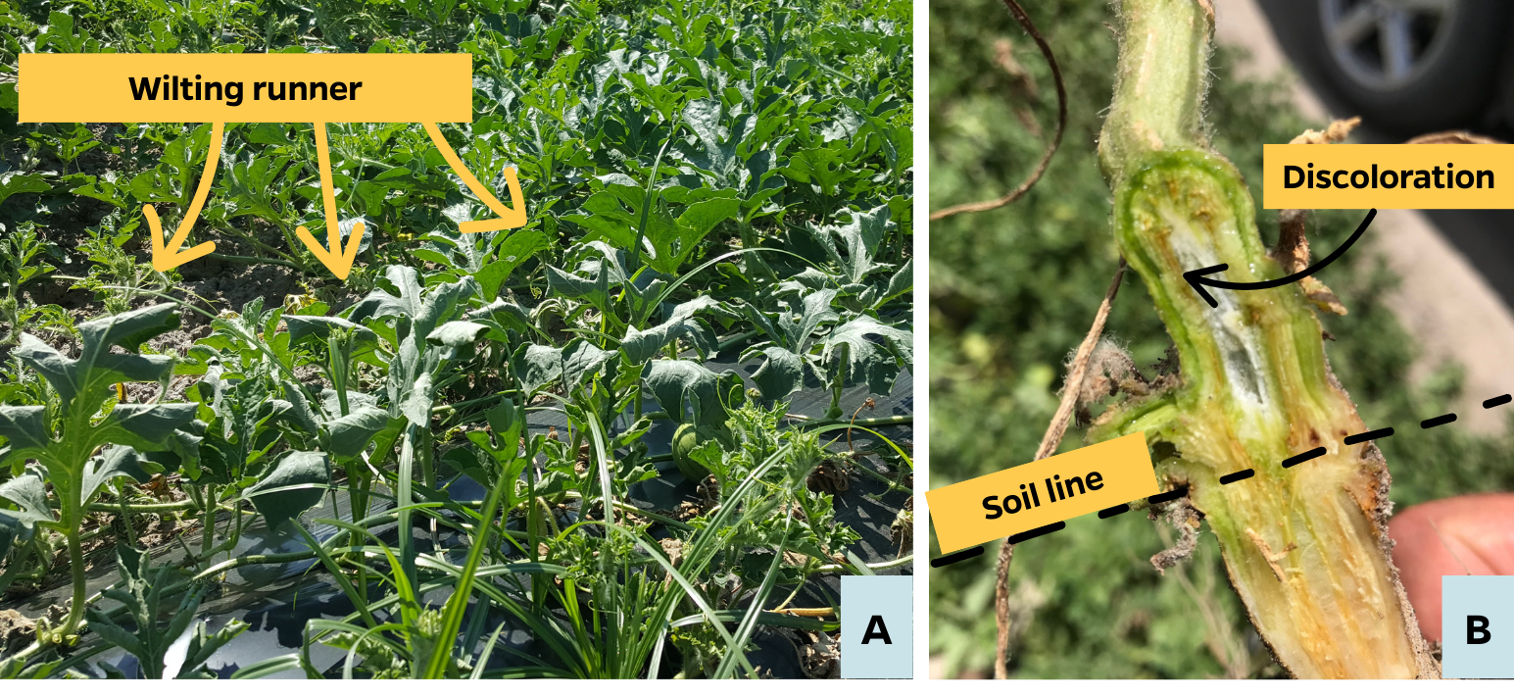

Calibrating Wick/Wiper Applicators for Nutsedge Control:
Research in Florida shows that 25 yellow nutsedge plants per square meter (2.3 plants per square foot) in watermelon beds can reduce yield by 98%. Just six plants per square meter (0.56 plants per square foot) can cause a 20% yield loss (Stall, 1999). If nutsedge is an issue in your watermelon fields, now is the time to treat. Sandea, containing the active ingredient halosulfuron, is labeled for use in transplanted watermelons grown on mulch with a wick wiper applicator ("hockey stick"). Always check the label to ensure the method is approved as some labels don’t list this application method.

Calibration: How Much Solution and Product?
The Sandea label recommends mixing 1/4 to 1 ounce of product per gallon of water for spot treatments when using this method of application. Tests and grower feedback show that treating 1 acre of bed top requires 4 to 6 gallons of solution, averaging 5 gallons per acre (GPA).
With 5 GPA and the label rate of 1/4 to 1 ounce of Sandea per gallon, the total product would range from 1.25 to 5 ounces per acre. Note: The label also limits Sandea applications to 2.0 ounces per acre per year.
In trials using 0.1, 0.25, 0.5, and 1.0 ounces per acre, the 0.5- and 1.0-ounce rates have provided nutsedge control.

Estimating the Treated Area
 |  | Row Spacing (in feet)
 |  | 8 | 9 | 10 | 12
Mulched Surface Width  (in inches) | 24” | 25 | 22 | 20 | 16
 | 28” | 29 | 26 | 23 | 19
 | 36” | 38 | 33 | 30 | 25.0
 |  | Percent of planted area covered by mulch
Example: For 30 row acres with 8-foot row spacing and 28-inch bed tops:
30 acres x 0.29 (29%) = 8.7 treated acres.

Additional Notes
- Avoid contact with watermelon plants.
- Minimize wick applicator contact with mulch to reduce residues that may be washed into the plant holes.
- Improved efficacy with use a non-ionic surfactant.
- Better results are seen if the sedge is swiped in both directions.
- Mix only what will be used within 24 hours.
- Follow label instructions for PPE and REI intervals. (Article by Mark Warren).
Photo: Mark Warren and wick applicator trial on farm.
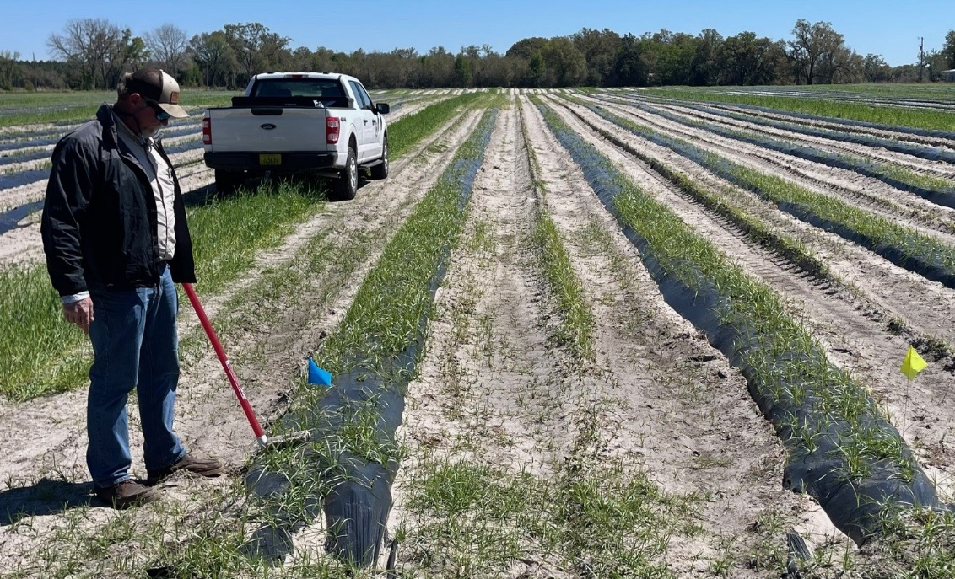

Photo: Close up of one of many wick applicator designs.
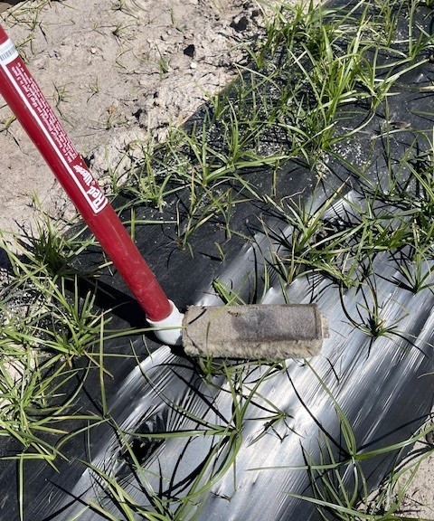

Row middle herbicide considerations:
Every year we get a few questions about plants in parts of the field on certain rows showing yellowing and stunting. Of course there are several different possible causes, but this article addresses the situation caused by cultivating/plowing herbicide-treated soil from row middles up on top of the beds. In this situation, I am describing situations where pre-emergent herbicides such as Sandea and Sinbar (which I often recommend as a great combination) are applied in a swath under the plastic mulch and perhaps a little wider than the bed top, or when applied to the row middles after the mulch is applied. In these situations, if a later cultivation or plowing of the soil next to the plastic-covered bed throws soil up onto the bed, it can also bring herbicide in that soil up onto the bed. That herbicide-treated soil can then be washed into the holes and result in a high concentration of herbicide into the plant hole. In my experience, these yellowed and stunted plants usually survive but are held back significantly (See Photo). Too much soil on the bed top also reduces the warming benefit of the black mulches. So, caution here, realize that herbicide treated soil placed on the bed top can be a very risky activity. See Photo below showing herbicide damage from treated soil on the bed top. Notice stunted plants where soil is located and no stunting where no soil is on the bed top. (Bob Hochmuth)
