**Welcome to our UF/IFAS Extension Suwannee Valley Watermelon Crop Update. These updates will be summarized by Bob Hochmuth, Regional Specialized Extension Agent- Vegetable Crops, with input from Suwannee Valley Extension Agents: Mark Warren (Levy), Tyler Pittman (Gilchrist), Tatiana Sanchez-Jones (Alachua), Luke Harlow (Bradford), Dan Fenneman (Madison), Keith Wynn (Hamilton), Emily Beach (Lafayette), Jim Devalerio (Union), Ben Hoffner (Jefferson), Raymond Balaguer(Suwannee), Derick Conover (Columbia) Kevin Athearn (RSA-Agri- business), Shivendra Kumar (RSA-Agronomic Crops), and Jay Capasso (RSA- Water Resources).**

**If you know someone who wants to be added to this weekly notice, contact your Extension Agent or Mark Warren (352-949-8288) if you want to be added to the regional watermelon group text app.**

We will continue this year to support our watermelon growers with a rapid diagnostics system through Suwannee Valley Regional and County Extension Agents. This industry-funded program allows Extension Agents to submit and pay for watermelon grower’s plant disease and other diagnostic samples. This **SV Rapid Diagnostic Watermelon Program** will help us to get quicker diagnostic results, helping to give early alerts to everyone, and not have to charge the growers directly. Plant disease samples are typically $40 and leaf tissue analyses are typically $20. **We are currently solicitating those industry reps interested in sponsoring this effort. The past year’s sponsorships have ranged from $200 to $2,000 per company. Sponsors will be recognized every week beginning this week. Those interested in being added as a sponsor can contact Bob Hochmuth at** [**bobhoch@ufl.edu**](mailto:bobhoch@ufl.edu) **or 386-288-6301.**

**Current 2025 sponsors of our Watermelon Rapid Diagnostics Program include: Mayo Ag Services, Gowan USA, Smurfit/WestRock Paper Mulch, Orbia Netafim, Syngenta Crop Protection, Harrell’s Fertilizer, TriEst Ag, and Triangle Chemical Company. Others are still welcome to join.**

**Plant Recovery Strategies:**

One thing that has been widespread this year throughout the region is wind and sandblasting damage. Frost damage is also a factor but is more scattered and less of a concern in most fields in comparison to damage from sandblasting. There have been several questions related to what should be done to help damaged plants to recover. The first suggestion is to be patient, watermelon plants that are not actually killed are resilient and generally amaze me how quickly they can recover. The warmer temperatures this coming week both at night and during the day will definitely help, just what the doctor ordered. Most of the wind damaged plants have dry crispy leaves (see Photo). To assess the potential to recover, focus on the new leaves and growing point, as that is where healthy leaves will emerge. We have not had any reports of bacteria which would show more of a wet or greasy looking spots. Last week, I recommended considering weekly banded applications of chlorothalonil over the row and I still would suggest that plan here early in the season. One of the questions this week has been whether copper should be added. First, we (UF/IFAS) do not recommend adding any forms of copper in a tank mix with chlorothalonil due to the increase in likelihood of plant burning. If there is a concern of bacterial diseases, then the recommendation would be to switch to mancozeb (Manzate or Penncozeb) and copper. However, I am always concerned about using copper on recovering plants due to the possible stunting that can occur and therefore slow the plant recovery. The other thing we have questions about is adding foliar fertilizer to the fungicide tank mix. For the same reason, I would be very careful about adding fertilizer due to the greater likelihood of burning too. Keep in mind, these plants are already burned and dry and crispy and therefore will not likely be very responsive in that stage to any foliar fertilizers anyway. A small fertigation event of liquid fertilizer (8-0-8, 10-0-10, or even 28-0-0) at a rate of only a few lbs (5 or less) of N per acre would be a better choice. Back to my first suggestion, be patient and replace any plants that clearly won’t make it (Bob Hochmuth and Mark Warren)

Photo: Wind and sandblasting damage. R. Hochmuth

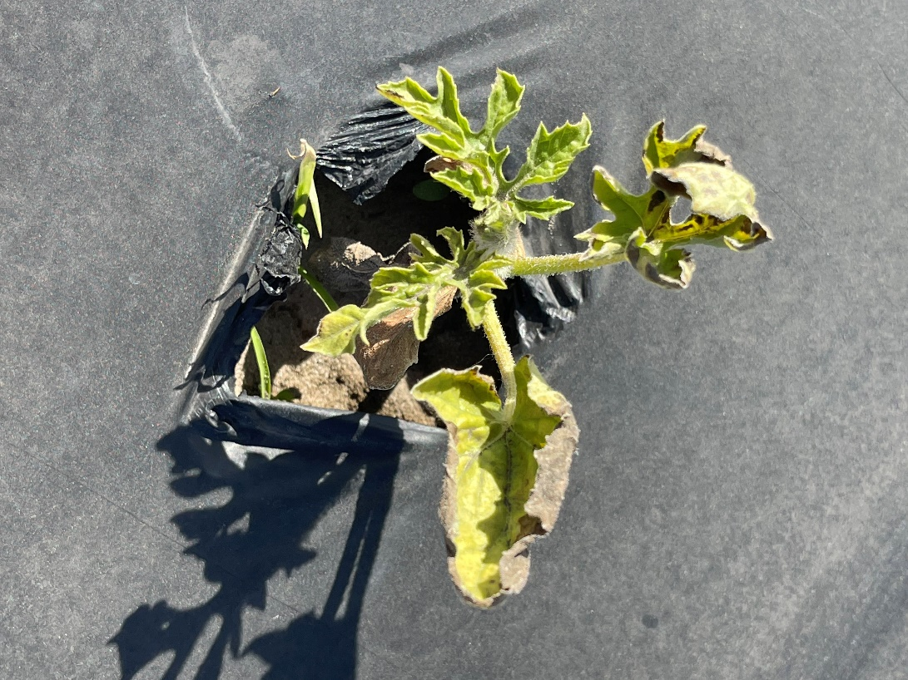

**Paper mulch update in 2025:**

The commercialization of the Smurfit WestRock paper mulch continues here in 2025. There was about 120 acres of this new paper mulch purchased for use here in the Suwannee Valley and a couple other areas in Florida and Georgia. However, most of the paper mulch used in 2025 is here in the Suwannee Valley region on about 6 farms on 2 to 35 acres (See photo). The application of the paper mulch is clearly more challenging than plastic mulch, but where the machines were well adjusted, the paper applications went reasonably well. But the set up and bed formation is very important, and the shoulder tires must be pointed straight ahead and not trying to pull or stretch the paper. In a few of the fields where paper is used this spring, the nutsedge population is very high. In these fields, the beauty of the paper mulch is shown where nutsedge will not penetrate through the paper. We have also documented again this year that black paper mulch keeps the soil temperature about 1-2 degrees warmer on these cold nights when compared to the soil under the plastic mulch. We continue to learn a lot about implementing paper mulches in the field. We are also conducting research at UF/IFAS NFREC-Suwannee Valley with new formulations of paper and coatings. (Bob Hochmuth)

Photo: On farm paper mulch 2025 season. (Bob Hochmuth)

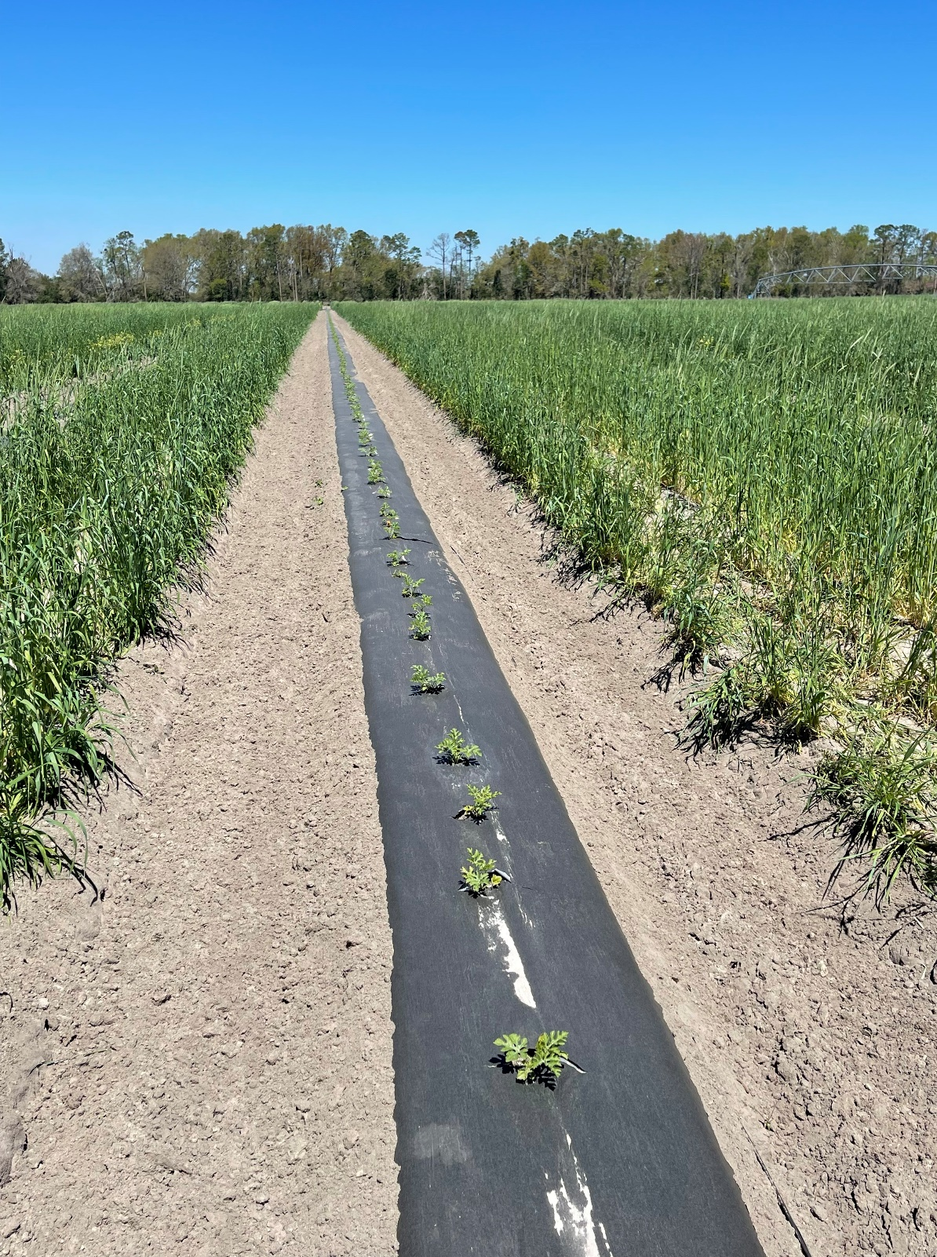

**Reminder: Petiole-sap testing service will be offered:**

UF/IFAS County Extension agents will again be offering the weekly petiole-sap testing service for growers in their counties. All Extension agents in the Suwannee Valley have the equipment and expertise to conduct this service. We offer testing for nitrogen and potassium, which helps growers fine tune the fertigation events for frequency and amounts to be fertigated. We are ready to conduct petiole-sap testing when the vines are at least 12-15 inches long. Contact your county Extension agent to get on their schedule. (All Extension Agents in Suwannee Valley)

