**Welcome to our UF/IFAS Extension Suwannee Valley Watermelon Crop Update. These updates will be summarized by Bob Hochmuth, Regional Specialized Extension Agent- Vegetable Crops, with input from Suwannee Valley Extension Agents: Mark Warren (Levy), Tyler Pittman (Gilchrist), Tatiana Sanchez-Jones (Alachua), Luke Harlow (Bradford), Dan Fenneman (Madison), Keith Wynn (Hamilton), Emily Beach (Lafayette), Jim Devalerio (Union), Ben Hoffner (Jefferson), Raymond Balaguer(Suwannee), Derick Conover (Columbia) Kevin Athearn (RSA-Agri- business), Shivendra Kumar (RSA-Agronomic Crops), and Jay Capasso (RSA- Water Resources).**

**If you know someone who wants to be added to this weekly notice, contact your Extension Agent or Mark Warren (352-949-8288) if you want to be added to the regional watermelon group text app.**

We will continue this year to support our watermelon growers with a rapid diagnostics system through Suwannee Valley Regional and County Extension Agents. This industry-funded program allows Extension Agents to submit and pay for watermelon grower’s plant disease and other diagnostic samples. This **SV Rapid Diagnostic Watermelon Program** will help us to get quicker diagnostic results, helping to give early alerts to everyone, and not have to charge the growers directly. Plant disease samples are typically $40 and leaf tissue analyses are typically $20. **We are currently solicitating those industry reps interested in sponsoring this effort. The past year’s sponsorships have ranged from $200 to $2,000 per company. Sponsors will be recognized every week beginning this week. Those interested in being added as a sponsor can contact Bob Hochmuth at** [**bobhoch@ufl.edu**](mailto:bobhoch@ufl.edu) **or 386-288-6301.**

**Current 2025 sponsors of our Watermelon Rapid Diagnostics Program include: Mayo Ag Services, Gowan USA, Smurfit/WestRock Paper Mulch, Orbia Netafim, Syngenta Crop Protection, Harrell’s Fertilizer, and TriEst Ag. Others are still welcome to join.**

**Overall assessment:**

There was not a lot new reported this week, except that much of the region (middle and north) received heavy rainfall. Overall rainfall reports ranged from 1.5 to 6-8 inches. If those areas with heavy rainfall and likely leaching events with conventional fertilizer in the bed may want to consider initiating at least a temporary fertigation event of 1.0 lbs of nitrogen per acre per day rate, perhaps a few day’s worth of N. Based on planting reports, it sounds like we are at least 90% planted in the region (Suwannee Valley). Generally, plant establishment has been good except where wind, sandblasting and some frost damage have occurred. Take notice of any concerns that appear disease related and contact your Extension agent for diagnostic samples. Nutsedge, as always, is common already in certain fields with a history of nutsedge. Remember, do not spray over the top of young watermelon transplants with Sandea, the damage is very severe early in the season. Those fields with paper mulch are resisting nutsedge really well, completely stopping the sedge from poking through the paper where the paper is intact. (Bob Hochmuth)

**Value of rye windbreaks:**

We have been using rye as a windbreak in watermelon fields for years in the Suwannee Valley, and for this spring, the value of windbreaks has been undisputable. Here are the points to review from past year’s articles in honor of the role rye plays in our system. But, before moving on, mark your calendars this fall to get seed and establish the windbreaks early.

Rye, when established early, can serve as a windbreak, and protects the young crop from high winds and sand blasting in March and April. Of the small grain options here, rye generally provides the greatest growth in the winter when temperatures are cool. Studies have shown that the effective distance of wind reduction on the lee side (protected side) of a windbreak is at least 10 times the height of the windbreak. So, the taller the windbreak, the greater the distance it provides protection. A 4 to 5-foot-tall windbreak should provide 40-50 feet of protection, assuming the rye strips are perpendicular to the wind direction. Rye variety “Florida 401” is perhaps our best rye variety for windbreaks, early to tiller and grow upward. Along with just the wind alone, we see great damage when sand is blown too. These issues are all too familiar, but rye has some other features as well. The aphids usually found feeding in rye is a grain aphid that poses no threat to watermelon, so do not spray the rye strips. These grain aphids are a food source for many beneficials, but mainly lady beetles in the Suwannee Valley. We frequently see high populations of lady beetles on watermelon rows next to the rye windbreaks (See photo). Cereal rye also produces several compounds in its plant tissues and releases root exudates that inhibit germination and growth of weed seeds. These allelopathic effects, together with cereal rye's ability to smother other plants with cool weather growth, make it an ideal choice for a windbreak. Have you ever noticed there is little to no nutsedge in the rye windbreaks when the rye is actively growing? This allelopathic effect of rye is why few weeds are associated with rye strips, especially when the rye is started early. A healthy rye windbreak, after it is mowed down can also provide cover to the soil keeping the soil cooler and helps in shading out weeds in the row middles (B. Hochmuth and T. Pittman).

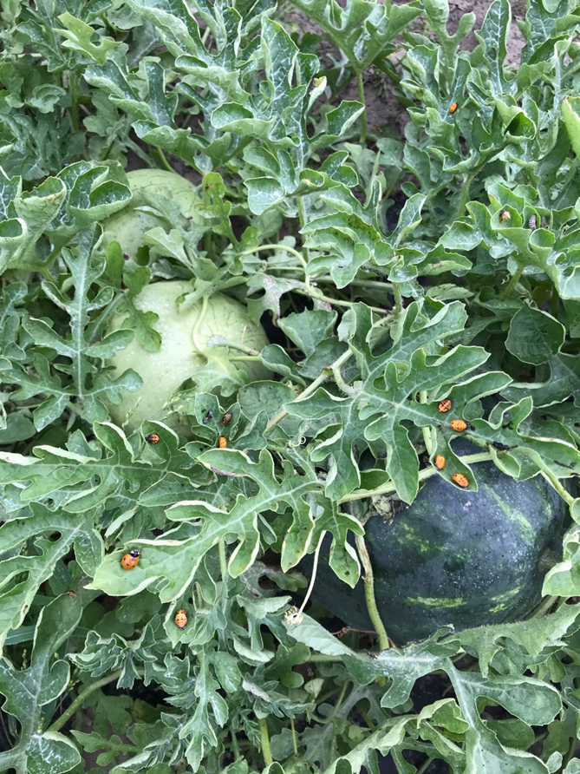

**Petiole-sap testing service will be offered:**

UF/IFAS County Extension agents will again be offering the weekly petiole-sap testing service for growers in their counties. All Extension agents in the Suwannee Valley have the equipment and expertise to conduct this service. We offer testing for nitrogen and potassium, which helps growers fine tune the fertigation events for frequency and amounts to be fertigated. We are ready to conduct petiole-sap testing when the vines are at least 12-15 inches long. Contact your county Extension agent to get on their schedule. (All Extension Agents in Suwannee Valley)

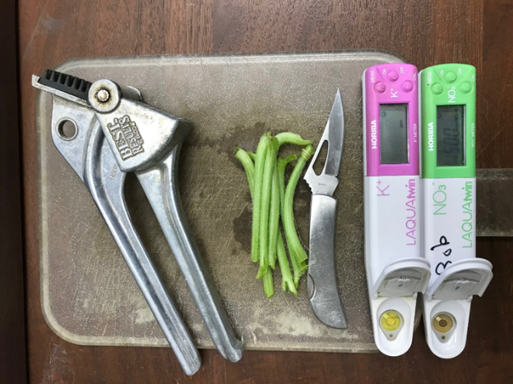

**Early season disease management:**

A repeat from last week. We will plan to update everyone as soon as we confirm foliar or other disease prevalence. The crops generally look very clean right now. Once plants are established, for foliar fungal pathogens, we recommend using a weekly Bravo or other chlorothalonil product schedule for this early part of the season, perhaps the first few sprays, while we can use chlorothalonil prior to fruit sizing stage. Banding sprays over the beds only while plants are small is very economical. (Bob Hochmuth)