Welcome to our UF/IFAS Extension Suwannee Valley Watermelon Crop Update. These updates will be summarized by Bob Hochmuth, Regional Specialized Extension Agent- Vegetable Crops, with input from Suwannee Valley Extension Agents: Mark Warren (Levy), Tyler Pittman (Gilchrist), Tatiana Sanchez-Jones (Alachua), Luke Harlow (Bradford), Dan Fenneman (Madison), Keith Wynn (Hamilton), Emily Beach (Lafayette), Jim Devalerio (Union), Ben Hoffner (Jefferson), Raymond Balaguer(Suwannee), Derick Conover (Columbia) Kevin Athearn (RSA-Agri- business), Shivendra Kumar (RSA-Agronomic Crops), and Jay Capasso (RSA- Water Resources).
If you know someone who wants to be added to this weekly notice, contact your Extension Agent or Mark Warren (352-949-8288) if you want to be added to the regional watermelon group text app.
We will continue this year to support our watermelon growers with a rapid diagnostics system through Suwannee Valley Regional and County Extension Agents. This industry-funded program allows Extension Agents to submit and pay for watermelon grower’s plant disease and other diagnostic samples. This SV Rapid Diagnostic Watermelon Program will help us to get quicker diagnostic results, helping to give early alerts to everyone, and not have to charge the growers directly. Plant disease samples are typically $40 and leaf tissue analyses are typically $20. We are currently solicitating those industry reps interested in sponsoring this effort. The past year’s sponsorships have ranged from $200 to $2,000 per company. Sponsors will be recognized every week beginning this week. Those interested in being added as a sponsor can contact Bob Hochmuth at bobhoch@ufl.edu or 386-288-6301.

Current 2025 sponsors of our Watermelon Rapid Diagnostics Program include: Mayo Ag Services, Gowan USA, Smurfit/WestRock Paper Mulch, Orbia Netafim, Syngenta Crop Protection, Harrell’s Fertilizer, TriEst Ag, and Triangle Chemical Company. Other sponsors are still welcome to join.

Disease and insect spray update:
We now have our first confirmed case of powdery mildew in the Suwannee Valley. As a result of generally having low disease incidence, I would suggest keeping things simple. Perhaps a simple program this week will be Mancozeb (Manzate, Penncozeb, or other trade name) plus something as a preventative for powdery mildew (Quintec, Rhyme (preferred as a spray), or Procure), plus something as a preventative for rindworms (Bt; Intrepid or Troubadour; or Coragen eVo. Note that Intrepid and Troubadour have the same active ingredient. Just an observation over the many years, when it is extremely dry like it is now, the lush, green watermelon fields may be quite attractive to adult moths which lay eggs of the rindworm complex. So, it is advisable to start rindworm sprays if not already started. It could be only about three weeks to our earliest harvests in the region, so we need to be on alert overall now.
There have been other reports concerning downy mildew, but to our knowledge, no other cases from this region have been confirmed in our lab at UF. I am not saying there are no other cases, I just can’t confirm any other new cases. (Bob Hochmuth and Mark Warren)

Drip irrigation management:
Irrigation needs have significantly increased this past week, as expected. Use soil moisture sensors to guide you decisions, but it seems like everyone already needs, or will soon need, to go to multiple events per day. The length of time per event depends on the flow rate of the drip tape. For higher flow tapes (0.4- 0.5 gal per minute per 100 ft of row), you should need no more than 1.5 hours per event (after pressurizing the system). But with low flow drip tapes (0.2-0.3 gal per minute per 100 ft of row), events after pressurizing the system will be slightly longer, perhaps 2.0-2.5 hours per event. The soil moisture sensor lines for each sensor depth can be very useful to determine the length of each event. Over 80% of the watermelon roots are in the top 12 inches, so irrigation events should not be so long as the water moves beyond about 16 inches, certainly not 24 inches or deeper. Note the “gauge” showing full or not full, does not help you make that decision, you need to look at the individual lines to determine how long each irrigation event should last. Contact your vendor or Extension agent to help with this assessment. (Bob Hochmuth)

Two Watermelon Field Days set for the Suwannee Valley- Hold the Dates. Flyers and Registration information below.
- Watermelon On Farm/ NFREC-SV Field Day, Monday, May 5, 2025, starting at 3:30 PM at a farm of Adrian Land’s near Obrien; then moving to the NFREC- Suwannee Valley to see the research plots there and enjoy dinner and fellowship.
Register here: Watermelon On Farm/ NFREC-SV Field Day Tickets, Mon, May 5, 2025 at 3:30 PM | Eventbrite

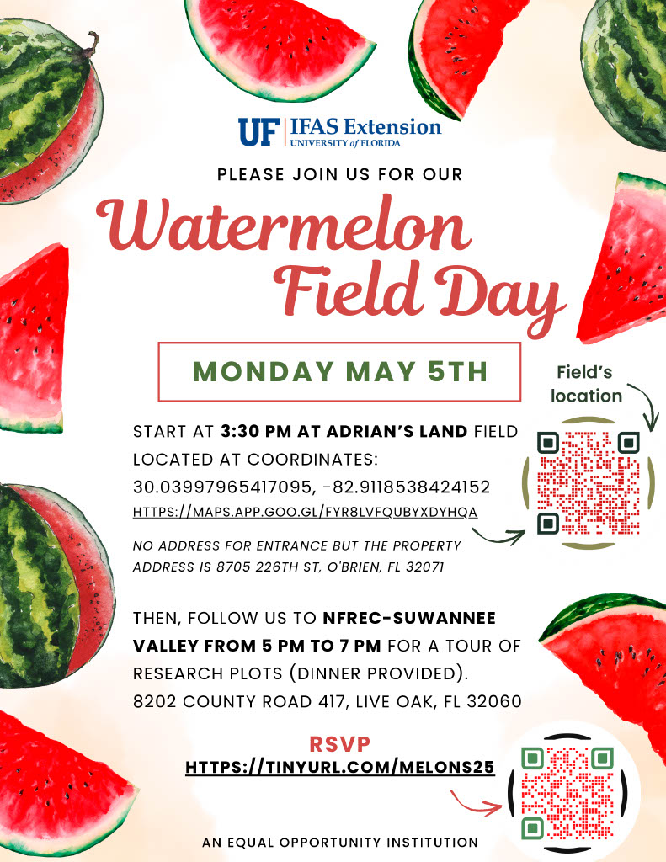
- Union County Watermelon Field Day Co-planned by BASF and UF/IFAS Extension at Dukes Family Farm, near Lake Butler. This will be a morning field day starting at 9 am on Wednesday, June 11, 2025.
Watermelon Variety Trial Tickets, Wed, Jun 11, 2025 at 8:30 AM | Eventbrite
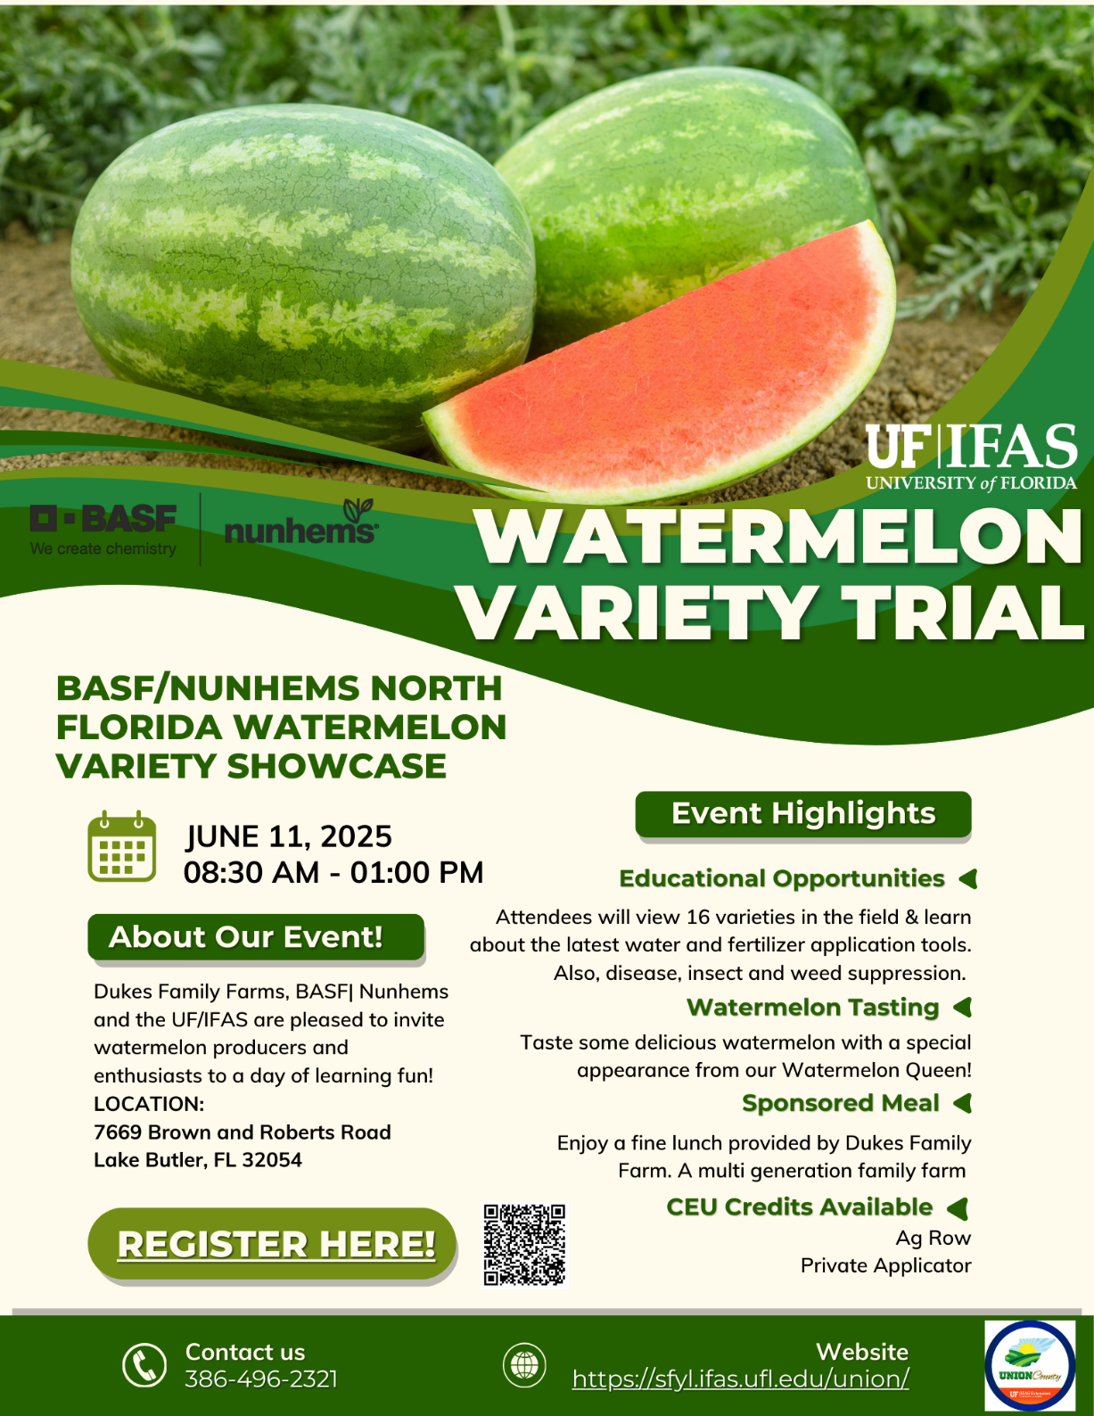

2025 Suwannee Valley CARES:
The Farm Bureau’s signature environmental stewardship recognition program, Suwannee Valley CARES, is set for Thursday, May 1, 2025, at NFREC-Suwannee Valley. The Florida Watermelon Association will be there along with the 2025 Florida Watermelon Queen, Reagan Hudson. Come get some fresh Florida watermelon and all types of other ag commodities for dinner that evening. (Bob Hochmuth, Kelly Aue)



