Welcome to our UF/IFAS Extension Suwannee Valley Watermelon Crop Update. These updates will be summarized by Bob Hochmuth, Regional Specialized Extension Agent- Vegetable Crops, with input from Suwannee Valley Extension Agents: Mark Warren (Levy), Tyler Pittman (Gilchrist), Tatiana Sanchez-Jones (Alachua), Luke Harlow (Bradford), Dan Fenneman (Madison), Keith Wynn (Hamilton), Emily Beach (Lafayette), Jim Devalerio (Union), Ben Hoffner (Jefferson), Raymond Balaguer(Suwannee), Derick Conover (Columbia) Kevin Athearn (RSA-Agri- business), Shivendra Kumar (RSA-Agronomic Crops), and Jay Capasso (RSA- Water Resources).
If you know someone who wants to be added to this weekly notice, contact your Extension Agent or Mark Warren (352-949-8288) if you want to be added to the regional watermelon group text app.

We will continue this year to support our watermelon growers with a rapid diagnostics system through Suwannee Valley Regional and County Extension Agents. This industry-funded program allows Extension Agents to submit and pay for watermelon grower’s plant disease and other diagnostic samples. This SV Rapid Diagnostic Watermelon Program will help us to get quicker diagnostic results, helping to give early alerts to everyone, and not have to charge the growers directly. Plant disease samples are typically $40 and leaf tissue analyses are typically $20. We are currently solicitating those industry reps interested in sponsoring this effort. The past year’s sponsorships have ranged from $200 to $2,000 per company. Sponsors will be recognized every week beginning this week. Those interested in being added as a sponsor can contact Bob Hochmuth at bobhoch@ufl.edu or 386-288-6301.

Current 2025 sponsors of our Watermelon Rapid Diagnostics Program include: Mayo Ag Services, Gowan USA, Smurfit/WestRock Paper Mulch, Orbia Netafim, Syngenta Crop Protection, Harrell’s Fertilizer, TriEst Ag, and Triangle Chemical Company. Other sponsors are still welcome to join.

Weekly Update:
Pretty short report this week as very little has changed. Happy Easter to everyone!
We sent a mid-week notice of confirmation of downy mildew in the very southern part of our Suwannee Valley region. But this confirmation is different than our normal infections that come in from South Florida on weather patterns. It appears that lone infected field was likely infected from movement into the area on transplants or workers. We are on high alert for other infections, but none are reported yet. We continue to see very few, if any, foliar diseases so far this season. With dry conditions predicted this upcoming week, the risk of new infections of bacterial or fungal diseases is low. Therefore, we may still be on a chlorothalonil or mancozeb cover spray this week. Seems pretty boring, we know, but it really is great news. We know our disease time, as always, will come later this season. If you choose to add tebuconazole to that cover spray, it may be useful. Also, if you like to switch to Miravis Prime, as it is best positioned ahead of disease infections, this week or next week would be the proper timing. But one more week of chlorothalonil is as good as any choice based on our current situation. With this dry warm weather, we need to be on the lookout for powdery mildew next.
Squash bugs have been frequently reported this past week. See past notices for the details, but the pyrethroid class of insecticides is our best choice. Spray at night or otherwise protect your bees. Use high volume and high pressure to assure coverage in the hole in the plastic and at the base of the plant.
As fruit set continues and fruit size increases, we see petiole sap numbers coming down somewhat, as expected. We are likely to see significant plant growth including great fruit set and sizing this week. As a result, it is expected fertigations will likely need to be 2.0 lbs per acre per day of nitrogen and potash in most fields and possibly even increasing to 2.5 lbs per acre per day in a few very early fields with small volleyball-sized fruits. But, as always, let the petiole-sap results dictate the recommendation.

Two Watermelon Field Days set for the Suwannee Valley- Hold the Dates. Flyers and Registration information below.

- Watermelon On Farm/ NFREC-SV Field Day, Monday, May 5, 2025, starting at 3:30 PM at a farm of Adrian Land’s near Obrien; then moving to the NFREC- Suwannee Valley to see the research plots there and enjoy dinner and fellowship.

Register here: Watermelon On Farm/ NFREC-SV Field Day Tickets, Mon, May 5, 2025 at 3:30 PM | Eventbrite

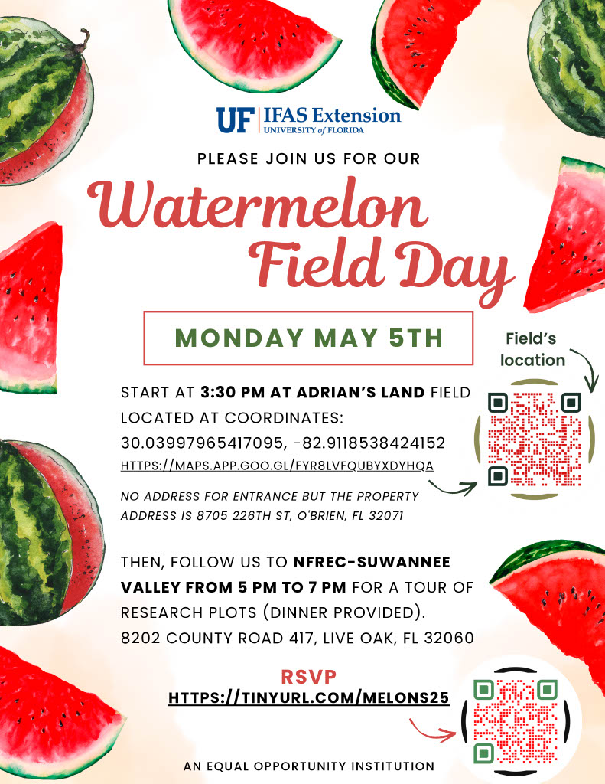

- Union County Watermelon Field Day Co-planned by BASF and UF/IFAS Extension at Dukes Family Farm, near Lake Butler. This will be a morning field day starting at 9 am on Wednesday, June 11, 2025.
Watermelon Variety Trial Tickets, Wed, Jun 11, 2025 at 8:30 AM | Eventbrite
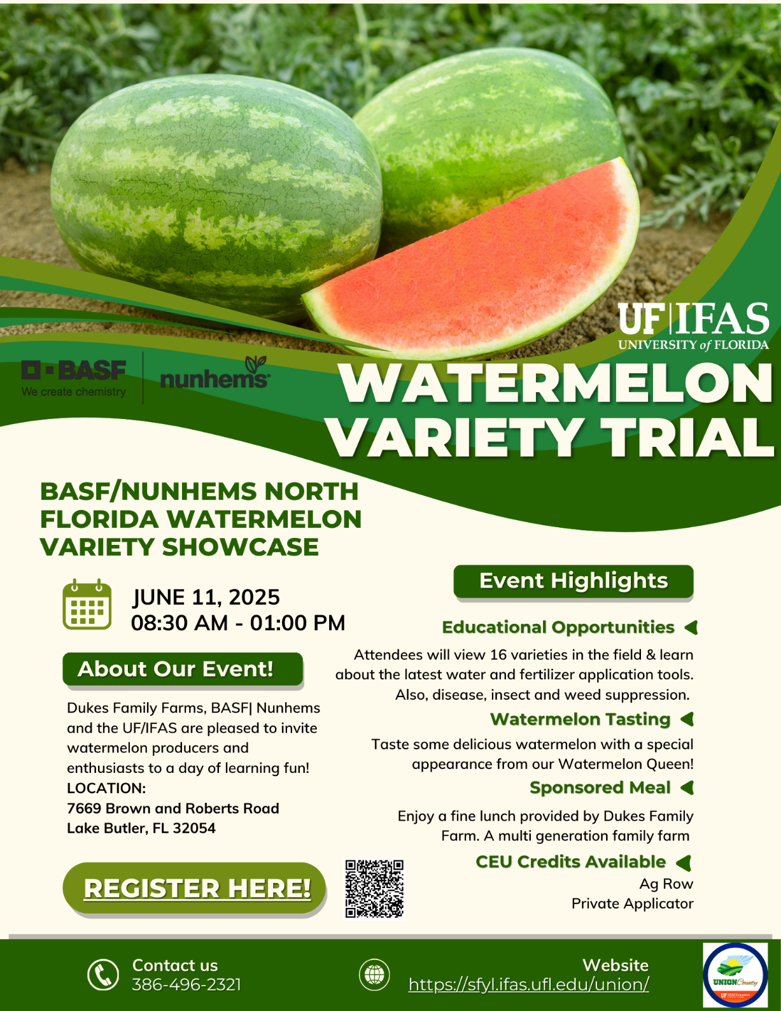

2025 Suwannee Valley CARES:
The Farm Bureau’s signature environmental stewardship recognition program, Suwannee Valley CARES, is set for Thursday, May 1, 2025, at NFREC-Suwannee Valley. The Florida Watermelon Association will be there along with the 2025 Florida Watermelon Queen, Reagan Hudson. Come get some fresh Florida watermelon and all types of other ag commodities for dinner that evening. (Bob Hochmuth, Kelly Aue)



