Welcome to our UF/IFAS Extension Suwannee Valley Watermelon Crop Update. These updates will be summarized by Bob Hochmuth, Regional Specialized Extension Agent- Vegetable Crops, with input from Suwannee Valley Extension Agents: Mark Warren (Levy), Tyler Pittman (Gilchrist), Tatiana Sanchez-Jones (Alachua), Luke Harlow (Bradford), Dan Fenneman (Madison), Keith Wynn (Hamilton), Emily Beach (Lafayette), Jim Devalerio (Union), Ben Hoffner (Jefferson), Raymond Balaguer(Suwannee), Derick Conover (Columbia) Kevin Athearn (RSA-Agri- business), Shivendra Kumar (RSA-Agronomic Crops), and Jay Capasso (RSA- Water Resources).
If you know someone who wants to be added to this weekly notice, contact your Extension Agent or Mark Warren (352-949-8288) if you want to be added to the regional watermelon group text app.
We will continue this year to support our watermelon growers with a rapid diagnostics system through Suwannee Valley Regional and County Extension Agents. This industry-funded program allows Extension Agents to submit and pay for watermelon grower’s plant disease and other diagnostic samples. This SV Rapid Diagnostic Watermelon Program will help us to get quicker diagnostic results, helping to give early alerts to everyone, and not have to charge the growers directly. Plant disease samples are typically $40 and leaf tissue analyses are typically $20. We are currently solicitating those industry reps interested in sponsoring this effort. The past year’s sponsorships have ranged from $200 to $2,000 per company. Sponsors will be recognized every week beginning this week. Those interested in being added as a sponsor can contact Bob Hochmuth at bobhoch@ufl.edu or 386-288-6301.

Current 2025 sponsors of our Watermelon Rapid Diagnostics Program include: Mayo Ag Services, Gowan USA, Smurfit/WestRock Paper Mulch, Orbia Netafim, Syngenta Crop Protection, Harrell’s Fertilizer, TriEst Ag, and Triangle Chemical Company. Other sponsors are still welcome to join.

Downy mildew Alert, but wait don’t jump off the bridge yet, read this first, please!

Yes, as of today, there is a UF-confirmed single isolated case of downy mildew in North Florida in the very southern portion of what we identify as this watermelon region. Today, there was also notice by University of Georgia Extension of a single isolated case in southern Georgia as well.
Now,…. the rest of the important details of these two cases. The Georgia downy mildew case was confirmed to come in on transplants in the transport trailer “from outside Georgia”, but the plants were planted to the field before the confirmation. That field is being treated now for downy mildew.
As for the North Florida case, the exact source has not been confirmed, however, there are a few facts to consider here. The nearest case of downy mildew south of the North Florida case is at least a few hundred miles away. This field also was planted from transplants from south FL and the pattern also seems odd for a wind-blown pathogen. So, even though we cannot confirm the source to be transplants or even field workers from outside this region, we can say both the GA and FL cases are very isolated and a few hundred miles from any other known cases. In addition, our recent weather patterns and forecasted weather in the next week or so, are simply not typical of normal downy mildew outbreaks. Remember to check your watermelon field guide for the downy mildew section and photos. Also see the photo below of a previous year’s case of downy mildew.
So, what does all this information mean? It means, don’t panic, but be very diligent in scouting fields. It could be an expensive mistake to automatically start spraying fungicides specifically for downy mildew unless there is reasonable evidence you can justify starting. Materials like Ranman, Elumin, or Orondis Ultra should only be used when more justification emerges. If we start too early needlessly, we will use up the limited number of applications allowed and increase the likelihood of resistance in these materials to downy mildew. Remember, both chlorothalonil and mancozeb both provide some measure of management of downy mildew. So, yes, we have cases both in the southern part of our region and north of us in Georgia, but it seems very likely these cases did not come into the area with the normal air-borne method of pathogen movement. Anything is possible but these two cases are simply not standard for downy mildew.
So, now you know everything we know. But I want to give credit to our system, The Watermelon Rapid Diagnostics Program. This Florida case was scouted by a private consultant and, in collaboration with a County Extension Agent, got the sample submitted to the UF Plant Disease Diagnostic Lab quickly and confirmation was made quickly by the lab. Finally, the information was passed on to me on the same day so I can get this notice out to everyone ASAP. This is a perfect example of how this system is designed to work, ultimately to help growers in the Suwannee Valley and beyond. Thanks to all involved!

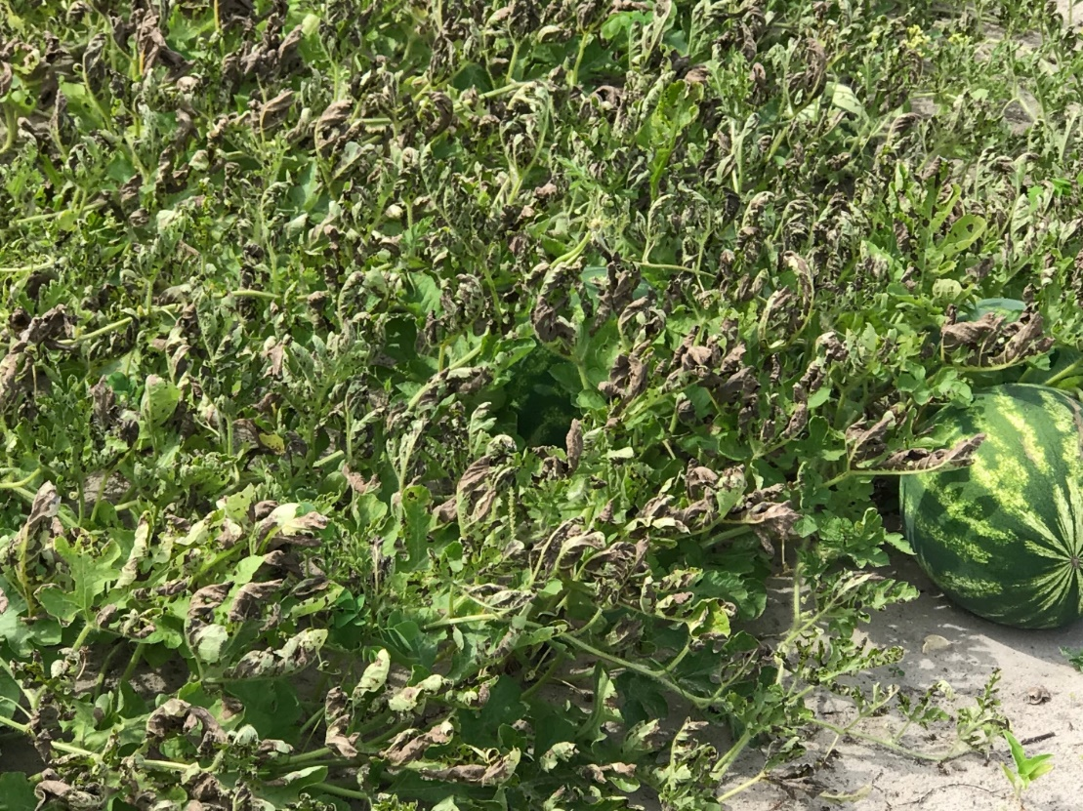
A 2023 advanced case of downy mildew.

