Welcome to a special mid-week issue of our 2024 season UF/IFAS Extension Suwannee Valley Watermelon Crop Update. These updates will be summarized by Bob Hochmuth, Regional Specialized Extension Agent- Vegetable Crops, with input from Suwannee Valley Extension Agents: Mark Warren (Levy), Tyler Pittman (Gilchrist), Tatiana Sanchez (Alachua), Luke Harlow (Bradford), Dan Fenneman (Madison), Keith Wynn (Hamilton), Emily Beach (Lafayette), Jim Devalerio (Union), De’Anthony Price (Jefferson), Raymond Balaguer(Suwannee), Kevin Athearn (RSA-Agri- business), Shivendra Kumar (RSA-Agronomic Crops), Jay Capasso (RSA- Water Resources), and Bob H. covering vacant Columbia County position.
If you know someone who wants to be added to this weekly notice, contact your Extension Agent or Mark Warren (352-949-8288) if you want to be added to the regional watermelon group text app.

We have initiated a more formal way to support our watermelon growers with a rapid diagnostics system through Suwannee Valley Regional and County Extension Agents. This industry-funded program allows Extension Agents to submit and pay for watermelon grower’s plant disease and other diagnostic samples. This SV Rapid Diagnostic Watermelon Program will help us to get quicker diagnostic results, helping to give early alerts to everyone, and not have to charge the growers directly. Plant disease samples are typically $40 and leaf tissue analyses are typically $20. We are currently extending our solicitation of those industry reps interested in sponsoring this effort. The past year’s sponsorships have ranged from $200 to $2,000 per company. Sponsors will be recognized every week beginning this week. Those interested in being added as a sponsor can contact Bob Hochmuth at bobhoch@ufl.edu or 386-288-6301.

Current 2024 sponsors of our Watermelon Rapid Diagnostics Program include Valdosta Plant Company, Mayo Ag Services, Gowan USA, Harrell’s Fertilizer, Triest Ag, Syngenta Crop Protection, WestRock Paper Company, Orbia Netafim, and Super Sweet Farms. Others are still welcome to join.

This is a mid-week alert that powdery mildew has now been confirmed in the Suwannee Valley. Of course, this was first found by Tatiana Sanchez-Jones, Alachua County Extension Agent, and our Suwannee Valley Extension Agent team’s leading plant pathologist!

Powdery mildew found brewing at the base of the plants:

Although most fields do not yet show signs of powdery mildew, we confirmed its presence on Tuesday. The disease is in its initial stages where it depends on the protected microclimate of the fully-grown vines to get the humidity it requires to establish and to start sporulating. If scouting for powdery mildew, take a closer look to leaves and stems closer to the base of the plants. Look for small yellow areas in the leaves (mostly round) and whitish growth on stems and petioles (Fig 1.). If you suspect you have lesions, hold the underside of the leaf against the light, infected tissue will appear lighter in color (Fig 2.). You may not see the fuzzy growth just yet but if you collect suspicious tissue and put it in a moist chamber at room temperature, you will be able to see the white fuzzy growth characteristic of powdery mildew in just a couple of days (Fig 3.).

Stay ahead of powdery mildew by incorporating a fungicide targeted specifically for powdery mildew such as Quintec, Procure or Rhyme. Rhyme can be applied through the drip, but we recommend spraying it as better results have been documented in research with foliar vs. drip applications (by Tatiana Sanchez-Jones).

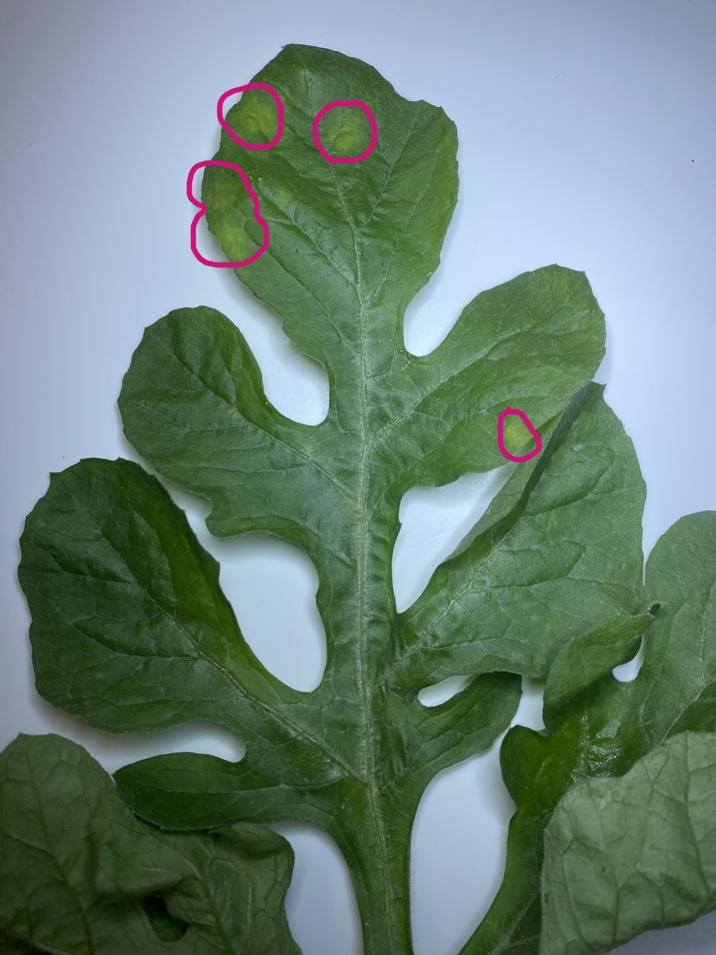
Figure 1. Very early stages of powdery mildew.
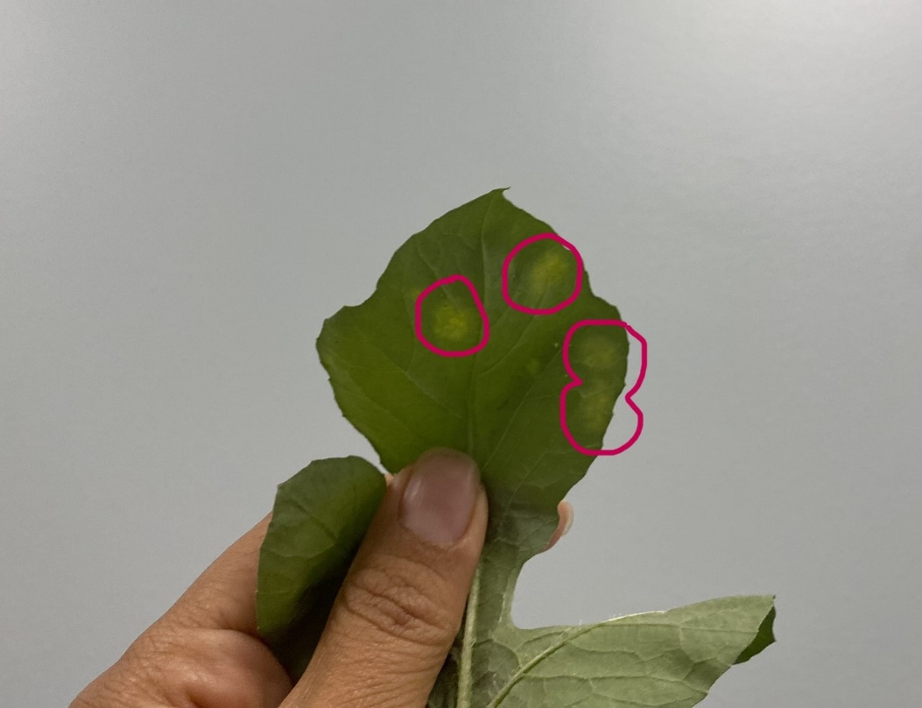
Figure 2. Powdery mildew lesions showing the lighter colors on the leaf when shown toward the light.

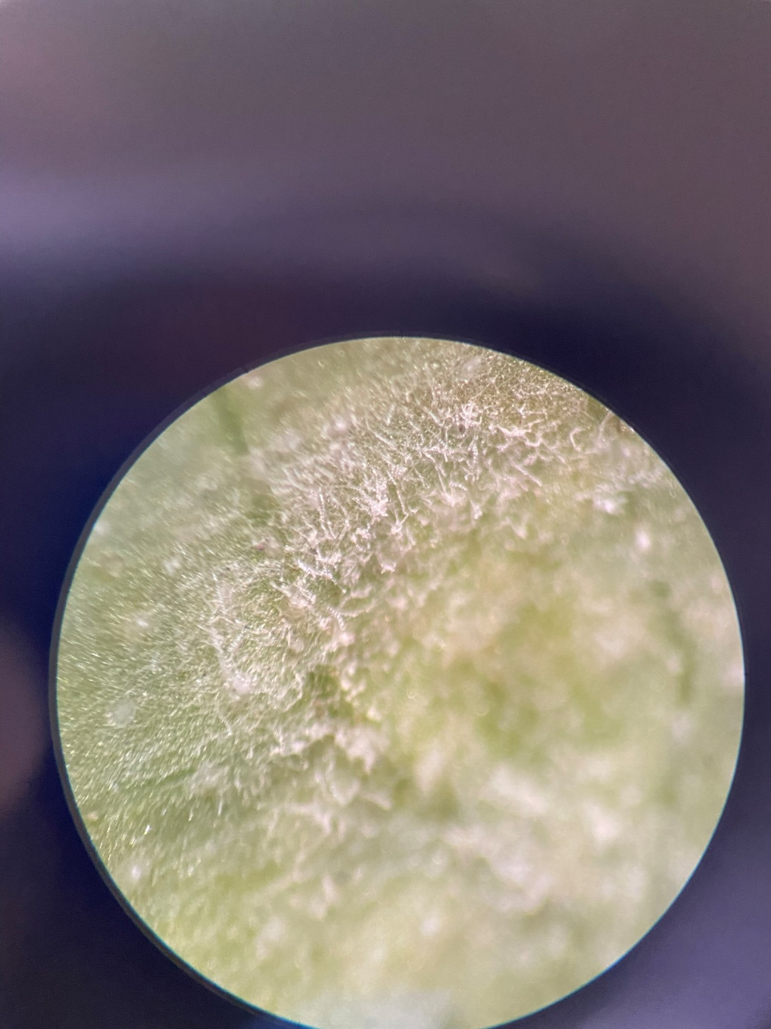
Figure 3. White fuzzy growth characteristic of powdery mildew in a growth chamber in just a couple of days.

