Welcome to this week’s issue of our 2024 season UF/IFAS Extension Suwannee Valley Watermelon Crop Update. These updates will be summarized by Bob Hochmuth, Regional Specialized Extension Agent- Vegetable Crops, with input from Suwannee Valley Extension Agents: Mark Warren (Levy), Tyler Pittman (Gilchrist), Tatiana Sanchez (Alachua), Luke Harlow (Bradford), Dan Fenneman (Madison), Keith Wynn (Hamilton), Emily Beach (Lafayette), Jim Devalerio (Union), De’Anthony Price (Jefferson), Raymond Balaguer(Suwannee), Kevin Athearn (RSA-Agri- business), Shivendra Kumar (RSA-Agronomic Crops), Jay Capasso (RSA- Water Resources), and Bob H. covering vacant Columbia County position.
If you know someone who wants to be added to this weekly notice, contact your Extension Agent or Mark Warren (352-949-8288) if you want to be added to the regional watermelon group text app.
We have initiated a more formal way to support our watermelon growers with a rapid diagnostics system through Suwannee Valley Regional and County Extension Agents. This industry-funded program allows Extension Agents to submit and pay for watermelon grower’s plant disease and other diagnostic samples. This SV Rapid Diagnostic Watermelon Program will help us to get quicker diagnostic results, helping to give early alerts to everyone, and not have to charge the growers directly. Plant disease samples are typically $40 and leaf tissue analyses are typically $20. We are currently extending our solicitation of those industry reps interested in sponsoring this effort. The past year’s sponsorships have ranged from $200 to $2,000 per company. Sponsors will be recognized every week beginning this week. Those interested in being added as a sponsor can contact Bob Hochmuth at bobhoch@ufl.edu or 386-288-6301.

Current 2024 sponsors of our Watermelon Rapid Diagnostics Program include Valdosta Plant Company, Mayo Ag Services, Gowan USA, Harrell’s Fertilizer, Triest Ag, Syngenta Crop Protection, WestRock Paper Company, Orbia Netafim, and Super Sweet Farms. Others are still welcome to join.

Topic this week: Downy mildew alert!

First Case of Downy Mildew Confirmed
Well, we hoped we may escape this season without seeing downy mildew. But, we now have our first confirmed case of the 2024 season for downy mildew in the southern part of the Suwannee Valley region (Mark Warren and Bob Hochmuth). See pages 40-41 in your UF/IFAS Watermelon Field Guide. In addition, I received a notice today from Ty Torrance, University of Georgia Extension Service, Tri-County Vegetable Agent for Colquitt, Tift, and Worth Counties that downy mildew was also confirmed in Tift County GA in watermelon. In both the Georgia and the Florida cases, the infection of downy mildew is very aggressive. It is unusual to have the situation where downy is found as far apart as southern Suwannee Valley all the way to Tift County, GA. Therefore, it is likely the entire Suwannee Valley is at risk. We do want everyone to have a heightened alert and to intensify scouting when we indicate alerts for any of these diseases or other pests. Our intent is to make sure everyone knows what is happening in the region, so you can make the best decision possible on your own farm.

Downy mildew is the disease traditionally known as “wildfire”. Last year, we confirmed the first case in our region on May 3, 2023. Because of the high risk of damage and movement throughout the region, we are expressing a high level of concern to consider a plan to spray if you have not already initiated a program targeted at downy mildew, anywhere in the Suwannee Valley region. Contact your Extension Agent if you see areas of the field where the plants look blighted (dried up leaves sticking straight up in the mid part of the canopy). The leaves in more advanced stages will quickly become “crispy” with the leaf veins being the only part of the leaf to become crispy and dry (see photo below). You should consider adding one of these fungicides to your program soon. The best choices, based on recent trials, are Ranman, Orondis Ultra, or Zampro (all three have a zero-day pre-harvest interval (PHI)) and should be added to a broader spectrum mancozeb (Manzate or Penncozeb (5-day PHI)) spray plus either Quintec, Rhyme, or Procure, for the continued management of powdery mildew. Good luck with this additional challenge. For those fields where downy mildew has been confirmed, we have suggested starting with Orondis Ultra or Zampro this week and Ranman next week. Where downy mildew has not yet been detected, you could start with Ranman this week and follow with Orondis Ultra, or Zampro. (Hochmuth)

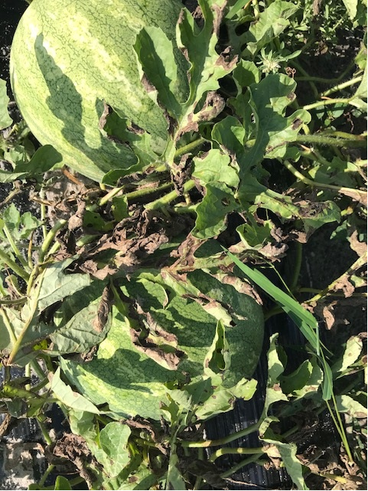
Photo: Downy mildew (R. Hochmuth)
A couple other disease notes. We also have confirmed cases of Anthracnose, Alternaria and Gummy Stem Blight. Of these, Gummy Stem Blight has been the most common in the region. The other two Alternaria and Anthracnose have been much less frequently found although have been very concerning in the few fields where they have been found. Again, if you see a disease symptom of great concern let your Extension Agent know so we can help confirm the cause. It looks like we will see a lot of changes in disease pressure now and moving forward.

