Welcome to this week’s issue of our 2024 season UF/IFAS Extension Suwannee Valley Watermelon Crop Update. These updates will be summarized by Bob Hochmuth, Regional Specialized Extension Agent- Vegetable Crops, with input from Suwannee Valley Extension Agents: Mark Warren (Levy), Tyler Pittman (Gilchrist), Tatiana Sanchez (Alachua), Luke Harlow (Bradford), Dan Fenneman (Madison), Keith Wynn (Hamilton), Emily Beach (Lafayette), Jim Devalerio (Union), De’Anthony Price (Jefferson), Raymond Balaguer(Suwannee), Kevin Athearn (RSA-Agri- business), Shivendra Kumar (RSA-Agronomic Crops), Jay Capasso (RSA- Water Resources), and Bob H. covering vacant Columbia County position.
If you know someone who wants to be added to this weekly notice, contact your Extension Agent or Mark Warren (352-949-8288) if you want to be added to the regional watermelon group text app.
We have initiated a more formal way to support our watermelon growers with a rapid diagnostics system through Suwannee Valley Regional and County Extension Agents. This industry-funded program allows Extension Agents to submit and pay for watermelon grower’s plant disease and other diagnostic samples. This SV Rapid Diagnostic Watermelon Program will help us to get quicker diagnostic results, helping to give early alerts to everyone, and not have to charge the growers directly. Plant disease samples are typically $40 and leaf tissue analyses are typically $20. We are currently extending our solicitation of those industry reps interested in sponsoring this effort. The past year’s sponsorships have ranged from $200 to $2,000 per company. Sponsors will be recognized every week beginning this week. Those interested in being added as a sponsor can contact Bob Hochmuth at bobhoch@ufl.edu or 386-288-6301.

Current 2024 sponsors of our Watermelon Rapid Diagnostics Program include Valdosta Plant Company, Mayo Ag Services, Gowan USA, Harrell’s Fertilizer, Triest Ag, Syngenta Crop Protection, WestRock Paper Company, Orbia Netafim, and Super Sweet Farms. Others are still welcome to join.
Topics this week include: Storm hammers farms in the I-10 Corridor including the UF IFAS Center, Disease update.

Storm hits Suwannee Valley region hard:
Friday morning, May 10th will be a day to remember for many in the region. Crops were blown over or down, buildings severely damaged, pivots turned over and more damage to much of the same area hit by Idalia last August. The UF/IFAS NFREC-SV was not spared again, in fact, the damage was much more severe than in Idalia. Friday’s tornadic or straight-line winds reached at least 73 miles per hour and persisted for about 15 minutes. At the IFAS Center, greenhouses, and several buildings at the farm sustained severe damage (see photos below), but the main conference room and pavilion survived with little or no damage. The research project crops hopefully will recover, but time will tell. We pray for the recovery for all farmers and other citizens affected. Please let us know how UF/IFAS may be able to assist farmers. (Bob Hochmuth)
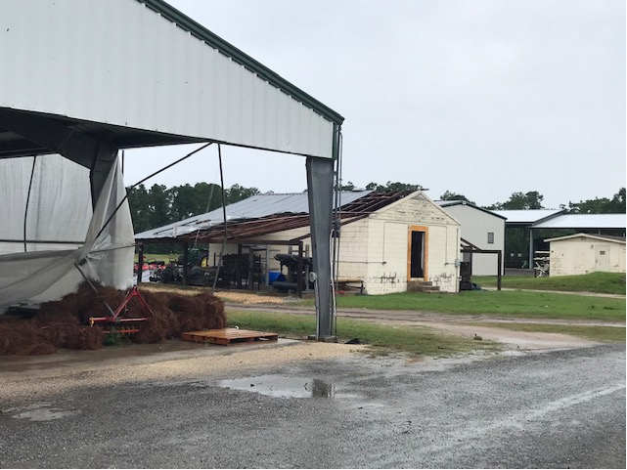
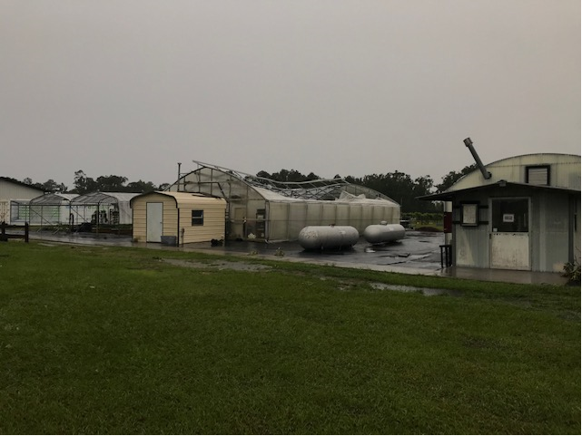

Disease and insect spray update:
Note: we have now confirmed powdery mildew in the very early stages, as of May 7th. We have received reports of low levels of rindworm activity. Our recommendations have not changed significantly unless specific diseases are in an individual field. We have very few cases of gummy stem blight, a very few cases of bacteria leaf spot and one very minor case of spider mites. We recommend you continue scouting for diseases and insects and base your spray program on what you find in your fields.
As a result of having low disease incidence, I would suggest still keeping things simple. Without anything specific in your fields, perhaps a simple program this week, like last week, will be Mancozeb (5 days to harvest restriction) (Manzate, Penncozeb, or other trade name) plus something as a preventative for powdery mildew (Quintec, Rhyme, or Procure), plus something as a preventative for rindworms (Intrepid or Troubadour; or Coragen eVo. Note that Intrepid and Troubadour have the same active ingredient.
Remember, once harvests start, pay close attention to the preharvest intervals on the label. Products like Inspire Super, if needed has a 7-day preharvest restriction, but a very similar fungicide, Aprovia Top has a zero day preharvest interval. (Bob Hochmuth)

Good luck as harvests are now getting under way!

