Welcome to our first 2024 season’s weekly issue of our UF/IFAS Extension Suwannee Valley Watermelon Crop Update. These updates will be summarized by Bob Hochmuth, Regional Specialized Extension Agent- Vegetable Crops, with input from Suwannee Valley Extension Agents: Mark Warren (Levy), Tyler Pittman (Gilchrist), Tatiana Sanchez (Alachua), Luke Harlow (Bradford), Dan Fenneman (Madison), Keith Wynn (Hamilton), Emily Beach (Lafayette), Jim Devalerio (Union), De’Anthony Price (Jefferson), Raymond Balaguer(Suwannee), Kevin Athearn (RSA-Agri- business), Shivendra Kumar (RSA-Agronomic Crops), Jay Capasso (RSA- Water Resources), and Bob H. covering vacant Columbia County position.
If you know someone who wants to be added to this weekly notice, contact your Extension Agent or Mark Warren (352-949-8288) if you want to be added to the regional watermelon group text app.

We have initiated a more formal way to support our watermelon growers with a rapid diagnostics system through Suwannee Valley Regional and County Extension Agents. This industry-funded program allows Extension Agents to submit and pay for watermelon grower’s plant disease and other diagnostic samples. This SV Rapid Diagnostic Watermelon Program will help us to get quicker diagnostic results, helping to give early alerts to everyone, and not have to charge the growers directly. Plant disease samples are typically $40 and leaf tissue analyses are typically $20. We are currently extending our solicitation of those industry reps interested in sponsoring this effort. The past year’s sponsorships have ranged from $200 to $2,000 per company. Sponsors will be recognized every week beginning this week. Those interested in being added as a sponsor can contact Bob Hochmuth at bobhoch@ufl.edu or 386-288-6301.

Current 2024 sponsors of our Watermelon Rapid Diagnostics Program include Valdosta Plant Company, Mayo Ag Services, Gowan USA, and Harrell’s Fertilizer. Others are still welcome to join.

2024 transplant establishment summary:
Getting the season started off well means we need to get transplants established quickly. In most cases this year, transplants have looked excellent and got established quickly. As in 2023, there was a large number of acres planted by March 1. In only a very few and isolated cases, transplants have shown some damping off and other disease issues. I have had a couple questions about “flattened” and associated cracking of the transplant stems below the cotyledons (see photos below). This is not caused by a pathogen but rather is a result of very rapid growth, typically within the first week after germination. This may be due to high temperatures and high fertilizer. Certain cultivars appear to be more sensitive than others in the same greenhouse. These plants can be more susceptible to disease later in the field so, we suggest culling them out, if possible. But the good news is that it is not something like gummy stem blight. (Bob Hochmuth)
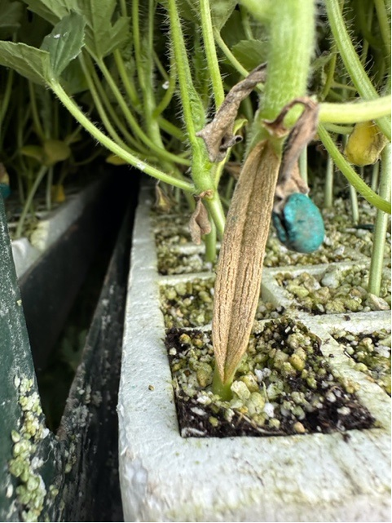
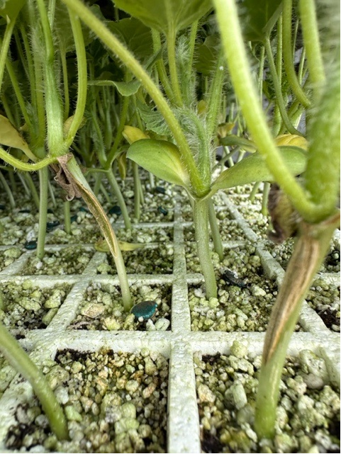

Early season disease management:
We will plan to update everyone as soon as we confirm foliar or other disease prevalence. The crops generally look very clean right now. We recommend using a weekly Bravo or other chlorothalonil product schedule for this early part of the season, perhaps the first few sprays, while we can use chlorothalonil prior to fruit sizing stage. Banding sprays over the beds only while plants are small is very economical. (Bob Hochmuth)

Early season irrigation and nutrient management:
It is important to protect your bed fertilizer investment. Without question, the early part of the season is the most difficult to manage potential loss of fertilizer in our drip irrigated cropping system. We can lose valuable nutrients due to leaching this time of the season with either heavy rainfall events or over-irrigation. We can manage the second one with a good irrigation management program. Soil moisture sensors are a great tool to keep us on track. But we must have confidence in what properly placed and working sensors are telling us and how to interpret them. Your service provider will give you regular guidance, but if we can help, let us know. Our Extension Agents and Regional Extension Agent for Water Resources, Jay Capasso, will be excellent resources. As a way of example here, early in the season assuming a medium flow drip tape (about 0.4 gal/min/100 ft), you should not run more than about 45 minutes per event this time of year. We realize, the larger the zone, the more difficult it is to run short events, but the 45-minute run (after coming up to pressure) with medium flow tape is the reality here early in the season. The point is that longer events every day undoubtedly will push water down well below the top 12 inches of the soil. With the water, goes the soluble portion of fertilizer. When high rates of soluble bed fertilizer are used followed by consistent over-irrigation early in the season, the shallow rooted transplants never uptake much of that fertilizer, forcing you into earlier season and higher, expensive injection programs. In our soil moisture sensors in the region this spring we have seen where soluble fertilizer has been moved 36 inches or more with repeated, daily events of 2 hours our more. We are continuing our demonstrations with pre-plant, controlled release fertilizer (CRF) large-scale demonstrations on 4 farms this spring. We will update you more on these as the season progresses. But one of the primary objectives is to demonstrate the use of CRFs in the bed as a way to reduce leaching losses and still maintain an excellent fertilizer program. (Bob Hochmuth)

Preparing for upcoming cool nights:
Weather forecasts for this upcoming week have caught my attention. Forecasts are predicting mid to upper-30s F, depending on the forecast source. Rain ahead of these cold fronts will be helpful to add water to the soil in the bed and also the row-middle soil so heat can build up in that moist soil ahead of the cold. A warmer moist soil takes longer to cool than a dry soil. Make sure you keep adequate but not excessive moisture in the beds ahead of the cold nights so the moist soil can warm during the sunny days under the black plastic or paper mulches. The same principles apply here, a moist bed will stay warmer longer. Long overnight drip irrigation events are not proven to be of any benefit to temperatures but have a major negative impact by leaching fertilizer. (Bob Hochmuth)

