Welcome to our 2023 season weekly issue of our UF/IFAS Extension Suwannee Valley Watermelon Crop Update. These updates will be summarized by Bob Hochmuth, Regional Specialized Extension Agent- Vegetable Crops, with input from Suwannee Valley Extension Agents: Mark Warren (Levy), Tyler Pittman (Gilchrist), Tatiana Sanchez (Alachua), Luke Harlow (Bradford), Jay Capasso (Columbia), Dan Fenneman (Madison), Keith Wynn (Hamilton), Emily Beach (Lafayette), Jim Devalerio (Union), De’Anthony Price (Jefferson), Bob Hochmuth (for vacant Suwannee position), Kevin Athearn (RSA-Agri- business), and Sudeep Sidhu (RSA- Water Resources).
If you know someone who wants to be added to this weekly notice, contact your Extension Agent or Mark Warren (352-949-8288) if you want to be added to the regional watermelon group text app.
We have initiated a more formal way to support our watermelon growers with a rapid diagnostics system through Suwannee Valley Regional and County Extension Agents. This industry-funded program allows Extension Agents to submit and pay for watermelon grower’s plant disease and other diagnostic samples. This SV Rapid Diagnostic Watermelon Program will help us to get quicker diagnostic results, helping to give early alerts to everyone, and not have to charge the growers directly. Plant disease samples are typically $40 and leaf tissue analyses are typically $20. We are currently soliciting industry reps interested in sponsoring this effort. Past year’s sponsorships have ranged from $200 to $2,000 per company. Sponsors will be recognized every week beginning next week. Those interested can contact Bob Hochmuth at bobhoch@ufl.edu or 386-288-6301.

Frost damage assessment:
The morning of March 16th brought cold temps and a widely frosty morning. Actual temperatures across the region ranged from 33 to 38 degrees F, which were about 3 degrees colder than predicted. No cloud cover, no wind and a high dewpoint temp resulted in the set up for frost. This type of frost is termed a radiant frost and that is what we had last week. Across the region we saw some frost damage (burn on leaves) but mostly minor damage. (Bob Hochmuth)

Early season disease management:
We will continue to update everyone as confirm foliar or other disease prevalence. The crops generally look very clean right now. We recommend continuing a weekly Bravo or other chlorothalonil product schedule for this early part of the season, perhaps the first few sprays while we can use chlorothalonil prior to fruit sizing stage. Banding sprays over the beds only while plants are small is very economical. We have seen very little Fusarium wilt symptoms so far, maybe due to the very warm condition at establishment time. However, we have confirmed Fusarium through our Rapid Diagnostics program. (Bob Hochmuth)

Beneficials on watermelon plants
In the last couple of weeks, we have noticed an increased presence of beneficials (various stages of lady beetles) in watermelon fields. Adult lady beetles migrate into watermelon fields in search of their prey, aphids. This does not necessarily mean you have aphids infesting your crop, in fact, these are grain aphids feeding on the rye and oat strips planted as windbreaks and will not move into the melons. It is important to recognize the various life stages of this beneficial insect to avoid confusing them with a pest. Check page 93 of the Watermelon Field Guide to learn more about these good bugs. (Tatiana Sanchez-Jones)
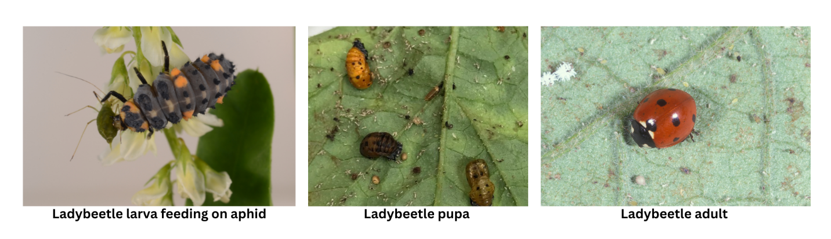

Early season irrigation and nutrient management:
We are now seeing the negative impact of recent rains on the movement of soluble fertilizer deeper in the soil profile as measured by the soil moisture probes throughout the region. Without question, the early part of the season is the most difficult to manage potential loss of fertilizer in our drip irrigated cropping system. We can lose valuable nutrients to leaching this time of the season with either heavy rainfall events or over-irrigation. Over the past week, we have consistently seen where fields going into the rain last week were already overirrigated, the rain moved the soluble fertilizer deep, in some cases down to 3-4 feet deep. On the other hand, fields with well managed irrigation programs prior to the rains saw movement of soluble fertilizer, but not past the root zone. The point is that longer events every day undoubtedly pushed water down well below the top 12-15 inches of the soil before the rain. With the water, goes the soluble portion of fertilizer. When high rates of soluble bed fertilizer are used followed by consistent over-irrigation early in the season, the shallow rooted transplants never uptake much of that fertilizer, forcing you into earlier season and higher, expensive injection programs. We are continuing our demonstrations with pre-plant, controlled release fertilizer (CRF) large-scale demonstrations on 8 farms this spring. Although early in the season, we are beginning to clearly see the benefit of CRF in the beds as the CRF fields have much less movement of fertilizer down in the beds. In fact, the CRF fields typically are maintaining the nutrient levels in the upper 12-15 inches very well. In addition, our assessment of the CRF versus Conventional Fertilizer programs on March 17 showed very similar growth and color of these two programs. It is too early to make any grand statements, but overall, we are very happy with what we see in the performance of the CRF treatments in terms of crop growth and even happier with how the CRF has reduced nutrient losses to date. (Bob Hochmuth and Mark Warren)

Fertigation system calibration:
Remember, if you would like to have a fertigation system calibration conducted on your fields or have petiole sap testing done this season when vines are 12-15 inches or more in length, contact your local county extension office. We have all been getting our petiole sap testing equipment up and running to be ready for your requests! (SV Extension Agents)

