Re-evaluation of current nitrogen recommendations for irrigated corn in Florida.
Diego A. H. de S. Leitão, Lakesh K. Sharma, Sudeep S. Sidhu, Sukhdeep Singh, Rajkaranbir Singh, Winniefred D. Griffin
Nitrogen recommendation studies evaluate different doses of nitrogen that can be applied by growers and select the best one that is both environmentally friendly and does not compromise yield potential or growers’ income. A small-plot trial was established in March 2023 at the North Florida Research and Education Center – Suwannee Valley (30° 18’ 46.56” N, 82° 54’ 1.26” W) in Live Oak, Florida, in two different sites: Site 1 (S1) and Site 2 (S2) to evaluate the new hybrid corn ‘Pioneer 1870’ (Zea mays) response to different N fertilizer rates. This is the second year of the project. We applied urea (46-0-0) as nitrogen source in six different rates (0, 70, 140, 210, 280, and 350 lb/ac) under a randomized complete block design with four replicates. Urea was applied in seven splits to meet crop requirements of nitrogen throughout its growing cycle: a starter dose of 30 lb/ac was applied as banding at planting; the remaining amount of fertilizer was then applied by hand in splits as follows: 10% at fourth leaf stage (V4), 15% at V8, 20% at V10, 25% at V12, 10% at V14, 10% at tasseling (VT) and 10% at silking stage (R1). Each small plot (20 x 40 ft²) was composed of eight rows with equal row spacing of 30 in and a 25-ft (North-South) and 15-ft (East-West) alleyways between plots and blocks. Starting at V4 (20 days after planting [DAP]), soil and biomass samples were collected, as well as plant height was measured, in 21-day intervals. Additionally, NDVI and SPAD readings were performed every week from 20 DAP until 71 DAP. Soil samples were collected at depths of 0-12, 12-24, and 24-36 in and were air-dried for at least 14 days and sent to the Analytical Research Laboratory (ARL)/University of Florida for total Kjeldahl nitrogen (TKN), nitrate-N, and ammonium-N analyses. Biomass samples consisted of complete shoot parts of three plants per plot and were oven-dried at 140 °F for at least 15 days, then ground to pass a 1-mm mesh, and sent to ARL for TKN analysis. Plant height and SPAD were recorded from three plants and their average represented each plot. NDVI was recorded from one of the two middle rows, and their average (≈ 90 readings per row) represented each plot. NDVI results are useful to detect nitrogen deficiencies at early stages, since control values were always lower when compared to the different N rates. Similarly, SPAD values for control plots were always lower, and there were slight differences among N rates. We are currently waiting for the results soil and biomass nitrogen contents from the ARL. Harvest is tentatively scheduled for late July/early August.

Site 1 (across main office)

Site 2 (Three towers pivot)

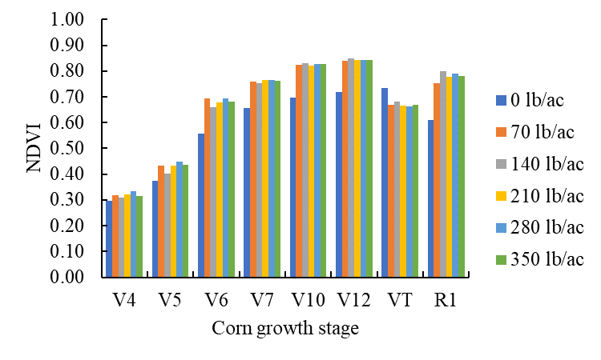
Site 1
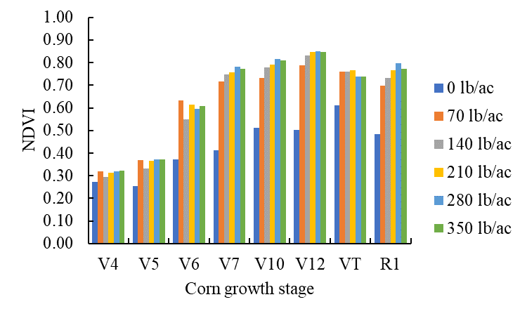
Site 2

