Corn Nematode Management Update
Zane Grabau, Extension Nematologist: zgrabau@ufl.edu
- Corn nematode management options: 1. Nematicide application, 2. Crop rotation
Conventional non-fumigant nematicides labelled for use in corn
 |  | Nematicide  (common name) | Maximum Single Application Rate² | Application method
Granular Nematicides | Counter 20G  (terbufos) |  | 6 oz/1000 ft of row. (4.9-6.5 lb/acre, depending on row spacing) | In-furrow
 | Mocap 15G  (ethoprop) |  | Broadcast: 40 lbs/acre.  Banded: 1 lb per 1000 ft of row (10–26.6 lb/ac depending on spacing) | Broadcast or banded
Liquid Nematicide | Velum  (fluopyram) |  | 3-5 fl oz/acre (up to 13.7 oz total/year) | In-furrow  (Other in-season methods allowed)
 | Propulse¹ (fluopyram) |  | 8 fl. oz/acre (34.2 oz total/year) | In-furrow  (Other in-season methods allowed)
 | Averland FC (abamectin) |  | 6 fl. oz/acre | In-furrow
¹ Propulse also has prothioconazole fungicide. 8 oz Propulse roughly equivalent to 3 oz Velum
² Fumigants, such as Telone II are also labelled for field corn

- Nematicide efficacy: On average, Counter has been more effective than fluopyram products (Velum or Propulse). Limited testing with Averland FC.
Figure 1. Small plot field trial results from Hastings, FL. Means that share a letter are not significantly different.

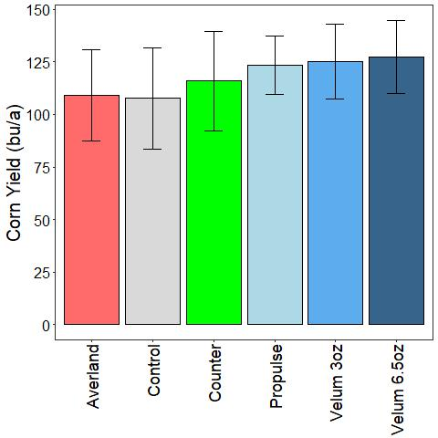
Figure 2. Corn grain yield in small plot trial at Citra, FL in 2022 for different nematicide treatments. Means were not significantly affected by nematicides.

- Reducing frequency of grasses will help manage nematodes in corn.

Figure 3. Forage corn yield following various rotation crops from small plot field trial in Citra, FL. CN is corn, MT-F is pearl millet with fertilizer, MT-U is millet without fertilizer, SSG is sorghum-sudangrass, and SH-H and SH-I are sunnhemp with or without residue incorporation.

