Evaluation of Biofertilizer technologies for improving phosphorus use efficiency in corn under Florida conditions.

Background:
Corn is an important crop in Florida, with approximately 80000 acres under cultivation in 2022. However, the heavy rainfall during the corn growing season and sandy soils that are prone to leaching result in poor fertilizer use efficiency, and the overuse of phosphorus (P) fertilizers can contaminate water bodies primarily through surface runoff and soil particle erosion. This can have negative impacts on both the environment and increase the cost of production. The solution to these problems is to improve nutrient use efficiency by the crop and thereby reducing fertilizer input rate. One potential remedy is the inclusion of biofertilizers in nutrient management systems, which aid in the mineralization of the unavailable forms of phosphorus in the soil and may reduce the requirement for P fertilization. This approach entails the introduction of a mixture of beneficial microorganisms, known as plant growth-promoting rhizobacteria (PGPR), into the soil to promote plant growth and P mineralization. This alternative and eco-friendly solution can help reduce the need for P fertilizer.

Objectives:
The objectives of this study are to observe the integrative effect of biofertilizers on corn grain yield and nutrient use efficiency and to identify whether a commercially available biofertilizer can be used to cut fertilizer rates. This study also aims to observe the response of variable rates of phosphorus applications on the yield of the corn crop.

Layout:

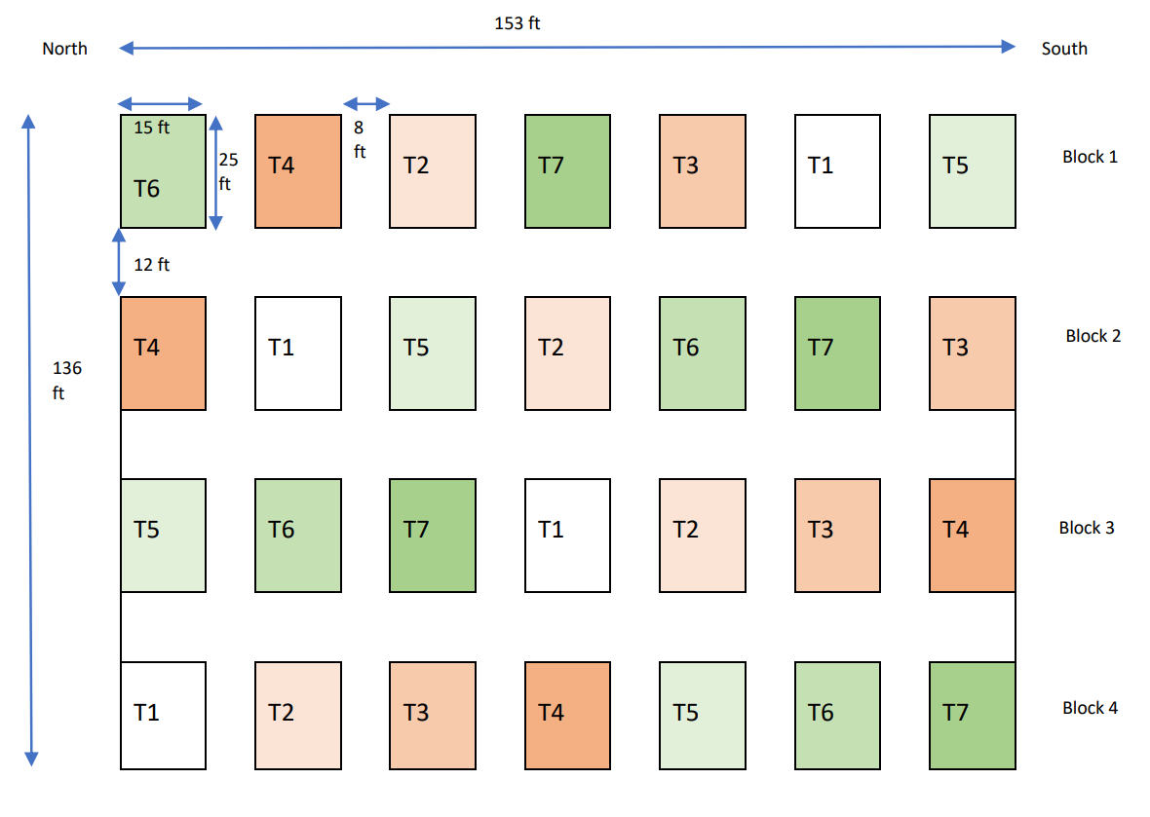
- T1- Control 0 P
- T2- Conventional P source (TSP) @ 50 lb/ac of P
- T3- Conventional P source (TSP) @ 100 lb/ac of P
- T4- Conventional P source (TSP) @ 150 lb/ac of P
- T5- Bio stimulant + TSP @ 50 lb/ac of P
- T6- Bio stimulant + TSP @ 100 lb/ac of P
- T7- Bio stimulant + TSP @ 150 lb/ac of P

Material and Methods:
The experiment was conducted during the 2023 growing season at the North Florida Research and Education Center Suwannee Valley (NFREC-SV) near Live oak, FL. The experiment consisted of treatments at variable rates of P, which were 0,50,100,150 pounds per acre with and without biofertilizer. The commercially available biofertilizer (Maizenp by BioLevel) containing Pseudomonas putida, Bacillus subtilis, Bacillus licheniformis, Bacillus amyloliquefaciens, Bacillus megaterium, Bacillus pumilus, Paenibacillus polymyxa and Azospirillium brasilense was used as a seed inoculant for this project. Triple superphosphate was used as phosphorus source, and it was banded at the planting.

Conclusion:
The integration of biofertilizer along with fertilizers has the potential to reduce the need P fertilizers in corn production. The study aims to identify the integrative effect of biofertilizers at different rates P application on grain yield and nutrient use efficiency. The findings of this study can be extremely useful for corn farmers in Florida, who may then be able to reduce their fertilizer input rates and support environmentally friendly farming methods.

Visuals from the experiment:

