Evaluation of Biofertilizers and Environmentally smart fertilizer technologies for improving nitrogen use efficiency in corn under Florida conditions.

Background:
Nitrogen has long been recognized as one of the finest agricultural input investments a farmer can make in terms of return on investment. Nitrogen is necessary for several physiological processes in the corn plant, all of which eventually lead to increased crop yields. However, the sandy soil characteristics and considerable rainfall in northern Florida restrict the effectiveness with which nitrogen may be used. As a result, farmers are compelled to use larger quantities of nitrogen fertilizer to keep their yields stable. In addition to lowering economic margins, excessive nitrogen fertilizer use has negative environmental effects, including nitrate leaching and runoff losses into the water bodies, which impact marine wildlife and the recreational value of the water. To solve this issue, the efficiency with which nitrogen is used must be increased, and one of the most practical ways to accomplish this objective is to include biofertilizers and ecologically smart fertilizer technologies (ESFTs) in the nutrient management system. This approach entails incorporating biofertilizers, such as N₂ fixing PGPRs, which contain a variety of bacteria from Acetobacter spp., Azotobacter spp., and Azospirillum spp. holds the promise of increasing soil N availability. Additionally, the use of ESFTs such as controlled release urea and nitrification inhibitors can better synchronize the nutrient release with uptake, thus reducing the leaching losses and water contamination while maintaining profitable yields.

Objectives:
The objectives of this study are to observe the integrative effect of ESFTs and biofertilizers along with various rates of nitrogen on corn grain yield and nutrient use efficiency and to identify whether commercially available ESFTs and biofertilizers can be used to cut fertilizer rates.

Layout:
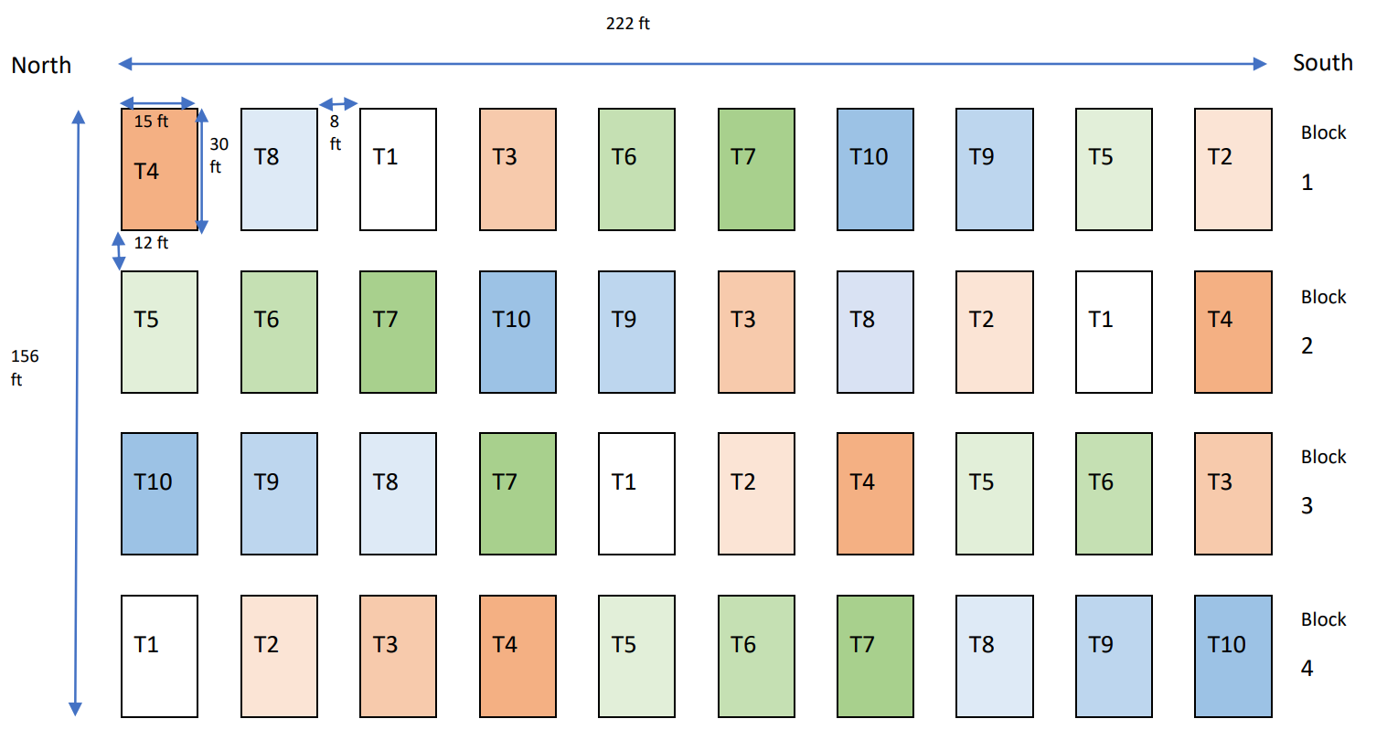
- T1 – Control 0 N
- T2 –Bio fertilizer + Granular urea @ 210 lb/ac of N (supplied in 7 splits from V4 to R1)
- T3 –Bio fertilizer + Granular urea @ 280 lb/ac of N (supplied in 7 splits from V4 to R1)
- T4 –Bio fertilizer + Granular urea @ 350 lb/ac of N (supplied in 7 splits from V4 to R1)
- T5 – Control release urea @ 210 lb/ac of N (banded at V4)
- T6 – Control release urea @ 280 lb/ac of N (banded at V4)
- T7 – Control release urea @ 350 lb/ac of N (banded at V4)
- T8 – Nitrate Inhibitor + urea @ 210 lb/ac of N (banded at V4)
- T9 – Nitrate Inhibitor + urea @ 280 lb/ac of N (banded at V4)
- T10 – Nitrate Inhibitor + urea @ 350 lb/ac of N (banded at V4)
Material and Methods:
The experiment was conducted during the 2023 growing season at the North Florida Research and Education Center Suwannee Valley (NFREC-SV) near Live Oak, FL. The experiment was conducted with variable rates of N, which were 0,210,280,350 pounds per acre, along with biofertilizer, controlled-release fertilizer, and nitrification inhibitors. This study used the commercially available bio-stimulant "Maize NP" supplied by Biolevel Limited, which comprises of a consortium of several bacterial species. Agxpress provided the nitrification inhibitor for the project, while Harrell's Profertilizer 43-0-0 was used as the Control release fertilizer. A starter dose of 30 lb/ac N was applied to all treatments except the control. In the case of biofertilizer treatments, the rest of N was applied as urea which was broadcasted in 7 splits from V4 to R1. The CRF and nitrification inhibitor were both incorporated into the soil all at once at the V4 stage.

Conclusion:
The integration of ESFTs and biofertilizers in nutrient management programs has the potential to reduce the need for N fertilizers in corn production. The study aims to identify the integrative effect of these products at different rates of N application on grain yield and whether they can reduce the amount of N fertilizer going into the soil. The findings of this study can be extremely useful for corn farmers in Florida, who may then be able to reduce their fertilizer input rates and support environmentally friendly farming methods.

Visuals from the experiment:

