Evaluation of Eight Kale Cultivars Grown Under an Open Shaded Structure in North Florida
Robert C. Hochmuth*, Wanda L. Laughlin, Natalie B. Parkell, and Betsy Martin
University of Florida, IFAS, Suwannee Valley Agricultural Extension Center, 7580 County Road 136 East, Live Oak, FL 32060-7434
Additional index words: hydroponic, protected agriculture, season extension
Footnote: This research was supported by Signature Supply (shade material), Double Thumb (coconut fiber/coir lay flat bags), and Johnny’s Selected Seeds (specialty crop seeds)
* Corresponding author; email: bobhoch@ufl.edu
Introduction
Families in the United States are increasing concerned about the nutritional quality of the food they are consuming. Kale (Brassica oleracea L. acephala group) is a “powerhouse” vegetable that is becoming increasingly popular for providing valuable nutrients to our diets. Due to increased demand, kale has become very popular at local markets such as farmer’s markets, restaurants, on-farm sales, and community supported agriculture (CSA) programs. This increased demand for locally grown vegetables has created new opportunities for farmers to establish a specialty crop enterprise. Kale is extremely hardy in many growing zones and, as a result, performs well nearly year-round in Florida. While various cultivars are still sensitive to the increased pressure of disease and insects that accompanies all summertime crops, many kale types can be grown, with appropriate strategies, nearly ten months out of the year, even in the southern zones of the state. Growers are using protected culture, such as a greenhouse, high tunnel, or even open shade structures to extend the typical marketing season. This trial was conducted to evaluate eight kale cultivars for yield and quality during the early summer months in North Florida using a hydroponic system under an open shade structure using lay-flat bags of coconut coir (Botanicoir “Dry” lay- flat bags, Double Thumb, Lake Wales, FL).
Materials and Methods
The trials were conducted under an open 40x40 ft. commercial shade structure (Atlas, Alapaha, GA). The structure was made from galvanized pipe and covered with a silver 30% polypropylene shade cloth (Signature Supply). The peak of the structure was 10 ft. tall. Kale was grown in Botanicoir “Dry” grow bags (coconut fiber/coir lay flat bags) arranged in randomized complete blocks with four replications. Plants were spaced six inches apart within the bags. Eight cultivars were selected from industry standards, new, and heirloom cultivars. The kale crop was established on February 16, 2015 using transplants that were seeded on January 14, 2015. Bags were arranged in double rows with 4-ft spacing between the centers of the double rows. There was a spacing of six inches between bags within each double row (Figure 1).
The crop was irrigated and fertilized using a hydroponic nutrient solution and low volume delivery system using half inch diameter poly tubing laid between bags in the row with 3 emitters per bag. The pH of the nutrient solution was set at 5.8 and the EC was set at 2.0 millimos. The nutrient solution provided approximately 150 ppm N, 50 ppm P, 200 ppm K, 48 ppm Mg, 220 ppm Ca, 60 ppm S, 3.5 ppm Fe, 0.3 ppm Cu, 1.3 ppm Mn, 0.3ppm Zn, 0.7 ppm B, and 0.05 Mo (Hochmuth and Hochmuth, 2008). Irrigation scheduling during the trial was set to provide 10-20% leaching at each irrigation event. The number and duration of the events increased as the crops grew, starting with three events per day at transplanting and increasing to six events per day at peak crop demand.
Insect pests and diseases were managed using a weekly scouting program and treatment as needed. Soft insecticide applications were used to manage insect pests. Plots were harvested 6 times beginning April 16 and ending July 10 (Figure 2). Weights were recorded (Table 1).
All data were analyzed using a mixed linear models approach as implemented in SAS PROC GLIMMIX (SAS Stat 14.2, SAS Institute, Cary, NC). Individual harvests were analyzed jointly using a repeated measures approach, where Entry and Harvest Date were fixed effects and Block and Entry x Block random effects. The residual variance structure was modeled and a heterogeneous compound symmetry structure found to be the best fitting one based on the AICC information criterion; this accounts for different standard errors at each harvest. Early and total yield were analyzed as a simple RCB, treating Block as the sole random effect. The simulation approach implemented in the LSMeans command of the above named SAS procedure was used to adjust the P-values for multiple comparisons.
Results and Discussion
‘Winterbor’ is the industry standard and performed very well in this trial for both early and total yield (Table 1). Similar total yields to ‘Winterbor’ were found with ‘Nero di Toscano’ and ‘Red Russian’. ‘Nero di Toscano’ has become a popular cultivar for juicing and making kale chips. Similar early yields, in comparison to ‘Winterbor’ were found with ‘Improved Dwarf Siberian’, ‘Red Russian’, and ‘Tronchuda’.
Kale is considered a cool season crop, but many markets demand as close to year-round production as possible. This trial, conducted under an open shade structure, showed several cultivars continued high production well into the mid-summer season in Florida. ‘Winterbor’, ‘Red Russian’, and ‘Nero di Toscano’ all had similar high yield on the July 10 harvest date (Figure 3).
Table 1. Early and total yield of eight kale cultivars grown in soilless culture under an open shade structure in Live Oak, FL. Yield by harvest date (lbs/plot)
Cultivar | Description | 16-Apr | 8-May | 22-May | 4-Jun | 19-Jun | 10-Jul | Early yield^{z} | Total yield^{y}
Blue Curled Scotch | curled  blue-green | 1.8 bc | 2.9 cd | 2.0 b | 1.9 bcd | 1.9 ab | 2.1 bc | 4.7 bc | 12.6 b
Improved Dwarf Siberian | curled leaf  dk green | 2.5 a | 3.8 abc | 2.2 b | 1.8 bcd | 1.7 b | 0.6 c | 6.3 ab | 12.6 b
Maribor | curled leaf- dk green pink ctr | 1.7 bc | 2.4 d | 1.5 b | 1.4 d | 1.6 b | 2.2 bc | 4.1 c | 10.8 b
Nero di Toscano | unique-savoyed  extra dk green | 1.3 c | 2.9 cd | 2.4 b | 2.8 abc | 3.4 a | 3.4 ab | 4.2 c | 16.2 ab
Red Russian | flat toothed  purple, dk green | 2.1 ab | 4.3 ab | 3.7 a | 3.1 ab | 3.5 a | 5.0 a | 6.4 ab | 21.8 a
Starbor | finely curled  dk blue green | 1.5 bc | 2.5 d | 1.5 b | 1.8 cd | 2.3 ab | 1.9 bc | 4.0 c | 11.5 b
Tronchuda | flat-rounded  green | 1.6 bc | 3.2 bcd | 2.4 b | 2.0 bcd | 2.0 ab | 2.1 bc | 4.9 abc | 13.5 b
Winterbor | curled, ruffled  blue-green | 2.0 ab | 4.7 a | 4.0 a | 3.4 a | 3.2 ab | 4.7 a | 6.7 a | 21.9 a
Standard error |  | 0.13 | 0.26 | 0.26 | 0.27 | 0.34 | 0.53 | 0.38 | 1.24

^{z} - Early yield was the first two harvests only, 16-April and 8-May
^{y}- Total yield was the total of all six harvests

Acknowledgements
The authors wish to thank Dr. Edzard van Santen, Director of the IFAS Statistical Consulting Unit, University of Florida, for conducting the statistical analysis.

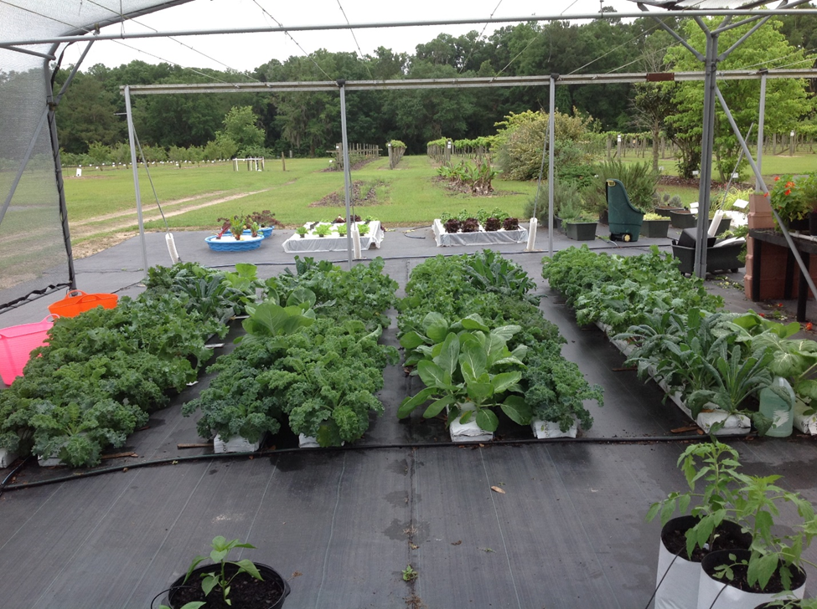
Figure 1. Kale cultivar trial conducted in lay-flat coconut coir bags under an open shade structure in Live Oak, FL.
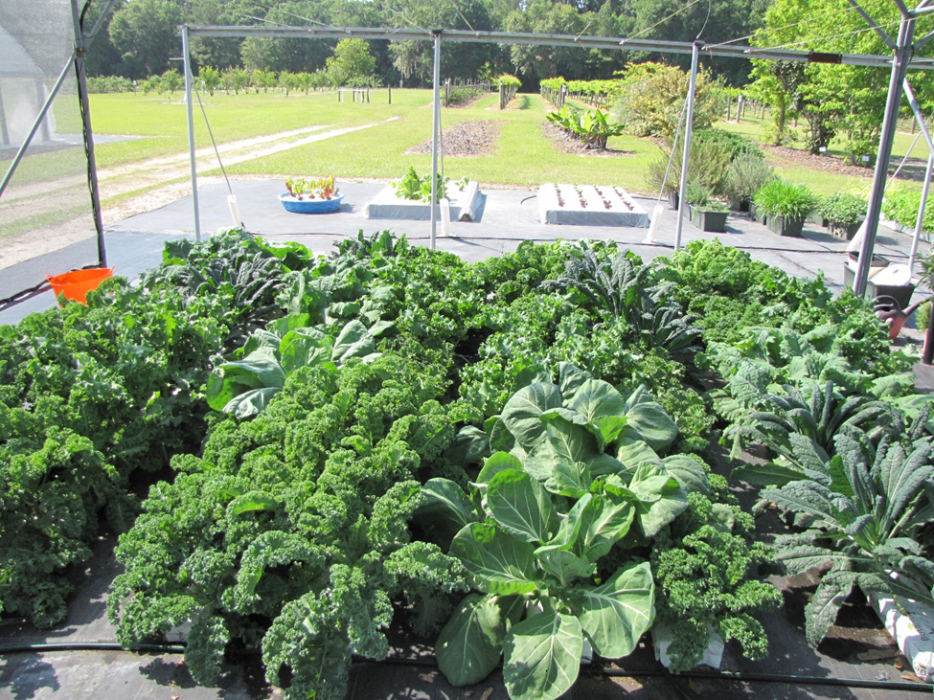
Figure 2. Kale cultivars ready for leaf harvesting procedure during the spring season of 2015 in Live Oak, FL

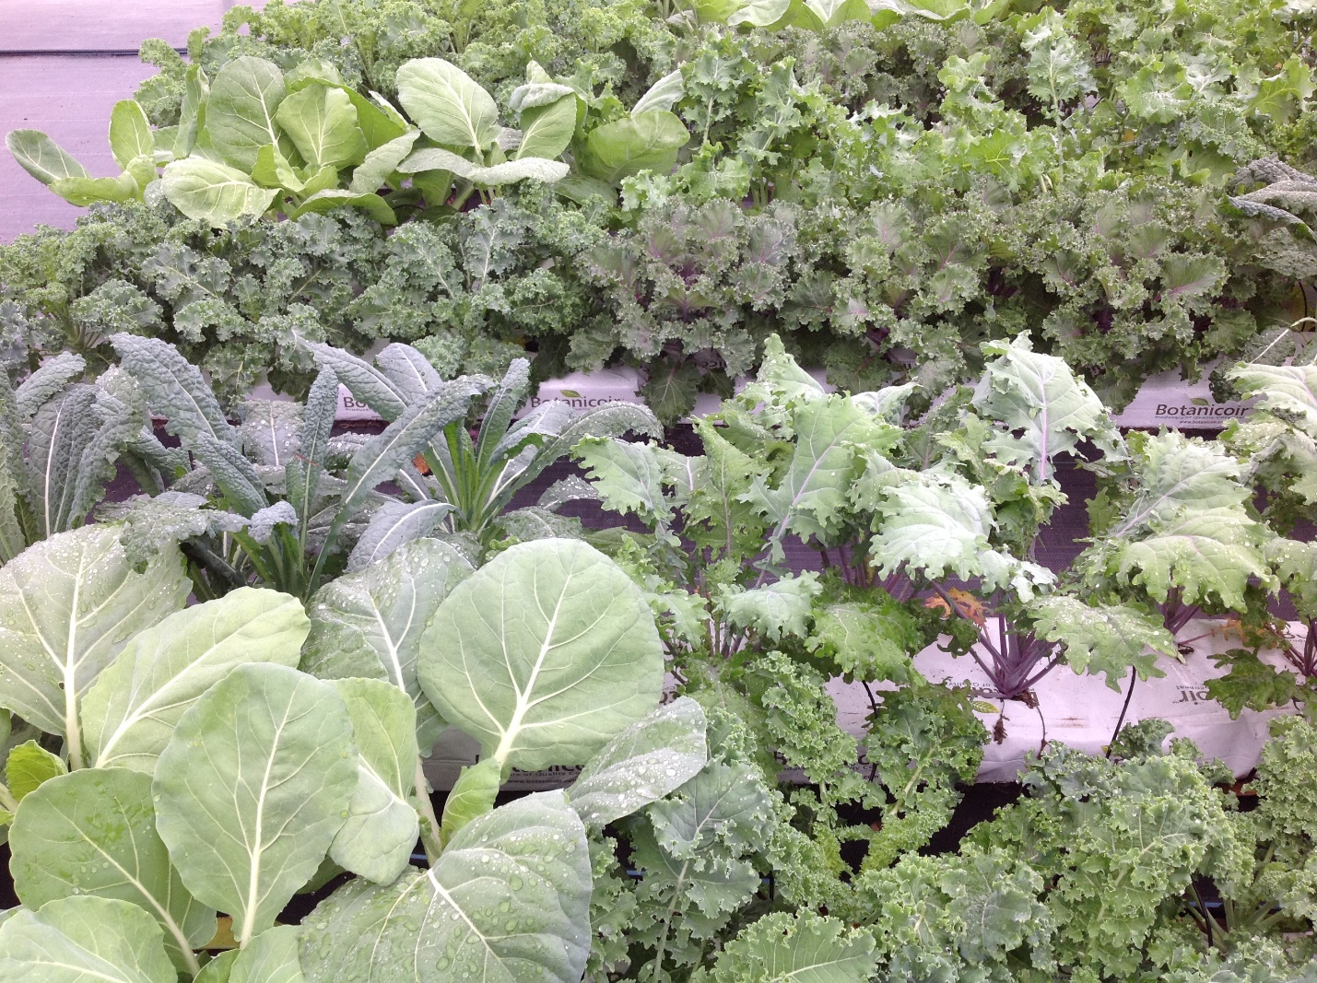
Figure 3. Kale cultivars used in 2015 cultivar trial exhibiting a wide range of leaf texture and color.

