Evaluation of Five Spinach Cultivars in Soilless Culture Under High Tunnel versus Open Shade Structures
Robert C. Hochmuth*, Wanda L. Laughlin, Natalie B. Parkell, and Betsy Martin
University of Florida, IFAS, North Florida Research and Education Center- Suwannee Valley, 7580 County Road 136 East, Live Oak, FL 32060-7434
Additional index words: hydroponic, protected agriculture, season extension
Note: This research was supported by funding from Florida Department of Agriculture and Consumer Services (FDACS) Specialty Crops Block Grant
* Corresponding author; email: bobhoch@ufl.edu
Introduction
Driven by fresh-market use, the consumption of spinach (Spinacia oleracea) has been on the rise in the United States. This specialty crop is gaining in popularity within the local foods movement in the United States emphasizing farm-to-table freshness and nutrient density, and as a result, Florida protected agriculture producers are hoping to capture that consumer demand.
In Florida, the in-ground planting season for spinach in North and Central Florida is from September through March. Southern Florida’s in-ground spinach season is recommended for October through February. Growers utilizing protected culture, including high tunnels and open shade structures have the added ability to extend those seasons in either direction of the typical planting and harvesting times. Florida has significant potential for increased soil or hydroponic crop production due to the mild climate, long growing season, and proximity to large markets. However, the mild climate also presents some unique challenges for Florida growers, including high pest pressure, high humidity, and high temperatures. Florida growers need research-based production information developed for the unique growing conditions to keep them on top of this fast growing specialty crops industry. One of the highest priority areas for information needs, as voiced by growers, is for new and more adapted crop cultivars and new crops that can expand the marketing opportunities and extend the production season. This trial was conducted to evaluate the performance of five spinach cultivars using a trough system filled with composted pine bark under both a high tunnel (hoop house) and an open shade structure at the North Florida Research and Education Center- Suwannee Valley in Live Oak, FL.
Materials and Methods
Above ground troughs were placed in a 20 ft. x 40 ft. commercial open side shade structure (Atlas, Alapaha, Ga.) (Figure 1). The structure was made from galvanized pipe and covered with a 30% silver shade cloth. The above ground troughs were 5 feet long and 2 feet wide. One trough was one plot. Plants were spaced in a 4 x 4-inch arrangement within each plot resulting in 60 plants per plot. In-ground troughs were constructed within a simple unheated 20 ft. x 40 ft. high tunnel (hoop house) with single layer plastic cover, with side and end walls that can be opened (Figure 2). Aluminet shade material (30% shade) was placed over the plastic covering. In-ground trough dimensions were 30 ft. x 2 ft. and 15 inches deep. The 30 ft. in-ground troughs were divided into 5 plots with 1 ft. spacing between each plot (Fgure 3). Plants were spaced in a 4 x 4-inch arrangement resulting in 60 plants per plot (Figure 4). Spinach was grown in plots arranged in a randomized complete block design with three replications in each structure (shade structure and high tunnel).
Media used was 100% aged and composted pine bark. The composted pine bark was obtained from a local source (Georgia Florida Mulch, Perry, FL). The pine bark was composted and aged for over ten years. It is important that the pine bark be well composted for successful use as a soilless media. Five cultivars were selected from industry standards and new cultivars. The spinach crop was established on February 22 and 23, 2016 using transplants that were seeded on January 21, 2016.
The crop was irrigated and fertilized using a hydroponic nutrient solution and low volume delivery system using drip tape. Two rows of John Deere Ro-Drip tape with 4-inch emitter spacing were placed on the tops of each trough and secured in position on the surface on the pine bark with metal nursery cloth staples. The pH of the nutrient solution was set at 6.2-6.5 and the EC was set at 1.8 millimos. The nutrient solution provided approximately 120 ppm N, 50 ppm P, 200 ppm K, 48 ppm Mg, 220 ppm Ca, 60 ppm S, 3.5 ppm Fe, 0.3 ppm Cu, 1.3 ppm Mn, 0.3 ppm Zn, 0.7 ppm B, and 0.05 ppm Mo (Hochmuth and Hochmuth, 2015). Initial N was set at 100 ppm for young plants then raised after two weeks to 120 ppm. The number and duration of irrigation events increased as the crops grew, starting with three short events per day at transplanting and increasing to six events per day at peak crop demand. Irrigation scheduling during the trial was set to provide 10-20% leaching at each irrigation event (Hochmuth, et al., 2015).
Insect pests were managed using a weekly scouting program and treatment as needed. Plots under the high tunnel were harvested 11 times staring March 9, 2016 thru May 11, 2016. Plots under the shade structure were harvested 6 times from April 16, 2016 thru May 11, 2016. Leaves were harvested at a small to medium size, somewhat larger than baby spinach leaves, but smaller than fully mature leaves (Figure 5). Marketable weights, unmarketable weights, and tip burn ratings were recorded. Tip burn ratings were made three times during the season (0 = none, 5 = high). Data is presented in the tables periods during the season identified as ‘early’, ‘middle’, or ‘late’ ‘Early’ harvests included harvests dates, March 9, 13, 16, and 21; the ‘middle’ harvests were from March 29, and April 5, 11, 18, and ‘late’ harvests were from April 27, and May 11, 15.
Results and Discussion
Most cultivars performed in a similar manner as related to early marketable yield in both the open shade and high tunnel systems (Table 1). There were no statistical differences found among the cultivars in the high tunnel. However, ‘Flamingo’ had higher yield than ‘Space’ in the open shade system, but all other cultivars were not statistically different from either ‘Flamingo’ or ‘Space’. No differences were found among cultivars for middle season yield in either the open shade or high tunnel. For late season yield, there was no statistical difference found among cultivars under the open shade system. However, significant differences were found in late season yields in the high tunnel. Late season high tunnel yields were highest for ‘Corvair’, ‘Space’, and ‘Reflect’. The lowest late season yield in the high tunnel was found in ‘Flamingo’. Total seasonal yield was similar for all cultivars under the open shade system, whereas all cultivars were similar under the high tunnel, with the exception of ‘Flamingo’ which was lower than all other cultivars.
Recording unmarketable yields was very useful in assessing quality differences among cultivars and differences between structures used. There were essentially no unmarketable yields recorded in the first four harvests, however, unmarketable leaves began to appear after the first four harvests under the open shade system (Table 2). Under the open shade system, ‘Flamingo’ consistently had the lowest unmarketable yields while all other cultivars were similar. Overall unmarketable yields under the high tunnel were very low for the entire season and there were no significant differences among cultivars.
Tip burn overall in this trial was very low until the late season harvests 9-11 (Table 3). The tip burn ratings for all cultivars under the open shade system were very low and no significant differences were found among any of the cultivars. Tip burn ratings were relatively low for most cultivars under the high tunnel, however, ‘Corvair’ had a significantly higher level of tip burn than all other cultivars late in the season.
Observations were made on leaf color during the season (data not reported here). There were moderate differences noted in leaf color between cultivars. ‘Space,’ ‘Reflect’, and ‘Corvair’ had somewhat lighter green leaf color; and ‘Flamingo’ and ‘Gazelle’ typically had darker green leaves in comparison to each other. However, all cultivars had very acceptable leaf color for the market.
Conclusions
This trial has demonstrated the usefulness of protected agriculture systems for growing high quality spinach for an extended season with 11 harvests in the high tunnel. The five cultivars evaluated in this trial performed in a very similar manner as related to total marketable yield whether using an open shade or high tunnel system. In terms of total season marketable yield, the only statistical difference was for ‘Flamingo’ which had lower yield than all other cultivars when grown under the high tunnel. In terms of unmarketable yield, only minor differences were found, but ‘Flamingo’ typically had lower unmarketable yields under the open shade system. Only ‘Corvair’ had other quality problems with tip burn late in the season under the high tunnel.
Although, both production structures produced high quality spinach, the high tunnel produced much higher spinach yields (approximately three times the yield) over the course of the season and typically had much higher quality spinach than under the open shade system. The high tunnel required harvesting of the spinach much sooner resulting in 11 harvests under the high tunnel and only six harvests under the open shade structure for the same period of time. All five cultivars had very high yield and excellent quality under the high tunnel. ‘Flamingo’ tended to have lower total yield under the high tunnel, but had very low unmarketable yield.

Tables
Table 1. Marketable yield of five spinach cultivars grown under an open shade structure and high tunnel in Live Oak, FL.

 |  | Shade Structure |  |  | High Tunnel
Season | Cultivar | lbs/plot |  |  | lbs/plot
Early^{z} | Corvair | 2.3 | ab^{y} |  | 4.5 | a
Early | Flamingo | 3.3 | a |  | 4.9 | a
Early | Gazelle | 3.0 | ab |  | 4.3 | a
Early | Reflect | 2.4 | ab |  | 4.5 | a
Early | Space | 2.1 | b |  | 4.5 | a
Level of significance |  | * |  |  | NS
Middle | Corvair | 1.3 | a |  | 7.4 | a
Middle | Flamingo | 1.6 | a |  | 6.3 | a
Middle | Gazelle | 1.8 | a |  | 6.7 | a
Middle | Reflect | 1.9 | a |  | 6.5 | a
Middle | Space | 0.9 | a |  | 7.1 | a
Level of significance |  | NS |  |  | *
Late | Corvair | 1.1 | a |  | 6.1 | a
Late | Flamingo | 0.4 | a |  | 1.9 | c
Late | Gazelle | 1.6 | a |  | 5.0 | b
Late | Reflect | 1.7 | a |  | 5.6 | ab
Late | Space | 0.9 | a |  | 6.6 | a
Level of significance |  | NS |  |  | *
Total | Corvair | 4.7 | a |  | 18.0 | a
Total | Flamingo | 5.3 | a |  | 13.0 | b
Total | Gazelle | 6.4 | a |  | 16.0 | a
Total | Reflect | 6.0 | a |  | 16.6 | a
Total | Space | 3.8 | a |  | 18.3 | a
Level of significance |  | NS |  |  | *
^{z} ‘Early’ harvests included the first 4 harvests, dates, March 9, 13, 16, and 21; the ‘middle’ harvests were harvests 5-8 from March 29, and April 5, 11, 18, and ‘late’ harvests were harvests 9-11from April 27, and May 11, 15.
^{y} Means with the same letter within a column are not significantly different (NS), Means with different letters are significantly different at the 5% level of significance (*).

Table 2. Weight of unmarketable spinach leaves from three parts of the season in both open shade and high tunnel systems.

 |  | Shade Structure |  |  | High Tunnel
Season | Cultivar | lbs/plot |  |  | lbs/plot
Early^{z} | Corvair | 0 |  |  | 0
Early | Flamingo | 0 |  |  | 0
Early | Gazelle | 0 |  |  | 0
Early | Reflect | 0 |  |  | 0
Early | Space | 0 |  |  | 0
Level of significance |  | NS |  |  | NS
Middle | Corvair | 0.9 | ab^{y} |  | 0.0 | a
Middle | Flamingo | 0.5 | c |  | 0.1 | a
Middle | Gazelle | 0.8 | abc |  | 0.0 | a
Middle | Reflect | 0.7 | bc |  | 0.1 | a
Middle | Space | 1.1 | a |  | 0.0 | a
Level of significance |  | * |  |  | NS
Late | Corvair | 2.7 | a |  | 0.4 | a
Late | Flamingo | 0.2 | b |  | 0.0 | a
Late | Gazelle | 2.0 | a |  | 0.1 | a
Late | Reflect | 2.0 | a |  | 0.2 | a
Late | Space | 2.6 | a |  | 0.1 | a
Level of significance |  | * |  |  | NS
Total | Corvair | 3.5 | a |  | 0.4 | a
Total | Flamingo | 0.7 | b |  | 0.1 | a
Total | Gazelle | 2.7 | a |  | 0.1 | a
Total | Reflect | 2.7 | a |  | 0.3 | a
Total | Space | 3.7 | a |  | 0.2 | a
Level of significance |  | * |  |  | NS
^{z} ‘Early’ harvests included the first 4 harvests, dates, March 9, 13, 16, and 21; the ‘middle’ harvests were harvests 5-8 from March 29, and April 5, 11, 18, and ‘late’ harvests were harvests 9-11from April 27, and May 11, 15.
^{y} Means with the same letter within a column are not significantly different (NS), Means with different letters are significantly different at the 5% level of significance (*).

Table 3. Tip burn ratings for five spinach cultivars from three parts of the season in both open shade and high tunnel systems.
 |  | Shade Structure |  |  | High Tunnel
Season | Cultivar | Avg. |  |  | Avg.
Early^{z} | Corvair | 0 |  |  | 0
Early | Flamingo | 0 |  |  | 0
Early | Gazelle | 0 |  |  | 0
Early | Reflect | 0 |  |  | 0
Early | Space | 0 |  |  | 0
Level of significance |  | NS |  |  | NS
Middle | Corvair | 0.0 | a^{y} |  | 0.4 | a
Middle | Flamingo | 0.0 | a |  | 0.2 | a
Middle | Gazelle | 0.0 | a |  | 0.0 | a
Middle | Reflect | 0.0 | a |  | 0.0 | a
Middle | Space | 0.0 | a |  | 0.0 | a
Level of significance
Late | Corvair | 0.3 | a |  | 1.5 | a
Late | Flamingo | 0.0 | a |  | 0.0 | b
Late | Gazelle | 0.3 | a |  | 0.5 | b
Late | Reflect | 0.0 | a |  | 0.3 | b
Late | Space | 0.2 | a |  | 0.5 | b
Level of significance |  | * |  |  | NS
Total | Corvair | 3.5 | a |  | 0.4 | a
Total | Flamingo | 0.7 | b |  | 0.1 | a
Total | Gazelle | 2.7 | a |  | 0.1 | a
Total | Reflect | 2.7 | a |  | 0.3 | a
Total | Space | 3.7 | a |  | 0.2 | a
Level of significance |  | * |  |  | NS
^{z} ‘Early’ harvests included the first 4 harvests, dates, March 9, 13, 16, and 21; the ‘middle’ harvests were harvests 5-8 from March 29, and April 5, 11, 18, and ‘late’ harvests were harvests 9-11from April 27, and May 11, 15.
^{y} Means with the same letter within a column are not significantly different (NS), Means with different letters are significantly different at the 5% level of significance (*).

References
Hochmuth, George, J. and Robert C. Hochmuth. 2015. Nutrient Solution Formulation for Hydroponic (Perlite, Rockwool, NFT) Tomatoes in Florida. University of Florida Institute of Food and Agricultural Sciences, Gainesville, FL. http://edis.ifas.ufl.edu/cv216

Hochmuth, Robert C., Natalie B. Parkell, Wanda L. Laughlin, and Sean C. Rider.2015. “Water and Nutrient Management Guidelines for Greenhouse Hydroponic Vegetable Production in Florida” University of Florida Institute of Food and Agricultural Sciences, Gainesville, FL. http://edis.ifas.ufl.edu/hs1274

Pictures (Figures)
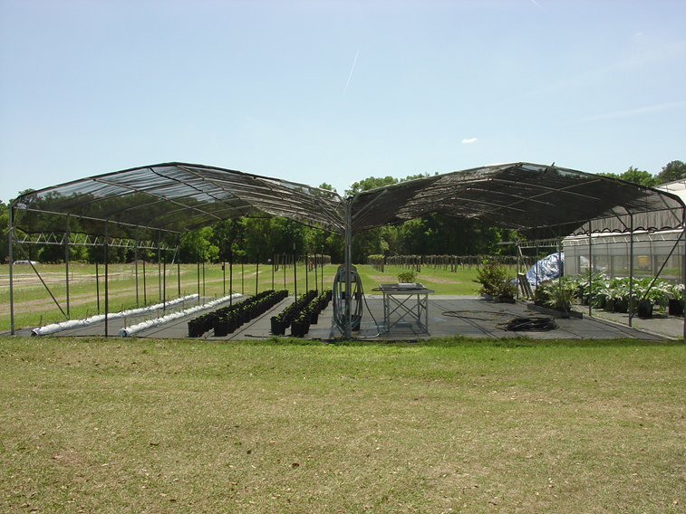
Figure 1. Open shade structure used in spinach trial in Live Oak, FL.
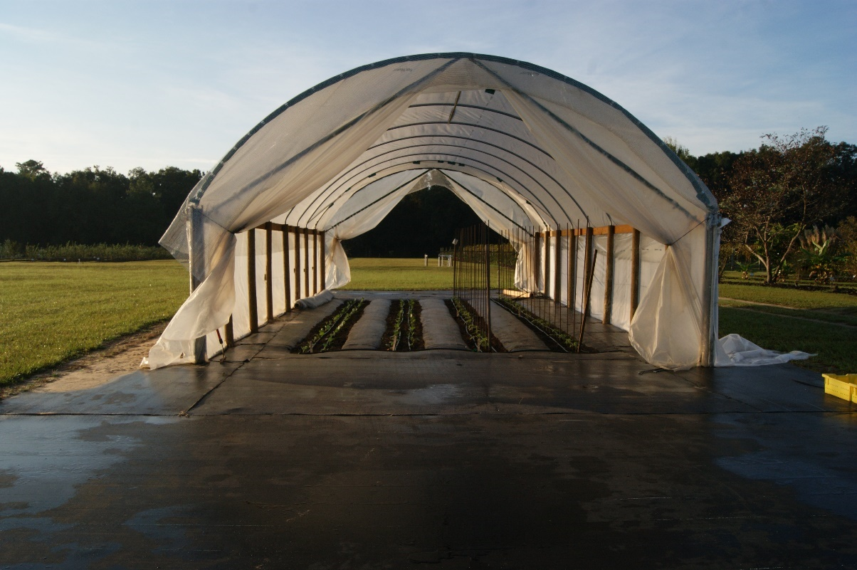
Figure 2. High tunnel used for spinach trial in Live Oak, FL.

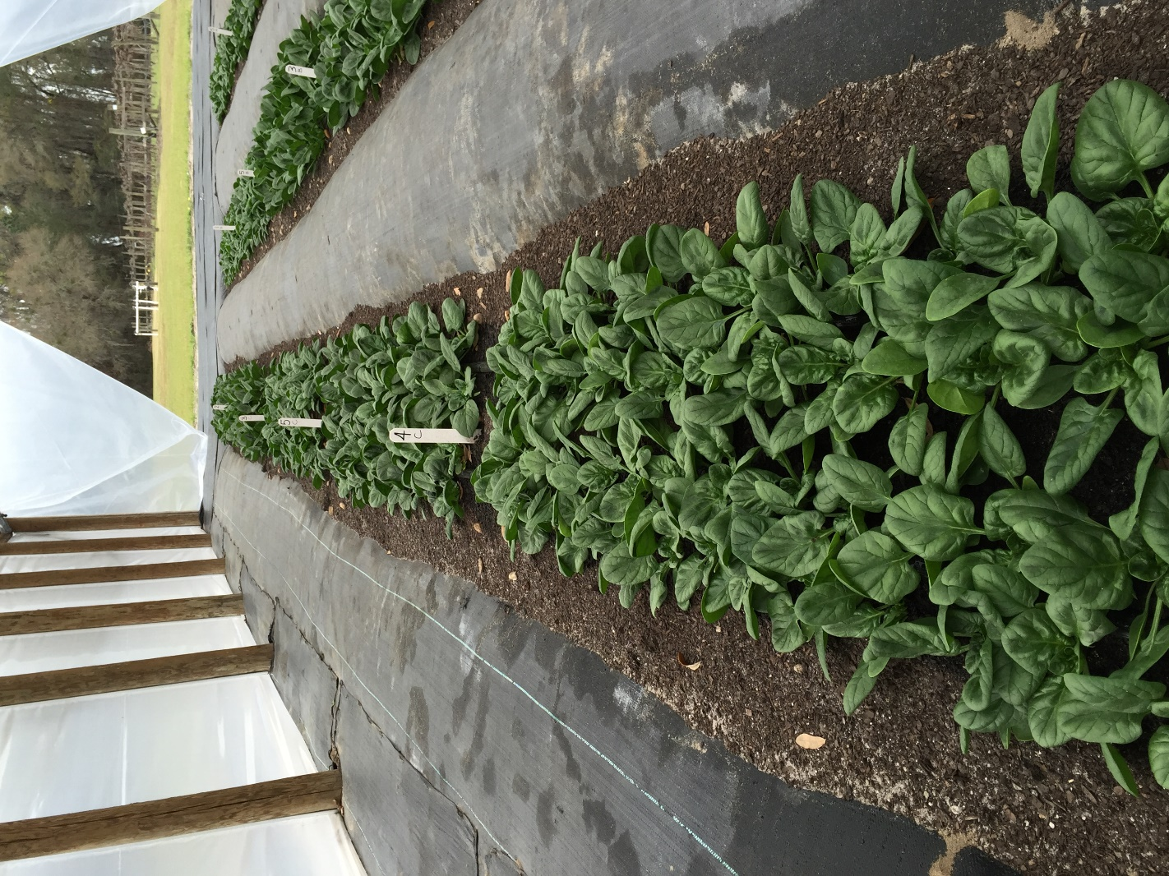
Figure 3: Spinach cultivars grown in plots five feet long in troughs under high tunnel in Live Oak, FL
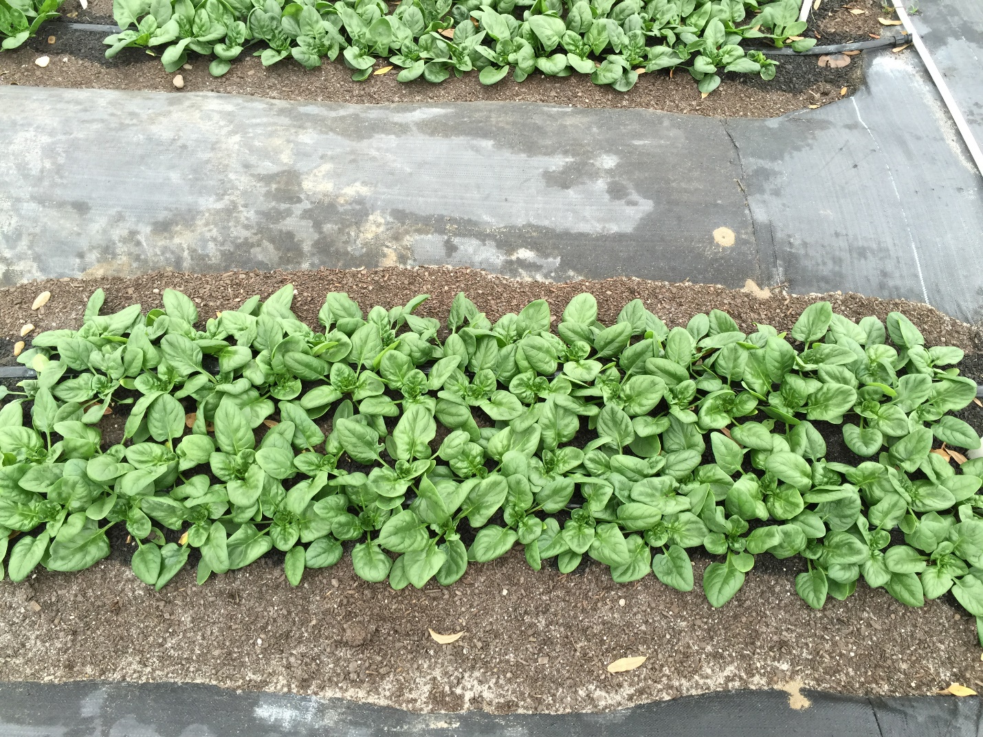
Figure 4 Plants arranged in a 4 inch x 4 inch spacing within a plot of spinach cultivars under a high tunnel in Live Oak, FL

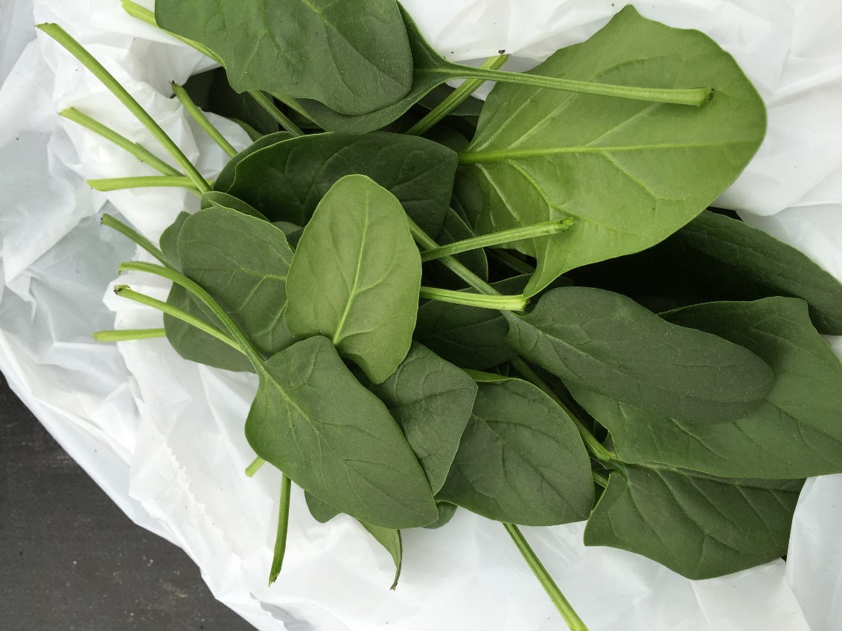
Figure 5. Spinach harvested from troughs under high tunnel at Live Oak, FL

