Welcome to this week’s issue of our 2024 season UF/IFAS Extension Suwannee Valley Watermelon Crop Update. These updates will be summarized by Bob Hochmuth, Regional Specialized Extension Agent- Vegetable Crops, with input from Suwannee Valley Extension Agents: Mark Warren (Levy), Tyler Pittman (Gilchrist), Tatiana Sanchez (Alachua), Luke Harlow (Bradford), Dan Fenneman (Madison), Keith Wynn (Hamilton), Emily Beach (Lafayette), Jim Devalerio (Union), De’Anthony Price (Jefferson), Raymond Balaguer(Suwannee), Kevin Athearn (RSA-Agri- business), Shivendra Kumar (RSA-Agronomic Crops), Jay Capasso (RSA- Water Resources), and Bob H. covering vacant Columbia County position.
If you know someone who wants to be added to this weekly notice, contact your Extension Agent or Mark Warren (352-949-8288) if you want to be added to the regional watermelon group text app.

We have initiated a more formal way to support our watermelon growers with a rapid diagnostics system through Suwannee Valley Regional and County Extension Agents. This industry-funded program allows Extension Agents to submit and pay for watermelon grower’s plant disease and other diagnostic samples. This SV Rapid Diagnostic Watermelon Program will help us to get quicker diagnostic results, helping to give early alerts to everyone, and not have to charge the growers directly. Plant disease samples are typically $40 and leaf tissue analyses are typically $20. We are currently extending our solicitation of those industry reps interested in sponsoring this effort. The past year’s sponsorships have ranged from $200 to $2,000 per company. Sponsors will be recognized every week beginning this week. Those interested in being added as a sponsor can contact Bob Hochmuth at bobhoch@ufl.edu or 386-288-6301.

Current 2024 sponsors of our Watermelon Rapid Diagnostics Program include Valdosta Plant Company, Mayo Ag Services, Gowan USA, Harrell’s Fertilizer, Triest Ag, and Syngenta Crop Protection. Others are still welcome to join.

Topics this week include: Paper mulch field day, Fusarium wilt symptoms starting, and, squash bugs and thrips are active.

Field Day Reminder this Tuesday
Is Nutsedge a Pain in Your Plastic?
Paper Mulch Field Day- Tuesday, April 2nd, 11:30 am to 1:00 pm
Agenda
11:30- Arrival/ Lunch
12:00-1:30 Self-led field walk (Extension staff and WestRock reps in the field)
12:00 Discussion led by Bob Hochmuth

Come and join your UF/IFAS Extension team and WestRock (paper company) to view an on-farm paper mulch trial at Loran Brookins’ farm in Chiefland on April 2, 2024, from 11:30-1:00. Mr. Brookins, one of eight area watermelon farmers in the Suwannee Valley who are participating in this trial. This research phase of the trial is allowing us to observe possible benefits of the paper mulch, such as, preventing nutsedge from poking through the mulch, warmer morning bed temps from 1-5 degrees and a visible increase in plant size, and no labor needed to pull plastic at the end of the season. These observations have been made in multiple fields by comparing paper and plastic beds that are side by side. The paper mulch is a heavier product, and the rolls have less linear feet of material per roll than plastic. We are inviting you to come look and provide your own unbiased opinions about this project. WestRock, the developer of the paper mulch product, will be on hand to answer questions and address concerns. Hot dogs and hamburgers on the grill plus all the fixings, chips, and drinks Lunch will be provided by WestRock. Swing by, get a bite, and see new technological developments for watermelon farmers. This region is the first area in the world to have this product being tested on farms. Let your Extension Agent know if you plan to attend so we have enough food.
(Beth Cannon and Mark Warren, Levy County Extension)
When: Tuesday, April 2 11:30-1:30
Where: Loran Brookins Farm 12651 NW 50th Ave Chiefland
https://maps.app.goo.gl/WHvXUrpnUPAMadfo9

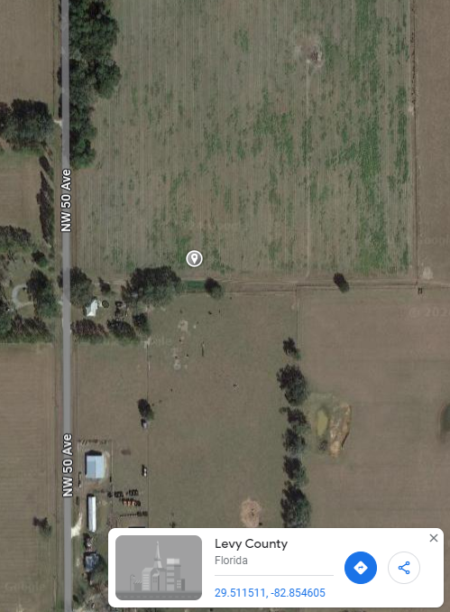

Note: Plastic mulch on left and paper mulch on right

Early season Fusarium wilt has arrived:
This past week began the first real sightings of Fusarium wilt symptoms. In many cases a few plants here and there, but in other cases a high percentage of plants in parts of fields have shown wilting. You may notice a runner or two starting to wilt but as the season progresses, the entire plant may succumb to the disease. Mild soil temperatures are favorable for the fungus to grow so in general, conditions will remain good for pathogen growth this week (disease incidence is maximum at around 80.6-84.2F). When soil temperatures increase, conditions are no longer favorable for the pathogen, but the infection has already occurred. As the demand for water increases as vines grow and fruit begin to set, you will notice more plants exhibiting symptoms resulting from the clogging of the vascular system responsible for transporting water. If you notice plants with low vigor, wilting during the hottest parts of the day and with a grayish-green appearance you can test in the field for Fusarium. Sample plants, including the plant’s crown area that are exhibiting these wilting symptoms (the crown area is around the soil line that separates roots from above-ground growth). Once you pull the plant, cut downward through the middle of the crown, and inspect the color of the vascular system. If the plant is infected, you will notice a brown or orangish discoloration along the vascular vessels at the crown, and if healthy, it will look whitish or light green. As you may know, there are no controls available for this disease after the crop is established. There are treatments (ex. Proline and Miravis Prime) at planting that research has shown to have some minor benefit in reducing infection, but those treatments are not effective at this stage of the season after infection is in full swing. If you suspect you have Fusarium and want confirmation, reach out to your local agent to submit a sample. Check page 33 of the UF/IFAS Watermelon Field Guide for more information.
Otherwise, we are still suggesting weekly chlorothalonil sprays unless very early planted field may be getting close to a Miravis Prime application for those choosing that program. Note, no bacterial spot, powdery mildew, or downy mildew have been detected or reported yet.
(Tatiana Sanchez-Jones and Bob Hochmuth)
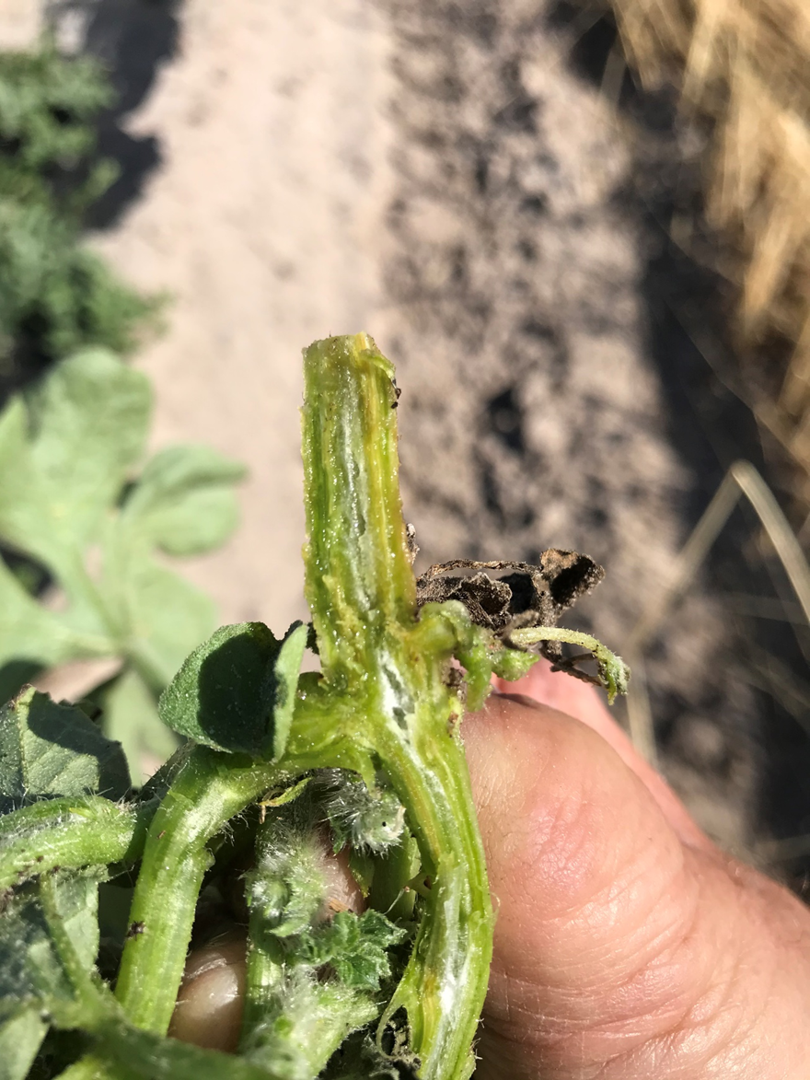

Weekly Insect Update:
Squash bugs (See pages 100-101 in your IFAS Watermelon Field Guide): During the last week, squash bugs were reported for the first time this season in the region. Most were still individual adults as opposed to mating pairs which tells us that the bugs are just now migrating from wooded areas outside the field perimeters into the fields. We encourage everyone to scout and detect them early. It is better to spray the borders earlier as they migrate in as opposed to having to spray the entire field potentially killing many beneficials as the pyrethroids recommended for use on squash bugs are hard on pollinators. (R. Hochmuth)
Thrips were out in full force across the region last week. These tiny yellowish/orange bullet shaped insects scratch on the surface of watermelon leaves and cause scarring (see photo below). Thrips can also feed in the blooms of watermelon. However, these insects rarely cause enough damage in watermelons to spray. These insects will also scratch on your skin and cause a mild itch as if you were being bitten by “no see-ums”. We mainly want everyone to be able to identify the damage of thrips feeding in the photo below. (R. Hochmuth)

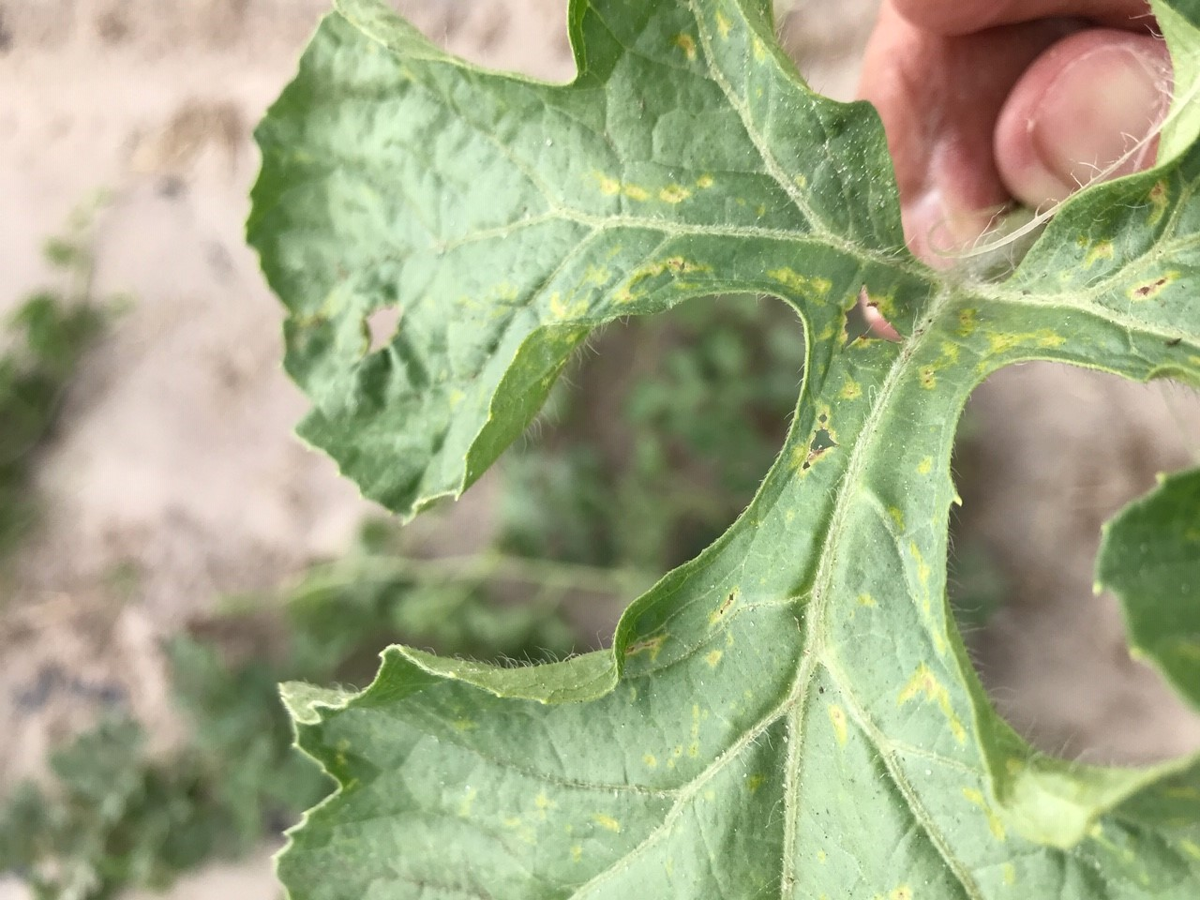

Petiole-sap testing service offered:
UF/IFAS County Extension agents will again be offering the weekly petiole-sap testing service for growers in their counties. All Extension agents in the Suwannee Valley have the equipment and expertise to conduct this service. We offer testing for nitrogen and potassium, which helps growers fine tune the fertigation events for frequency and amounts to be fertigated. We are ready to conduct petiole-sap testing when the vines are at least 12-15 inches long or more. Contact your county Extension agent to start this service. (Bob Hochmuth)

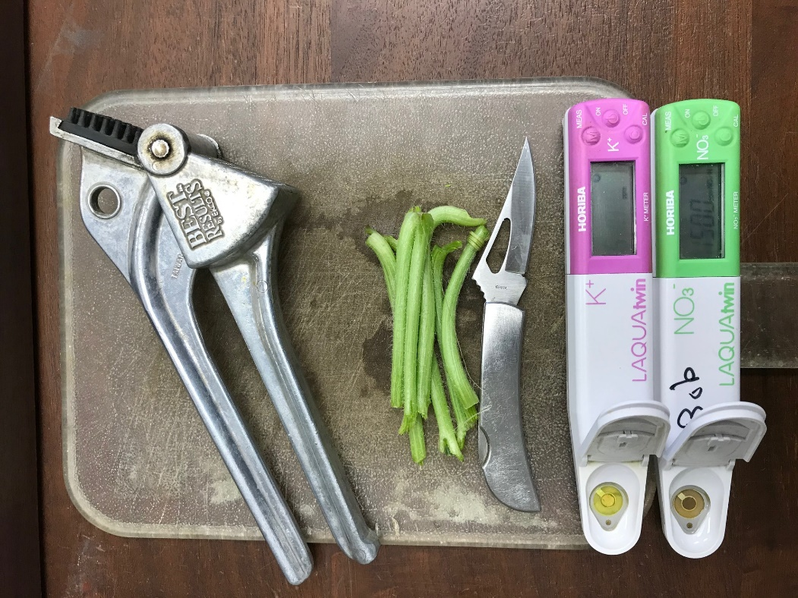

Hold the Date:
Hold the date April 18th for our Suwannee Valley Spring Twilight Watermelon Field Day at the farm of Adam Whitehurst where you will see topics on controlled release fertilizer use, irrigation automation, soil moisture sensors, grafted watermelons, and paper mulch all in one field. CEUs will be provided. Look for more details in next week’s update. (Extension Agent team)

