Welcome to our 2024 season’s weekly issue of our UF/IFAS Extension Suwannee Valley Watermelon Crop Update. These updates will be summarized by Bob Hochmuth, Regional Specialized Extension Agent- Vegetable Crops, with input from Suwannee Valley Extension Agents: Mark Warren (Levy), Tyler Pittman (Gilchrist), Tatiana Sanchez (Alachua), Luke Harlow (Bradford), Dan Fenneman (Madison), Keith Wynn (Hamilton), Emily Beach (Lafayette), Jim Devalerio (Union), De’Anthony Price (Jefferson), Raymond Balaguer(Suwannee), Kevin Athearn (RSA-Agri- business), Shivendra Kumar (RSA-Agronomic Crops), Jay Capasso (RSA- Water Resources), and Bob H. covering vacant Columbia County position.
If you know someone who wants to be added to this weekly notice, contact your Extension Agent or Mark Warren (352-949-8288) if you want to be added to the regional watermelon group text app.

We have initiated a more formal way to support our watermelon growers with a rapid diagnostics system through Suwannee Valley Regional and County Extension Agents. This industry-funded program allows Extension Agents to submit and pay for watermelon grower’s plant disease and other diagnostic samples. This SV Rapid Diagnostic Watermelon Program will help us to get quicker diagnostic results, helping to give early alerts to everyone, and not have to charge the growers directly. Plant disease samples are typically $40 and leaf tissue analyses are typically $20. We are currently extending our solicitation of those industry reps interested in sponsoring this effort. The past year’s sponsorships have ranged from $200 to $2,000 per company. Sponsors will be recognized every week beginning this week. Those interested in being added as a sponsor can contact Bob Hochmuth at bobhoch@ufl.edu or 386-288-6301.

Current 2024 sponsors of our Watermelon Rapid Diagnostics Program include Valdosta Plant Company, Mayo Ag Services, Gowan USA, and Harrell’s Fertilizer. Others are still welcome to join.

Is Nutsedge a Pain in Your Plastic?
Paper Mulch Field Day- Tuesday, April 2nd, 11:30 am to 1:00 pm
Come and join your UF/IFAS Extension team and WestRock (paper company) to view an on-farm paper mulch trial at Loran Brookins’ farm in Chiefland on April 2, 2024, from 11:30-1:00. Mr. Brookins, one of eight area watermelon farmers in the Suwannee Valley who are participating in this trial, has been most helpful in growing a very nice nutsedge field in his watermelon patch. We have all been there! While the plastic mulch looks like it needs a shave, the paper mulch is smooth as a baby’s bottom, and free of nutsedge. This research phase of the trial is allowing us to observe other possible benefits of the paper mulch, such as steadily warmer bed temps from 1-5 degrees and a visible increase in plant size, and no labor needed to pull plastic at the end of the season. These observations have been made in multiple fields by comparing paper and plastic beds that are side by side. The paper mulch is a heavier product, and the rolls have less linear feet of material per roll than plastic. We are asking for you to come look and provide unbiased opinions from the farming community for this project. WestRock, the developer of the paper mulch product, will be on hand to answer questions and address concerns. Lunch will be provided by WestRock and will be via food truck! Swing by, get a bite, take a gander and be on about your business. This region is the first area in the world to have this product being tested on farms. (Beth Cannon and Mark Warren, Levy County Extension)
When: Tuesday, April 2 11:30-1:00
Where: Loran Brookins Farm 12651 NW 50th Ave Chiefland
https://maps.app.goo.gl/WHvXUrpnUPAMadfo9

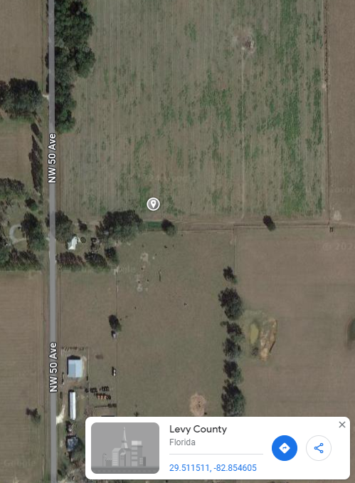

Note: Plastic mulch on left and paper mulch on right
Early season disease management:
The crops continue to generally look good right now. The early planted crops have vines well off of the plastic and are beginning to bloom. Without a specific disease problem being detected on a farm, we continue to recommend using a weekly Bravo or other chlorothalonil product schedule for this early part of the season, perhaps the first few sprays, while we can use chlorothalonil prior to fruit sizing stage. Banding sprays over the beds only while plants are small is very economical. However, our UF/IFAS lab has confirmed a couple of gummy stem blight infections in early planted transplants. Most cases are pretty limited and may not require initiating something like Inspire Super, but growers should assess whether the infections warrant something other than chlorothalonil. You certainly do not want to unnecessarily use those expensive targeted products. Our UF/IFAS lab has also confirmed isolated cases of Fusarium wilt which is no surprise and almost guaranteed here early in the season. I am also aware there has been confirmation of bacterial fruit blotch in a greenhouse, but the confirmation has not been through us at UF/IFAS and therefore, I don’t have much detail. Needless to say, you may want to check with your seed dealer of greenhouse transplant provider for details. These situations are generally very specific and very isolated and very few growers should be connected. (Bob Hochmuth)

Petiole-sap testing service offered:
UF/IFAS County Extension agents will again be offering the weekly petiole-sap testing service for growers in their counties. All Extension agents in the Suwannee Valley have the equipment and expertise to conduct this service. We offer testing for nitrogen and potassium, which helps growers fine tune the fertigation events for frequency and amounts to be fertigated. We are ready to conduct petiole-sap testing when the vines are at least 12-15 inches long. Contact your county Extension agent to start this service. (Bob Hochmuth)

