**Welcome to our 2023 season weekly issue of our UF/IFAS Extension Suwannee Valley Watermelon Crop Update. These updates will be summarized by Bob Hochmuth, Regional Specialized Extension Agent- Vegetable Crops, with input from Suwannee Valley Extension Agents: Mark Warren (Levy), Tyler Pittman (Gilchrist), Tatiana Sanchez (Alachua), Luke Harlow (Bradford), Jay Capasso (Columbia), Dan Fenneman (Madison), Keith Wynn (Hamilton), Emily Beach (Lafayette), Jim Devalerio (Union), De’Anthony Price (Jefferson), Bob Hochmuth (for vacant Suwannee position), Kevin Athearn (RSA-Agri- business), and Sudeep Sidhu (RSA- Water Resources).**

**If you know someone who wants to be added to this weekly notice, contact your Extension Agent or Mark Warren (352-949-8288) if you want to be added to the regional watermelon group text app.**

We have initiated a more formal way to support our watermelon growers with a rapid diagnostics system through Suwannee Valley Regional and County Extension Agents. This industry-funded program allows Extension Agents to submit and pay for watermelon grower’s plant disease and other diagnostic samples. This SV Rapid Diagnostic Watermelon Program will help us to get quicker diagnostic results, helping to give early alerts to everyone, and not have to charge the growers directly. **Sponsors of this program in 2023 to date include Harrell’s, TriEst Ag, Gowan USA, and Syngenta Crop Protection.**

**Those reps interested in sponsoring can contact Bob Hochmuth at** [**bobhoch@ufl.edu**](mailto:bobhoch@ufl.edu) **or 386-288-6301.**

**First Confirmation This Year of Powdery mildew:**

Late last week, powdery mildew was confirmed in the Suwannee Valley region. This discovery has been expected for a couple weeks now and perhaps has been delayed due to the early initiation of sprays for powdery mildew over the past couple weeks. If you are concerned about powdery mildew or have not already started sprays for powdery mildew, we are still suggesting rotating targeted products such as Procure or Quintec in combination with broad spectrum fungicides such as Mancozeb. Initial symptoms appear as circular yellow areas on the leaves. As the infection progresses, powdery growth of the fungus appears and can be seen initially on the underside of the leaves (see photo below and pages 36-37 in the IFAS Watermelon Field Guide). Eventually the “white powder” can be found on both surfaces of the leaves and stems as the tissue decays. (Tatiana Sanchez and Bob Hochmuth. Thanks to De Broughton, 6Gen Ag Services for detecting and submitting saples).

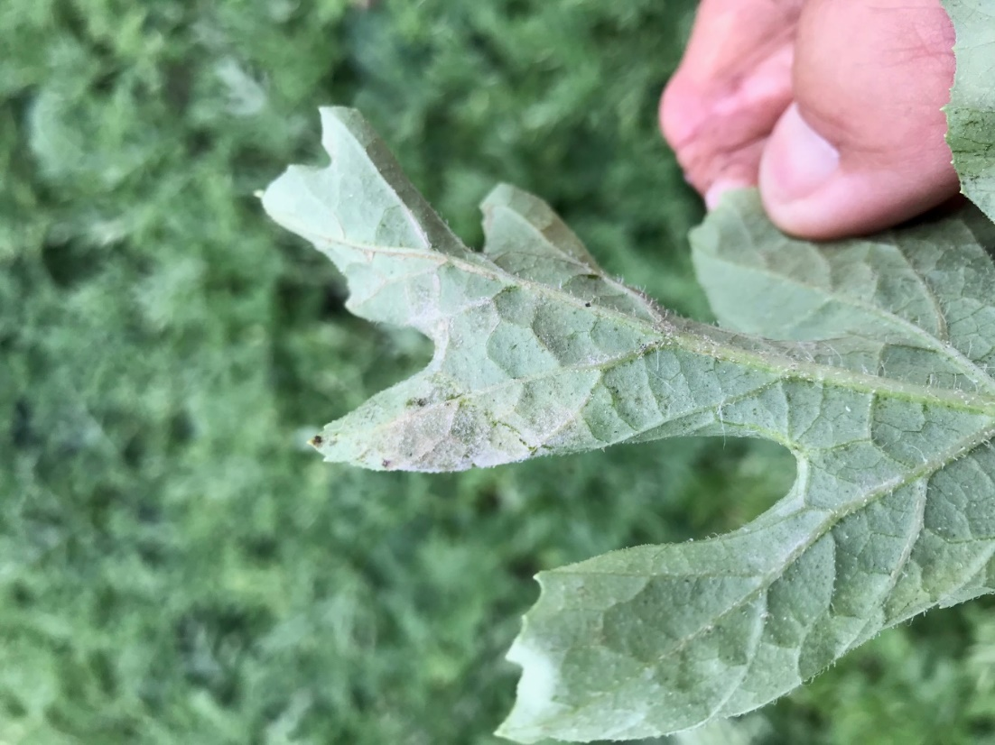

**Alternaria leaf spot and leaf blight**

Over the past two weeks, we have submitted several watermelon leaf samples from the Suwannee Valley region. Interestingly enough, one of the most common diseases detected in samples this spring has been *Alternaria* species (see pages 28-29 in your IFAS Watermelon Field Guide). In fact, the first downy mildew confirmation last week also had *Alternaria*, and most of the “ugly” lesions in that sample were actually *Alternaria* species, although both diseases were found in that sample. *Alternaria alternata* is the causal agent of Alternaria leaf spot and Alternaria leaf blight is caused by *Alternaria cucumerina*, though these disease names are sometimes used interchangeably. Alternaria sp. occur on many cucurbit crops including cantaloupe, watermelon, summer squash, cucumber, musk melon, etc. Alternaria has traditionally been considered a minor disease of watermelon. However, this year and the past couple years, Alternaria has become much more common and quite concerning in some fields. Symptoms begin on the upper surface of older leaves as very small yellow or tan spots that may be surrounded by light green or yellow halos or by a water-soaked area. The spots later grow up to ¾ of an inch (2 cm) in diameter and turn brown in color. Similar in appearance to gummy stem blight, the lesions are the source of spores spread primarily by the wind. Under severe infestations, the disease produces some defoliation and can lower yields. This fungus can survive on or in crop debris, with debris on the surface more likely to spread spores because of exposure to the wind. Volunteer cucurbit plants and weeds, such as balsam apple, are also sources of inoculum. When watermelons are planted successively for multiple harvest dates, older infested plants located upwind can also contribute to disease spread. Although wind is the main vehicle for spore dispersal, movement by rain splash and mechanical means can also occur. As in other fungal diseases, spores require moisture to germinate and enter the leaf tissue, while spore release from the plant is best achieved under dry conditions. The optimum temperature for infection is 68°F and in 3 to 12 days from spore penetration, the next group of spores is released. Fungicides typically used at this time of the season for diseases like gummy stem blight, which are also effective against *Alternaria* include: Inspire Super, Aprovia Top, and Miravis Prime. The older fungicide, Pristine, is also effective against *Alternaria*. (Bob Hochmuth, edited from UF/IFAS Plant Diagnostic Center)

**Spider Mites detected:**

We had two reports of early infestation of spider mites in the last week or so. This pest is more common in dry weather, so in areas that had been missing rainfall before last week, spider mites would not be a surprise. Unlike disease warnings, spider mites are generally very isolated and do not represent a call to action across the region, but keep up a good scouting program and be on the lookout for small patches of bronzed leaves typical of spider mite feeding. It is common to see these infestations along the edges of the fields where the mites may have moved in from weedy borders. See pages 104-105 in your UF/IFAS Watermelon Field Guide. (by Bob Hochmuth. Thanks to Steve Hoak, Ag Consulting Solutions, and De Broughton, 6Gen Ag Services for reporting these)

**Watermelon mosaic virus:**

We are seeing much more watermelon mosaic virus in fields as we approach harvest. The leaf symptoms are mottled greenish/grayish colors, especially on new leaves. This virus is transmitted by aphids and little can be done to stop this infection. So, do not spray for mosaic virus now thinking it will do some good. Usually, we see mosaic virus on the perimeters of fields due to aphids moving into the fields from hedgerows or wooded areas where they overwinter. See pages 44-45 in your IFAS Watermelon Field Guide). (Bob Hochmuth)

**Lightning Strike:**

One of the most interesting things we see in watermelon fields is the result of a lightning strike. The power of the electricity in a strike “etches” a line across the watermelon fruit through the vines laying on the fruit. In addition, we often see a hole melted or blown in the drip tape or plastic mulch. The first reported case was from last week. See the photo below and also refer to pages 66-67 in your IFAS Watermelon Field Guide. (Mark Warren and Bob Hochmuth)

