**Welcome to our 2023 season weekly issue of our UF/IFAS Extension Suwannee Valley Watermelon Crop Update. These updates will be summarized by Bob Hochmuth, Regional Specialized Extension Agent- Vegetable Crops, with input from Suwannee Valley Extension Agents: Mark Warren (Levy), Tyler Pittman (Gilchrist), Tatiana Sanchez (Alachua), Luke Harlow (Bradford), Jay Capasso (Columbia), Dan Fenneman (Madison), Keith Wynn (Hamilton), Emily Beach (Lafayette), Jim Devalerio (Union), De’Anthony Price (Jefferson), Bob Hochmuth (for vacant Suwannee position), Kevin Athearn (RSA-Agri- business), and Sudeep Sidhu (RSA- Water Resources).**

**If you know someone who wants to be added to this weekly notice, contact your Extension Agent or Mark Warren (352-949-8288) if you want to be added to the regional watermelon group text app.**

We have initiated a more formal way to support our watermelon growers with a rapid diagnostics system through Suwannee Valley Regional and County Extension Agents. This industry-funded program allows Extension Agents to submit and pay for watermelon grower’s plant disease and other diagnostic samples. This SV Rapid Diagnostic Watermelon Program will help us to get quicker diagnostic results, helping to give early alerts to everyone, and not have to charge the growers directly. **Sponsors of this program in 2023 to date include Harrell’s, TriEst Ag, Gowan USA, and Syngenta Crop Protection.**

**Those reps interested in sponsoring can contact Bob Hochmuth at** [**bobhoch@ufl.edu**](mailto:bobhoch@ufl.edu) **or 386-288-6301.**

**Internal quality assessments:**

In most cases, quality has been very good in the first and second cutting watermelons. In a few cases, there have been questions about internal quality related to “watery” tissue mainly isolated to the belly side of the watermelon fruit. The symptoms have been noticeable but overall, pretty mild. Perhaps the issue has been more prevalent on first cutting seeded fruit. The affected fruit seem to be the earliest set fruit and may not continue to appear in later fruit in the same field. This symptom is very different than when fruit pickup too much water and the entire fruit is full of water like we see after excessive rain or overirrigation. In those cases, those fruit will pop and split when you put a knife into the fruit. But, in the fruit we are seeing now, the fruit cut relatively normal, yet has this isolated mildly watery area in the rind and transition area inside the rind, but mainly on the belly side (See Photo 1 below). Although it is difficult to pinpoint the exact cause, we believe the symptom is related to the environmental conditions a couple weeks ago. There was a period to very high temperatures, high winds, low humidity, all resulting in very high evapotranspiration (ET) rates. The plants were pulling a lot of water to keep up with the high ET. This very high intake of water results in water mainly evaporating through the leaves and this reduces the internal root pressure. However, the high internal pressure also results in higher levels of water in the fruit also, with little ability to reduce that pressure through the watermelon fruit rind and waxy exterior. In other words, the fruit can’t evaporate out the water like the leaves can. A recent report from Dr. Gordon Johnson in 2017, described the same symptom and had a similar assessment of the cause. The article can be found at this link, (<https://sites.udel.edu/weeklycropupdate/?p=10982>). In that article Dr. Johnson notes the following: *“In this situation, water is still being translocated in the xylem but there is limited transpiration through the leaves. Watermelon fruits are still transpiring, but due to the nature of the fruit (thick rind, waxy surface); transpiration is lower than in leaf tissue, leading to water buildup in the fruit. At the same time solute accumulation has been reduced because foliage is compromised leading to cells full of water but with little sugar”.*

So, we do not believe this current situation is related to simply over-irrigation or heavy rainfall events. In fact, some fields with this symptom have been very well managed with irrigation. We do not support “turning off” the water as a way to cure this issue. It is much more complicated than that would suggest. During these days, turning off the water for even one day can result in severe wilting and much more severe damage as a result. You may consider following the soil moisture sensor data to guide a more conservative irrigation schedule daily, especially with rains predicted this week, but you should not turn the water off. Remember most of the root system is in the top 15 inches and plants will deplete available water in one day from the upper soil profile. (Bob Hochmuth and Mark Warren)

Photo 1. Symptoms of internal quality issues in belly area (bottom of photo). Photo by Bob Hochmuth, UF/IFAS.

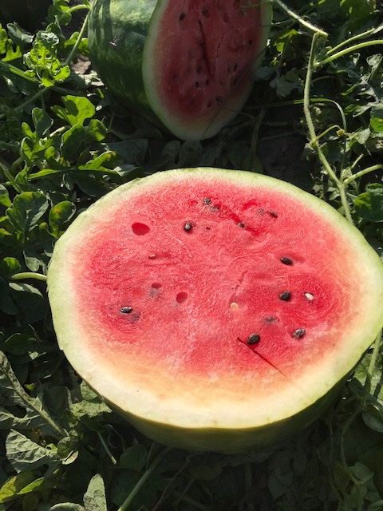

Disease and Insect updates:

We seem to be in full swing of several insect and disease issues right now, much as we would expect in early to mid-harvest season. Here is what we are seeing and hearing:

* Fusarium is again a very serious problem with no in-season remedies. Remember to terminate the crops as soon as soon as the crop is done. This greatly reduces the Fusarium build-up after the season is complete. The benefit of the crop termination is likely VERY underestimated. Without terminating the crop quickly, you will go from a small amount of inoculum to a huge increase in a short period of time.
* Downy and powdery mildew pressure is reported throughout the region for both diseases and growers should continue sprays until one-week to final harvest. For downy, choose either Ranman or Orondis Ultra (in rotation with each other).
* Broad spectrum fungicides like Manzate should still be added to the tank mix if harvest is not 5 days or less. Another good option is Aprovia Top which has a 0-day preharvest interval, whereas Inspire Super has a 7-day preharvest interval. There are a few other good options, but these are the top options for now.
* Rindworm (usually several worm species including, corn earworm, fall armyworm and beet armyworm, etc.) damage has been very light to this point, but we have noticed a large hatch of eggs and small worms this last week. We expect increased rindworm feeding, therefore, continue to scout for damage and spray weekly. Intrepid and Coragen as sprays are still good choices.
* Spider mites are being detected in some fields in small patches. Be on the lookout for mite damage which will appear as yellow/golden leaves and drying of leaves as well. This usually starts on field perimeters and may need spraying with a miticide, if several weeks remain in the harvest season.

(Bob Hochmuth).