Welcome to our 2023 season weekly issue of our UF/IFAS Extension Suwannee Valley Watermelon Crop Update. These updates will be summarized by Bob Hochmuth, Regional Specialized Extension Agent- Vegetable Crops, with input from Suwannee Valley Extension Agents: Mark Warren (Levy), Tyler Pittman (Gilchrist), Tatiana Sanchez (Alachua), Luke Harlow (Bradford), Jay Capasso (Columbia), Dan Fenneman (Madison), Keith Wynn (Hamilton), Emily Beach (Lafayette), Jim Devalerio (Union), De’Anthony Price (Jefferson), Bob Hochmuth (for vacant Suwannee position), Kevin Athearn (RSA-Agri- business), and Sudeep Sidhu (RSA- Water Resources).
If you know someone who wants to be added to this weekly notice, contact your Extension Agent or Mark Warren (352-949-8288) if you want to be added to the regional watermelon group text app.
We have initiated a more formal way to support our watermelon growers with a rapid diagnostics system through Suwannee Valley Regional and County Extension Agents. This industry-funded program allows Extension Agents to submit and pay for watermelon grower’s plant disease and other diagnostic samples. This SV Rapid Diagnostic Watermelon Program will help us to get quicker diagnostic results, helping to give early alerts to everyone, and not have to charge the growers directly. Sponsors of this program in 2023 to date include Harrell’s, TriEst Ag, Gowan USA, and Syngenta Crop Protection.
Those reps interested in sponsoring can contact Bob Hochmuth at bobhoch@ufl.edu or 386-288-6301.

You are invited to the 22nd Annual CARES event at the UF/IFAS NFREC-Suwannee Valley to help recognize farmers who have done a great job of environmental stewardship on their farms. There will be several food booths and you can visit each one until you get your fill of great Florida ag products. The Florida Watermelon Association and the Florida Watermelon Queen will be there too. Try your luck in the watermelon seed spit area as well. No registration is needed.
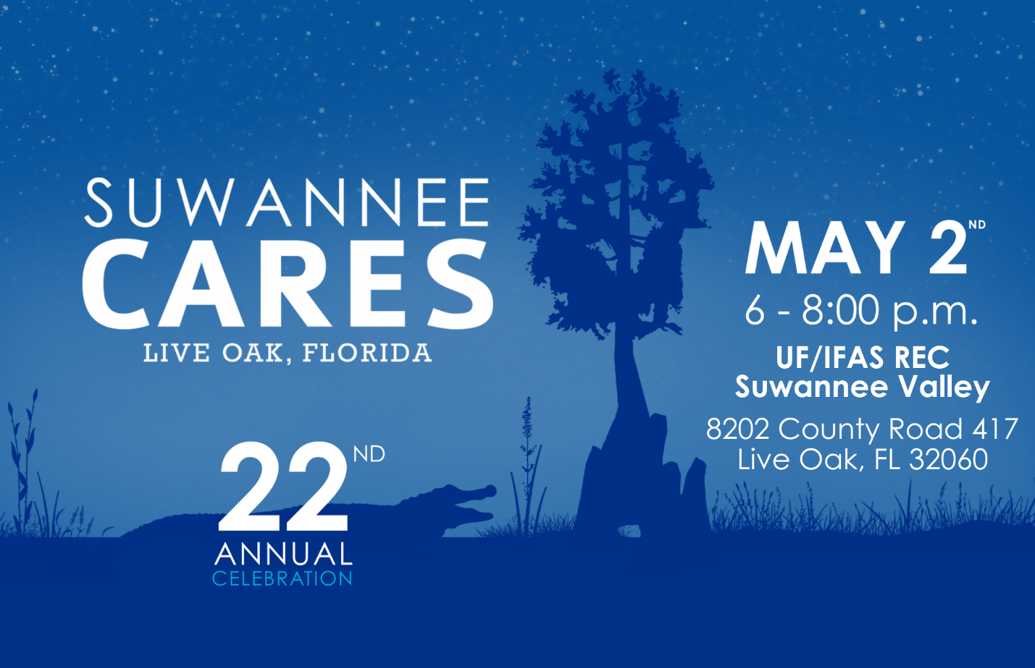
Disease and insect update:
This week has been a continuation of not much new or significant to report on diseases. We have submitted a couple samples that show some significant lesions, and we will report the findings, if significant, later this week. But nothing major has been confirmed this past week in our UF/IFAS labs. Powdery mildew is still a concern because it is very difficult to cure if it gets well established. Therefore, we encourage you to add Quintec or Procure to a broad spectrum fungicide like Manzate or Penncozeb to stay ahead of powdery mildew. We will continue to monitor fields for other pathogens as well. Many fields are well-advanced, and harvest is targeted to be May 10-15 for the earliest fields. I don’t ever remember staying this clean this close to harvest, but we are far from done yet. In the early planted fields, preventative rindworm sprays should have been initiated and other later fields should be started soon. The two primary insecticides with relative safety to bees include Intrepid and Coragen in rotation. Read the labels for all use precautions. We have begun seeing a few patches of watermelon mosaic virus, transmitted by aphids earlier in the season (See Photo A below and] pages 44-45 in the UF/IFAS Watermelon Field Guide). There is no need to worry about this virus now, mainly because we have no cure. It usually only impacts the crop in a minor way until later in the season. (B.Hochmuth).
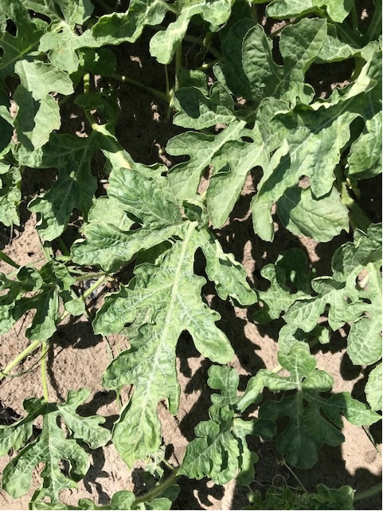
Photo A. Watermelon mosaic virus.
A few other short notes.
Remember to get everything together for your food safety program. Have all of your records in order before things get hectic at harvest.
We have seen symptoms of copper toxicity in fields where copper was sprayed repeatedly for bacterial spot and no rainfall to “wash” it off. Copper toxicity shows as a bright yellow margin on the leaves and later can turn brown on that margin. See pages 20-21 in the UF/IFAS Watermelon Field Guide and the Photo B below. (B. Hochmuth)

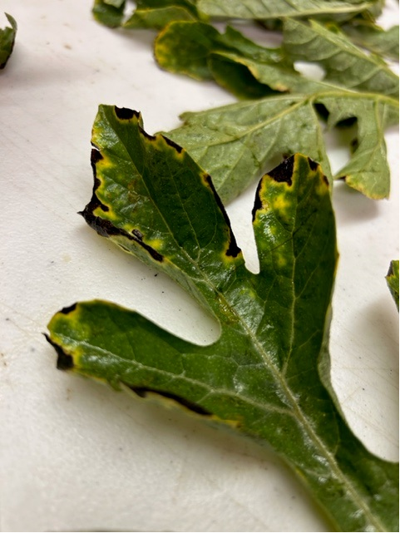
Photo B. Toxicity from copper sprays.

