**Welcome to our 2023 season weekly issue of our UF/IFAS Extension Suwannee Valley Watermelon Crop Update. These updates will be summarized by Bob Hochmuth, Regional Specialized Extension Agent- Vegetable Crops, with input from Suwannee Valley Extension Agents: Mark Warren (Levy), Tyler Pittman (Gilchrist), Tatiana Sanchez (Alachua), Luke Harlow (Bradford), Jay Capasso (Columbia), Dan Fenneman (Madison), Keith Wynn (Hamilton), Emily Beach (Lafayette), Jim Devalerio (Union), De’Anthony Price (Jefferson), Bob Hochmuth (for vacant Suwannee position), Kevin Athearn (RSA-Agri- business), and Sudeep Sidhu (RSA- Water Resources).**

**If you know someone who wants to be added to this weekly notice, contact your Extension Agent or Mark Warren (352-949-8288) if you want to be added to the regional watermelon group text app.**

We have initiated a more formal way to support our watermelon growers with a rapid diagnostics system through Suwannee Valley Regional and County Extension Agents. This industry-funded program allows Extension Agents to submit and pay for watermelon grower’s plant disease and other diagnostic samples. This SV Rapid Diagnostic Watermelon Program will help us to get quicker diagnostic results, helping to give early alerts to everyone, and not have to charge the growers directly. **Sponsors of this program in 2023 to date include Harrell’s, TriEst Ag, Gowan USA, and Syngenta Crop Protection.**

**Those reps interested in sponsoring can contact Bob Hochmuth at** [**bobhoch@ufl.edu**](mailto:bobhoch@ufl.edu) **or 386-288-6301.**

**…………………………………………………………………………………………………………………………………………………………**

**Reminder: Our second watermelon field day planned for the Suwannee Valley region will be held on Thursday, April 20th at UF/IFAS NFREC-Suwannee Valley. See the information below for details. Hope to see you there. Call your Extension agent or Bob Hochmuth if you plan to attend or click on this link to register.**

[2023 Twilight Watermelon Field Day Tickets, Thu, Apr 20, 2023 at 5:30 PM | Eventbrite](https://nam10.safelinks.protection.outlook.com/?url=https%3A%2F%2Fwww.eventbrite.com%2Fe%2F2023-twilight-watermelon-field-day-tickets-607499496347&data=05%7C01%7Cbobhoch%40ufl.edu%7C58fd355735ae408d224e08db345d7340%7C0d4da0f84a314d76ace60a62331e1b84%7C0%7C0%7C638161348186809546%7CUnknown%7CTWFpbGZsb3d8eyJWIjoiMC4wLjAwMDAiLCJQIjoiV2luMzIiLCJBTiI6Ik1haWwiLCJXVCI6Mn0%3D%7C3000%7C%7C%7C&sdata=oieJmrHmreY6cIrQbSZEsAdgr053mDpZRSZ61MSdLQY%3D&reserved=0)

**Twilight “At-The-Research and Education Center” Watermelon Field Day- Automation of Irrigation Systems, Paper Mulch Research Update, and Fertilizer Management Programs**

**Thursday, April 20th, 2023**

**Presented by the UF/IFAS Suwannee Valley Watermelon Extension Team**

**Location: UF/IFAS NFREC-Suwannee Valley, 8202 CR 417, Live Oak FL 32060**

5:30 PM   —    Registration Opens

6:00 PM — Welcome

(Note: CCA and 1 Pesticide Applicator CEUs have been approved for this meeting)

6:05 PM — **Presentations and Field Tour of Research Trials.**

**Automating Irrigation Systems in Vegetable Crops.** Andy Voelz, Anthony Tasselli, Michael Steele, ToroAg; and Marshall Hall, Josh Freeman, TriEst Ag.

**Cost Share Opportunities for Automating Irrigation Systems,** Jonathan Crain, Suwannee River Water Management District.

**Paper Mulch in Watermelon Production A Research Update,** Fritz Paulsen, WestRock.

**Florida Watermelon Association- funded Fertilizer Trial (including comparison of Traditional, Controlled Release Fertilizers, and All-liquid season-long program).** Bob Hochmuth and Sydney Williams, UF/IFAS NFREC Suwannee Valley.

**Insect and Disease Update.** Jay Capasso Columbia County Extension and Bob Hochmuth.

7:00 PM    —    **Sponsored Dinner- ToroAg (Irrigation Automation, Supplies), WestRock (Paper Mulch)**

**Comments from Florida Watermelon Association (FWA)**, Laura Land, FWA Research Committee Chair.

8:00 pm  - Adjourn

Note: Something new you will see at this field day. Our paper mulch trial and the impressive control of nutsedge. This photo shows the black plastic mulch row with heavy nutsedge, and the row of black mulch on the left is WestRock’s paper mulch being researched.

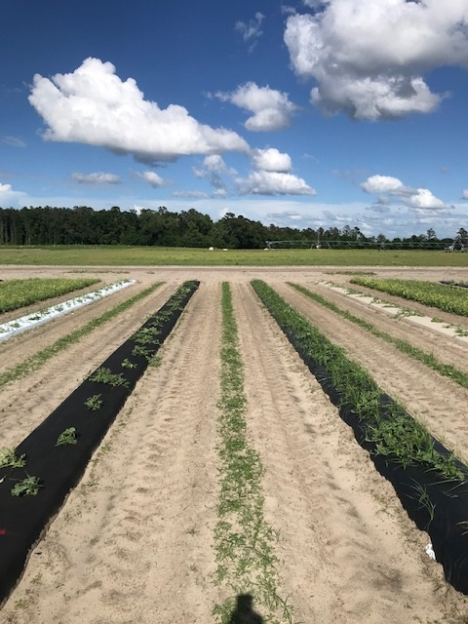

**…………………………………………………………………………………………………………………………………………………………**

**Weekly Updates:**

At the end of this past week, we detected some bacterial leaf spot on watermelon leaves. This is not unexpected as the early part of last week was cold, rainy and windy, all very good conditions for bacterial leaf spot to infect. As in past updates, if you see bacterial leaf spot, we recommend adding a low rate (0.5 lbs/A) to your spray program. See photo below (Bob Hochmuth and Shivendra Kumar).

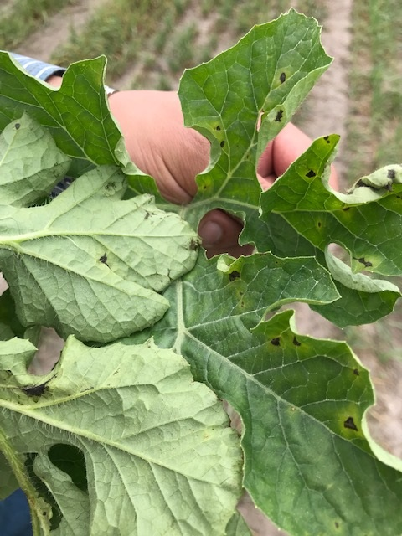

Powdery mildew update: We have not had any confirmation of powdery mildew in the Suwannee Valley on watermelons yet, but we do expect to see it in the next week. This was about the time we first detected it in 2022. We had good luck last year with a rotation of Quintec and Procure, one or the other weekly, added to a broad-spectrum fungicide. (Bob Hochmuth)