Welcome to this week’s 2022 season’s weekly issue of our UF/IFAS Extension Suwannee Valley Watermelon Crop Update. These updates are summarized by Bob Hochmuth with input from Suwannee Valley Extension Agents: Mark Warren (Levy), Tyler Pittman (Gilchrist), Tatiana Sanchez (Alachua), Luke Harlow (Union), Jay Capasso (Columbia), Dan Fenneman (Madison), Keith Wynn (Hamilton), Danielle Sprague (Jefferson), Emily Beach (Lafayette), Amanda Phillips (Suwannee), Kevin Athearn (RSA-Agri- business), and Sudeep Sidhu (RSA- Water Resources).
If you know someone who wants to be added to this weekly notice, contact your Extension Agent or Mark Warren (352-949-8288) if you want to be added to the regional watermelon group text app.
Thank You to the 2022 Suwannee Valley Rapid Diagnostic Watermelon Program and Its Industry Sponsors. Syngenta Crop Protection, Glades Crop Care, TriEst Ag Group, Gowan USA, Summit Agro-USA, and Harrell’s Fertilizer for sponsoring this effort. Other industry reps interested in sponsoring this effort can contact Bob Hochmuth at bobhoch@ufl.edu or 386-288-6301.

Harvest Begins
From all of us in the allied watermelon industry, we wish you the best as harvest has begun.

Disease Update
Well, we hoped we may escape this season without seeing downy mildew. But, we now have our first confirmed case of the season for downy mildew in Levy County. See pages 40-41 in your UF/IFAS Watermelon Field Guide.
Before I go any further, I want to caution everyone these alerts do not necessarily mean for everyone should automatically pull the trigger on control measures. In fact, this has always been a concern of mine with these weekly updates. We do want everyone to have a heightened alert and to intensify scouting when we indicate alerts for any of these diseases or other pests. But, our intent is to make sure everyone knows what is happening in the region, so you can make the best decision possible on your own farm.
Downy mildew is the disease traditionally known as “wildfire” and arrived last year about this same time in May. Because of the high risk of damage and movement throughout the region, we are expressing a high level of concern to consider a plan to spray if you have not already initiated a program targeted at downy mildew, especially in the southern parts of the Suwannee Valley region (Levy and Gilchrist County is where the report has been made. However, it is expected to continue to move north to Suwannee, Lafayette, Columbia, Madison, and Union Counties next. Contact your Extension Agent if you see areas of the field where the plants look blighted (dried up leaves sticking straight up in the mid part of the canopy). The leaves in more advanced stages will quickly become “crispy” with the leaf veins being the only part of the leaf to become crispy and dry (see Photos below). You should consider adding one of these fungicides to your program soon. The best choices, based on recent trials, are Ranman, Orondis Ultra, or Zampro (all three have a zero-day pre-harvest interval (PHI)) and should be added to a broader spectrum mancozeb (Manzate or Penncozeb (5-day PHI)) spray plus either Quintec or Procure, for the continued pressure from powdery mildew. Good luck with this additional challenge. For those fields where downy has been confirmed, we have suggested starting with Orondis Ultra or Zampro this week and Ranman next week. Where downy mildew has not yet been detected, you could start with Ranman this week and follow with Orondis Ultra, or Zampro.
Rindworm preventative materials should also be continued. Be very cautious with your spray this week in the high temperatures. Likelihood of burn is greater when temperatures are high, and 2-3 materials are tank mixed. (Bob Hochmuth and Mark Warren)

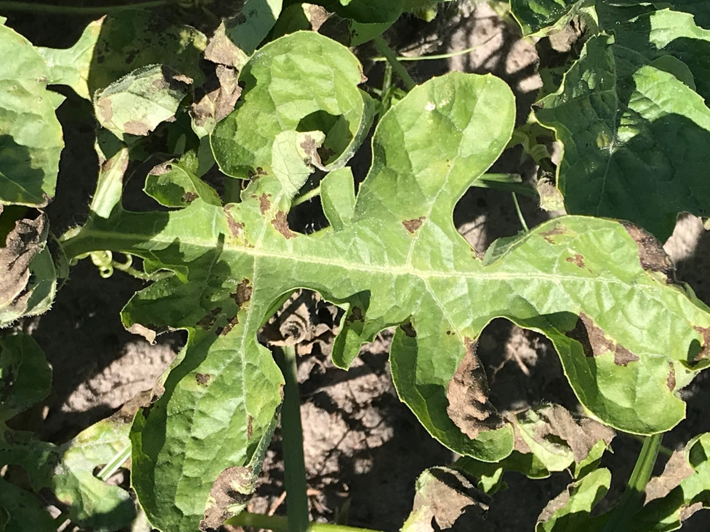
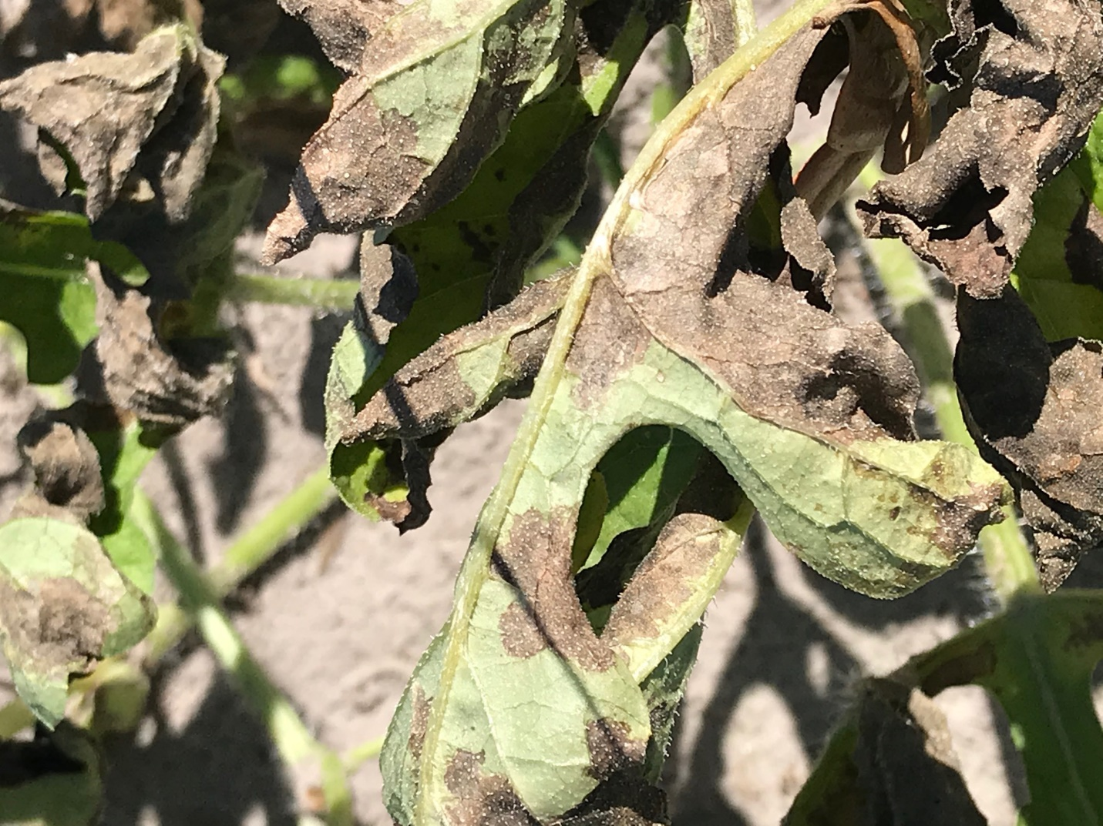

Nutrient Management Update:
Once harvests start, it is common to set the rate at 2.0 lbs per acre per day and leave it there until one week from last pick. It is not useful to fertigate that last week of harvest. Once we get to first harvest, we typically stop using petiole-sap testing and set things at the 2.0 lbs/A/day rate. (Bob Hochmuth)

Spider Mites detected
We have one report of early infestation of spider mites this past week. This pest is more common in dry weather, so in areas that had been missing rainfall, spider mites would not be a surprise. Unlike disease warnings, spider mites are generally very isolated and do not represent a call to action, other than to keep up a good scouting program and be on the lookout for small patches of bronzed leaves typical of spider mite feeding. It is common to see these infestations along the edges of the fields where the mites may have moved in from weedy borders. See pages 104-105 in your UF/IFAS Watermelon Field Guide. (Bob Hochmuth, thanks to the scout reporting this)

