Welcome to this week’s 2022 season’s weekly issue of our UF/IFAS Extension Suwannee Valley Watermelon Crop Update. These updates are summarized by Bob Hochmuth with input from Suwannee Valley Extension Agents: Mark Warren (Levy), Tyler Pittman (Gilchrist), Tatiana Sanchez (Alachua), Luke Harlow (Union), Jay Capasso (Columbia), Dan Fenneman (Madison), Keith Wynn (Hamilton), Danielle Sprague (Jefferson), Emily Beach (Lafayette), Amanda Phillips (Suwannee), Kevin Athearn (RSA-Agri- business), and Sudeep Sidhu (RSA- Water Resources).
If you know someone who wants to be added to this weekly notice, contact your Extension Agent or Mark Warren (352-949-8288) if you want to be added to the regional watermelon group text app.
Thank You to the 2022 Suwannee Valley Rapid Diagnostic Watermelon Program and Its Industry Sponsors:
We have initiated a more formal way to support our watermelon growers with a rapid diagnostics system through Suwannee Valley Regional and County Extension Agents. This industry-funded program allows Extension Agents to submit and pay for watermelon grower’s plant disease and other diagnostic samples. This SV Rapid Diagnostic Watermelon Program will help us to get quicker diagnostic results, helping to give early alerts to everyone, and not have to charge the growers directly. Plant disease samples are typically $40 and leaf tissue analyses are typically $20. We want to thank the 2022 sponsors of this program: Syngenta Crop Protection, Glades Crop Care, TriEst Ag Group, Gowan USA, Summit Agro-USA, and Harrell’s Fertilizer for sponsoring this effort. Other industry reps interested in sponsoring this effort can contact Bob Hochmuth at bobhoch@ufl.edu or 386-288-6301.

Time for starting petiole or leaf tissue analysis (By Mark Warren and Bob Hochmuth):
Watermelon vines in many fields are growing off the plastic beds now and we recommend starting to look at nutrient levels to determine when to start a routine fertigation program. Many producers and consultants use tissue sampling as an important management tool for in-season fertility assessments. Like sap testing, it is important to recognize that tissue tests are just a snap-shot views of the crop at the time the sample was collected. Results can be affected by many factors (time of day, cloud cover, stage of maturity, time since last fertilizer application). Tissue analysis and petiole-sap tests are most valuable when taken consistently, routinely, and then considered over time.
Sample collection is the most critical part of the process. Representative samples are essential. Avoid taking samples from areas that have symptoms not related to nutrition (disease, cold, insect, drought…) Some labs may suggest different sampling protocols (whole plant, petiole, full leaf), but UF research, including the nutrient sufficiency/ deficiency ranges, are based on samples of the “most recently matured leaf” (MRML). Regardless of the lab that you choose, you should submit samples using the MRML (the 5-6th leaf from tip) as these will most accurately correlate to the published information for Florida crops and conditions.
- 15-20 leaves
- Full leaf samples to be sent to a lab are collected/ submitted in paper bag
- Petioles for sap testing should be collected, immediately remove the leaf blade from the petiole (petioles only), put in plastic bags and immediately tested, or stored in a cooler with a little ice or refrigerator if testing will occur after a couple of hours. Samples must be brought to room temperature for testing.
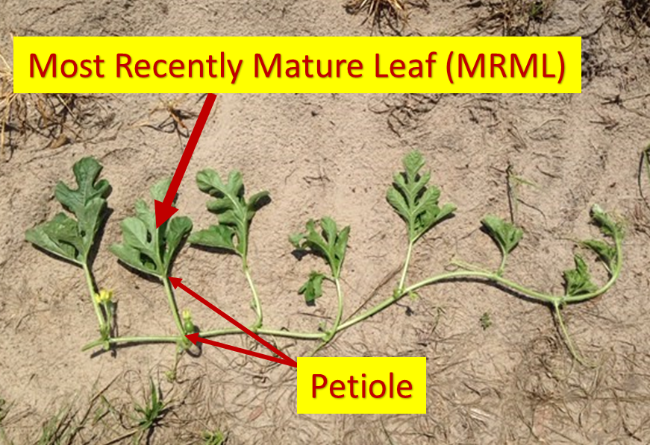
Photo. Bob Hochmuth
When nutrient related stress is suspected, it is best to submit a “good” versus “bad” set of samples so that the results can be compared.
For watermelon whole leaf analysis at first flower, we recommend the N levels be in the range of 2.5-3.5% and K levels between 2.7-3.5%. Adapted from, Plant Tissue Analysis and Interpretation for Vegetable Crops in Florida. HS964.
https://edis.ifas.ufl.edu/pdffiles/EP/EP08100.pdf

When using plant petiole sap tests, at or before first flower, we recommend the nitrate-N levels be between 1200 and 1500 ppm and the K levels between 4,000 and 5,000 ppm.
UF/IFAS Extension Agents in the Suwannee Valley are ready to begin petiole-sap testing at growers’ requests. So let your Extension agent know when you are ready for sap testing.
Disease and Insect Updates (by Tatiana Sanchez and Bob Hochmuth)
Extension Agents and industry field personnel generally report this past week the watermelon crop is still mostly free of insects and disease, other than fields where transplants were infected with gummy stem blight and a few isolated cases of Pseudomonas bacterial leaf spot. Many of the plants still look pretty rough from the freeze damage and constant wind abrasion, but these plants have pushed new growth and seem like they are doing as well as could be expected. Unless growers have a specific disease established, we suggest you consider chlorothalonil (Bravo or other generic) this week. We realize Miravis Prime may be another option in future sprays ahead of infections, however, it is more expensive. We are concerned about more expensive options this year, unless needed, especially given the high inputs and uncertain market.
This is the time to also be on the lookout for adult squash bugs emerging from woodlands and field perimeters. Be sure to let us know if you need insect or disease samples collected for ID or analysis.

