Welcome to this week’s 2022 season’s weekly issue of our UF/IFAS Extension Suwannee Valley Watermelon Crop Update. These updates are summarized by Bob Hochmuth with input from Suwannee Valley Extension Agents: Mark Warren (Levy), Tyler Pittman (Gilchrist), Tatiana Sanchez (Alachua), Luke Harlow (Union), Jay Capasso (Columbia), Dan Fenneman (Madison), Keith Wynn (Hamilton), Danielle Sprague (Jefferson), Emily Beach (Lafayette), Amanda Phillips (Suwannee), Kevin Athearn (RSA-Agri- business), and Sudeep Sidhu (RSA- Water Resources).
If you know someone who wants to be added to this weekly notice, contact your Extension Agent or Mark Warren (352-949-8288) if you want to be added to the regional watermelon group text app.
Thank You to the 2022 Suwannee Valley Rapid Diagnostic Watermelon Program and Its Industry Sponsors. Syngenta Crop Protection, Glades Crop Care, TriEst Ag Group, Gowan USA, Summit Agro-USA, and Harrell’s Fertilizer for sponsoring this effort. Other industry reps interested in sponsoring this effort can contact Bob Hochmuth at bobhoch@ufl.edu or 386-288-6301.

You are invited to a Watermelon Field Day at the Watson’s Farm near Trenton on May 3rd, 2022. The Field Day will begin at 6:00pm at one of the Watson fields near the intersection of NW 60th Avenue and NW 165th Street, southwest of Trenton (see attached map). Dinner will be provided by Industry and will be served after the fertilizer plot tour. The topics to be covered will include: Irrigation Management, Use of Controlled Release Fertilizer, Automating Irrigation Systems, and an update on food safety.

There is no registration fee for the Field Day. Attendees must register on Eventbrite by April 29th. 2022 Watermelon Field Day Tickets, Tue, May 3, 2022 at 6:00 PM | Eventbrite

2022 Watermelon Field Day

Watson’s Farm
Tuesday, May 3rd, 2022

6:00 PM Program/ Tour of Fertilizer Plots

Discussion on Nutrient Management as part of a BMP program
Mark Warren, UF/IFAS Extension Agent, Levy County

Controlled Release Fertilizer Project Overview and Observations
Annual Food Safety Update (Certificate Provided)
Bob Hochmuth, Regional Specialized Extension Agent-Vegetables/Assistant Center Director North Florida REC-Suwannee Valley

Automating Irrigation Systems
Tyler Pittman, UF/IFAS Extension Agent, Gilchrist County

7:00 PM Dinner (Sponsored by Industry)

Directions:

Off US 129 in Trenton turn onto NW 160th Street, turn right onto NW 60th Avenue, turn right at the 1st cross street onto NW 165th Street

Special thanks to:
- Greg and Dale Watson, Watson Farms for hosting and cooperating on the project
- Loran Brookins for cooperating on this project at a second farm location
- Pursell Agri-Tech Fertilizer and Mayo Fertilizer for partnering and providing fertilizers for this trial
- NFREC-SV – Technical support
- FDACS-OAP-Funding
- Florida Watermelon Association

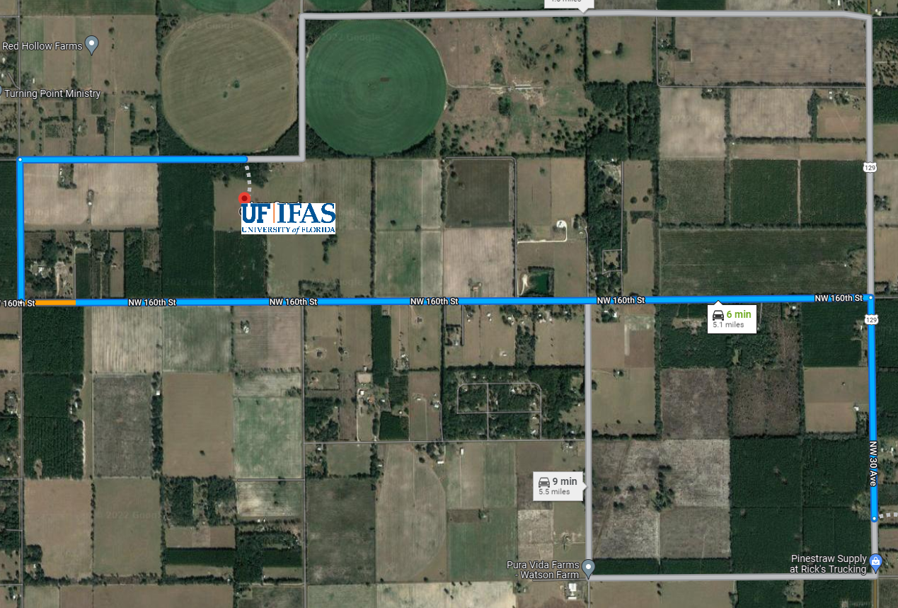

First Powdery Mildew Confirmation of 2022 (Mark Warren, Bob Hochmuth)
We had the first UF lab confirmation of powdery mildew in the Suwannee Valley this past week. The sample collected did not show vivid symptoms of powdery mildew, however, the UF Plant Diagnostic lab at UF found powdery mildew. So, we now know the conditions are favorable for powdery mildew and it simply “feels like” powdery mildew weather now, dry breeze, and relatively low humidity. As a result, we suggest you start your powdery mildew preventative fungicide programs. Once powdery mildew is present, we recommend you rotate between Quintec and Procure. This weekly rotation worked well last year when started early. Research results last year in the Suwannee Valley showed these two materials were still effective and showed low resistance levels. Switch may be another option later in the season, but we suggest you start with Quintec and Procure rotated and one or the other sprayed weekly along with your broad-spectrum fungicides (Mancozeb or Chlorothalonil). Intensify your scouting regimine now until harvest.
Fusarium Wilt (By Bob Hochmuth, Mathews Paret, and Tatiana Sanchez)
We are continuing to see Fusarium wilt in some fields as plants get to the point of vigorous fines and fruit set, and as a result, demanding more water than the plant can get through the Fusarium clogged water vessels. The warm weather should help slow the spread of the disease but expect to continue to see more plants succumb to Fusarium. We wish there was a magic bullet at this stage of the season, but there is none. Proline has to be applied very early in the season to be effective. I caution growers to think hard before spending a lot of money on expensive cocktails as a remedy. I saw some of these firsthand in 2021 with absolutely no effect on the level of control. Believe me, we wish we had a silver bullet for you on this one.

Petiole Sap Testing Results (Bob Hochmuth and Mark Warren)

Extension Agents in the Suwannee Valley are now in full swing with petiole-sap testing for nitrogen and potassium. Collectively Extension Agents and support staff are sampling over 100 fields each week now. Prior to last week, most samples were high on N and perfect on K. Sampling during the end of last week began to show significant movement on nitrogen in fields where many baseball or larger-sized fruit were seen. In these fields, potassium was still excellent, but nitrogen began to naturally decline. In those fields, it was common to recommend increasing fertigations to 2.0 lbs per acre per day rates of nitrogen and potash. This is only informational and not intended as an across-the-board recommendation for everyone. Use the guidance given by Extension Agents in YOUR fields. With very high prices of nutrients, this is not the year to over fertilize!

