Weekly Watermelon Crop Update for May 31, 2021
Welcome to our UF/IFAS Extension Suwannee Valley Weekly Watermelon Crop Update. These updates will be summarized by Bob Hochmuth with input from Suwannee Valley Extension Agents: Mark Warren, Tyler Pittman, Tatiana Sanchez, Luke Harlow, Jay Capasso, Sylvia Wills, Dan Fenneman, Keith Wynn, Danielle Sprague, Kevin Athearn, and Charles Barrett.
Topics this week:
Harvest in Full Swing
Heat and Drought Stress
Reminder- Join the Florida Watermelon Association
Rapid Diagnostic Watermelon Program

Harvest in Full Swing: Fruit quality has been outstanding based my frequent sampling,…..very high brix (sugars). With harvest in full swing, there are no major changes in diseases. There are some fields with downy mildew infections, but the dry weather and good fungicide programs being used have kept it managed. Powdery mildew and gummy stem blight are also around, but good fungicide programs there Have also helped manage these diseases. I begin to think about how long you may want to continue spraying fields that will be only harvested a short time. As you get to 10-14 days from final harvest, and if the field is relatively clean from disease, you should choose fungicide options wisely and consider no more sprays that final week if things look clean. Please feel free to contact us with questions, but the needs are highly varied from farm to farm now so I hesitate to use any blanket recommendations (Hochmuth).

Heat and Drought Stress: The main thing we are seeing all over the region is heat/drought stress (See Photos 1 and 2). The older leaves turn yellow with not disease lesions and eventually those affected leaves completely dry. My observation has been those fields with light vegetation cover over the plastic mulch are most affected. Without full vegetative cover over the plastic last week, the soil temperatures in the bed have been extremely high adding to the stress of the plants. These fields may initially look like disease, but the leaves are generally clean of pathogens but dry or burned appearing. I know pivots have been used to supplement irrigation, which I normally am not a big fan due to increased disease pressure. But, in these conditions, it may be necessary if there is no other option. Let’s hope we get some relief with rain later this week. Several fields with good cover are being maintained well with drip irrigation only but require multiple events filling a 24-hour period. There certainly is no leaching going on this time of this season (Hochmuth).

Photos 1 and 2. Heat/drought stress symptoms
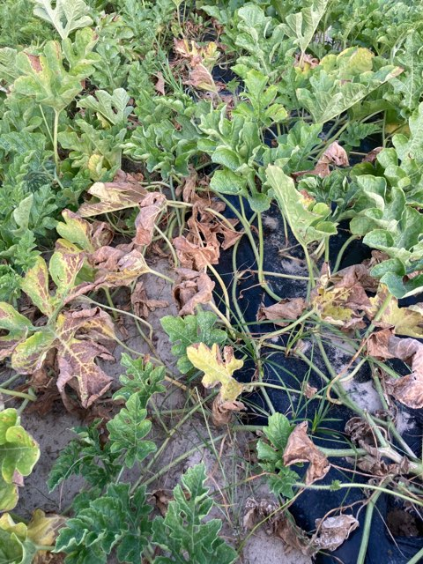

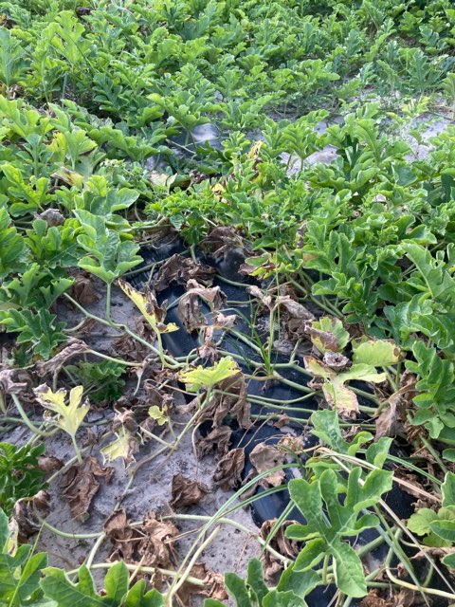

Reminder- Join the Florida Watermelon Association: It is the mission of the Florida Watermelon Association to support research, education, and promotion of the fresh Florida watermelon industry. If you are not a current member, I encourage you to join. Your voice as a watermelon farmer needs to be heard on so many issues, now more than ever. All watermelon farmers and allied industry representatives should join. I am a member, and I encourage every reader of this weekly update to join as well. To join, go to https://www.flfwa.com/
(Bob Hochmuth).

Thank You to the Suwannee Valley Rapid Diagnostic Watermelon Program and Its Industry Sponsors: UF/IFAS Extension agents have initiated a more formal way to support our watermelon growers with a rapid diagnostics system through Suwannee Valley Regional. This industry-funded program allows Extension Agents to submit and pay for watermelon grower plant disease and other diagnostic samples. This SV Rapid Diagnostic Watermelon Program will help us to get quicker diagnostic results and not have to charge the growers directly. Plant disease samples are typically $40 and leaf tissue analyses are typically $20. We want to thank the initial sponsors of this program: Syngenta Crop Protection, Harrell’s Fertilizer, Koppert Biological Systems, SEEDWAY LLC, BASF Vegetable Seeds, Bayer Crop Science, Gowan Seed, and Gowan USA for sponsoring this effort. Other industry reps interested in sponsoring this effort can contact Bob Hochmuth at bobhoch@ufl.edu or 386-288-6301.

