Weekly Watermelon Crop Update for June 7, 2021
Welcome to our UF/IFAS Extension Suwannee Valley Weekly Watermelon Crop Update. These updates will be summarized by Bob Hochmuth with input from Suwannee Valley Extension Agents: Mark Warren, Tyler Pittman, Tatiana Sanchez, Luke Harlow, Jay Capasso, Sylvia Wills, Dan Fenneman, Keith Wynn, Danielle Sprague, Kevin Athearn, and Charles Barrett.
Topics this week:
Disease and Stress Update
New Watermelon Field Guide
Reminder- Join the Florida Watermelon Association
Rapid Diagnostic Watermelon Program

Disease, Insect, and Stress Update: This week, there are still no major changes in diseases over the past two weeks. For several of us who see a lot of fields each week are in agreement, we are just not seeing much movement in downy mildew. I am sure good fungicide programs have really helped, but we feel like there are situations where growers may be able to reduce intensity of downy mildew sprays IF, the past 2-3 weeks have included Orondis Ultra or Ranman AND if the field looks clean from downy mildew symptoms. Powdery mildew and gummy stem blight are also around, but good fungicide programs there have also helped manage these diseases. If any disease has increased this past week, it is powdery mildew, so do not eliminate your powdery materials if you still have a few weeks to keep picking. As noted last week, as you get to 10-14 days from final harvest, and if the field is relatively clean from disease, you should choose fungicide options wisely and consider no more sprays that final week if things look clean. Please feel free to contact us with questions, but the needs are highly varied from farm to farm so we hesitate to use any blanket recommendations. Rindworms are definitely still active, so stay on a good preventative program up to that last week. Last week we also noted concerns of “yellowing” foliage have been noted, and we often summarize the symptom with heat stress and perhaps temporary water stress. In those cases, the yellow leaves are the older leaves and are “just yellow”, not with any diseases. One common factor we see with these symptoms is that the fields have much of the field where you can see the black plastic (not much vine cover). I see a correlation with the yellowing and poor vine cover resulting in the soil temperatures being higher than in other fields with good vine cover. It is also more prevalent on the outside rows (rows next to drive roads) if vines have been turned back too completely leaving the black plastic more exposed (R. Hochmuth).

New Watermelon Field Guide: Many of you have seen the newest product of the UF/IFAS County Extension Agents in the Suwannee Valley and we hope you find it useful and of high quality. This guide is the collective work of the agents in this region. It is full of 140 photographs, almost all taken by the agents in the Suwannee Valley region, and in fact, you will likely see photos from your farms. Each photo has a short summary of important points related to that photo. We are all very proud to get this “pay for” publication ready at our IFAS Extension Bookstore (see flyer below). We would not have been able to complete the printing without the sponsorship provided by the Florida Watermelon Association. We say THANK YOU to FWA for their support and collaboration on this unique field guide; the only one like it in the country! If you have any questions regarding the guide, contact your local Extension Agent.
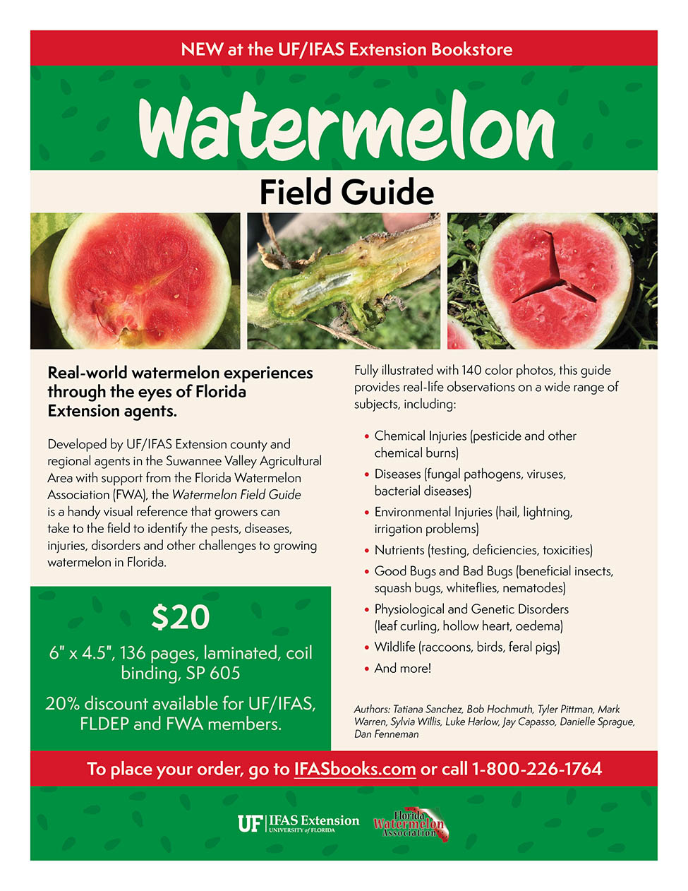

Reminder- Join the Florida Watermelon Association: It is the mission of the Florida Watermelon Association to support research, education, and promotion of the fresh Florida watermelon industry. If you are not a current member, I encourage you to join. Your voice as a watermelon farmer needs to be heard on so many issues, now more than ever. All watermelon farmers and allied industry representatives should join. I am a member, and I encourage every reader of this weekly update to join as well. To join, go to https://www.flfwa.com/
(Bob Hochmuth).

Thank You to the Suwannee Valley Rapid Diagnostic Watermelon Program and Its Industry Sponsors: UF/IFAS Extension agents have initiated a more formal way to support our watermelon growers with a rapid diagnostics system through Suwannee Valley Regional. This industry-funded program allows Extension Agents to submit and pay for watermelon grower plant disease and other diagnostic samples. This SV Rapid Diagnostic Watermelon Program will help us to get quicker diagnostic results and not have to charge the growers directly. Plant disease samples are typically $40 and leaf tissue analyses are typically $20. We want to thank the initial sponsors of this program: Syngenta Crop Protection, Harrell’s Fertilizer, Koppert Biological Systems, SEEDWAY LLC, BASF Vegetable Seeds, Bayer Crop Science, Gowan Seed, and Gowan USA for sponsoring this effort. Other industry reps interested in sponsoring this effort can contact Bob Hochmuth at bobhoch@ufl.edu or 386-288-6301.

