Weekly Watermelon Crop Update for June 30, 2021
Welcome to our Final UF/IFAS Extension Suwannee Valley Weekly Watermelon Crop Update of the season. These updates have been summarized by Bob Hochmuth with input from Suwannee Valley Extension Agents: Mark Warren, Tyler Pittman, Tatiana Sanchez, Luke Harlow, Jay Capasso, Sylvia Wills, Dan Fenneman, Keith Wynn, Danielle Sprague, Kevin Athearn, and Charles Barrett.
Topics this week:
Final Thoughts
Help us to Improve our Service
Dates to Remember
Reminder- New Watermelon Field Guide
Reminder- Join the Florida Watermelon Association
Rapid Diagnostic Watermelon Program

Final Thoughts: Well, the season here started with the first transplant put in the ground about February 20th or so and the final main market harvest here coming to completion in late June. There are still a few selling watermelons to local harvesters and haulers, but many fields are completely done. I am always amazed at how intense the few weeks of harvest is for our Suwannee Valley growers. I am happy for all of our growers in that the market was a pretty good one for prices received and yields in many fields were quite high. That is a pretty good combination, but we needed it due to the much higher inputs this year. I hope these updates have been helpful and have helped you make good decisions on inputs. I am glad to say we seem to have managed our insects and diseases with timely sprays and overall, the crop was clean. All of us, your UF/IFAS Suwannee Valley Extension agents say thank you for timely input and early detection opportunities. Together we can succeed! See you at the meetings!

Help us to Improve our Service: We (UF/IFAS Extension Agents) always want to know how we can improve our service to our growers and allied industry. Your Extension agents will soon be reaching out to you with a few questions on a short survey. Your time (only a few minutes) will really help us to know how we can modify our efforts to better serve you. So, be on the look out for that upcoming survey. Your input is like gold (or this year as valuable as a pallet).

Dates to Remember:
Suwannee Valley Watermelon Institute- December 2nd, Gainesville, FL
Florida Watermelon Convention October 20-22, Orlando, FL

Reminder- New Watermelon Field Guide: We are all very proud to get this “pay for” publication ready at our IFAS Extension Bookstore (see flyer below). We would not have been able to complete the printing without the sponsorship provided by the Florida Watermelon Association. We say THANK YOU to FWA for their support and collaboration on this unique field guide; the only one like it in the country! If you have any questions regarding the guide, contact your local Extension Agent.
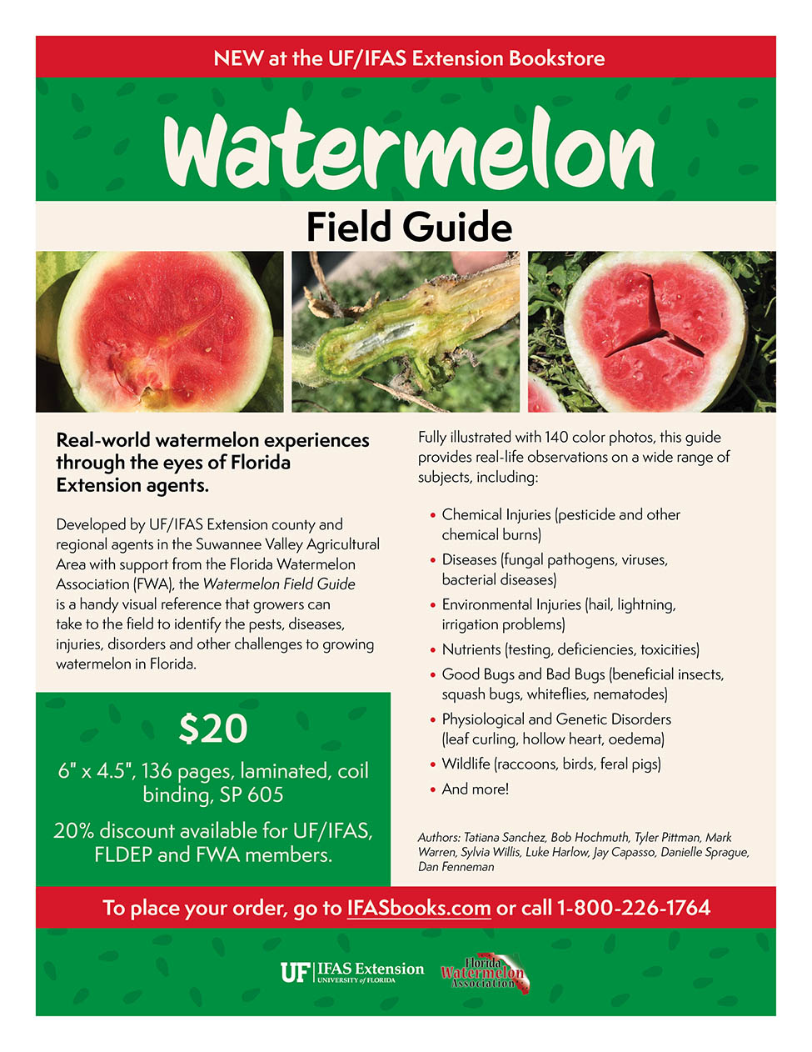

Reminder- Join the Florida Watermelon Association: All watermelon farmers and allied industry representatives should join. I am a member, and I encourage every reader of this weekly update to join as well. To join, go to https://www.flfwa.com/
(Bob Hochmuth).

Thank You to the Suwannee Valley Rapid Diagnostic Watermelon Program and Its Industry Sponsors: This year UF/IFAS Extension agents initiated a more formal way to support our watermelon growers with a rapid diagnostics system through Suwannee Valley Regional. This industry-funded program allowed Extension Agents to submit and pay for watermelon grower plant disease and other diagnostic samples. This SV Rapid Diagnostic Watermelon Program helped us to get quicker diagnostic results and not have to charge the growers directly. There were well over 100 samples submitted this year through this program. We want to thank the 2021 sponsors of this program: Syngenta Crop Protection, Harrell’s Fertilizer, Koppert Biological Systems, SEEDWAY LLC, BASF Vegetable Seeds, Bayer Crop Science, Gowan Seed, and Gowan USA. Your support made a difference!

